Academic year

(2021-2022)





Aditya Silver oak Institute of Technology

**INTERNSHIP REPORT**

UNDER SUBJECT OF

**SUMMER INTERNSHIP (3170001)**

B.E. SEMESTER-VII **CE**

**Submitted by :-**

**Rushi Rajeshbhai Shah(181200107058)**

Company logo

Jalpa Shah Sagar Jasani

(Internal Guide) (External Guide)

**Company Profile**



**Company Name:** BrainyBeam Technologies Pvt Ltd

**Address:** 118, Sukan Mall , Science city road, Ahmedabad

**Contact No:** +91 9033237336

**Email Id :** sagar@brainybeam.com

**Website:** www.brainybeam.com

**About Us**

At BrainyBeam, we see Innovation as a clear differentiator. Innovation, along with focus on deep, long-lasting client relationships and strong domain expertise, drives every facet of our day-to-day operations.

BrainyBeam Technologies was founded with a vision to address growing businesses' needs of reducing the time to market and cost effectiveness required to develop and maintain unique and customized web and mobile solutions. We are uniquely and strategically positioned to partner with startups and leading brands to help them expand their business and offer the most effective and cost-efficient solutions that provide revenues and value to their business needs.

**Vision**

To become the most trusted and preferred offshore IT solutions partner for Startups, SMBs and Enterprises through innovation and technology leadership. Understanding your ambitious vision, honing in on its essence, creating a design strategy, and knowing how to technically execute it is what we do best. Our promise? The integrity of your vision will be maintained and we'll enhance it to best reach your target customers. With our primary focus on creating amazing user experiences, we'll help you understand the tradeoffs, prioritize features, and distill valuable functionality. It's an art form we care about getting right.

**Joining Letter**

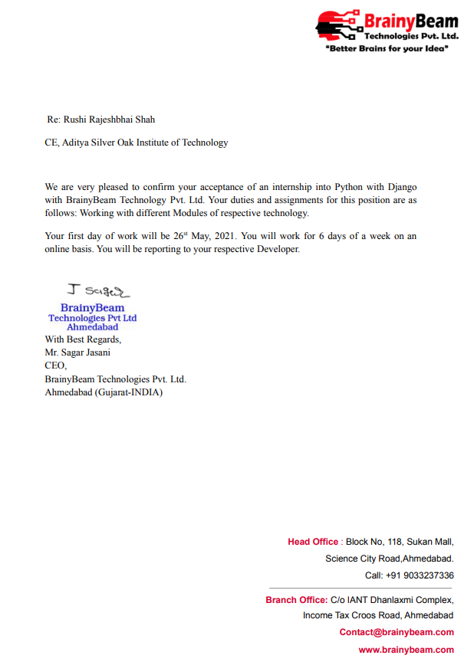

**Completion Certificate**



**ACKNOWLEDGEMENT**

“I would start by thanking my honorable faculty Mr. Darpan Salunkhe sir Who has provided me with the necessary guidance and information needed to complete this internship report. I would like to thank Mr. Darpan (in-charge of Brainy Beam Technology) for giving me technical and non-technical knowledge and guideline during activation period, and the entire team for being helpful and support.

Also I would like to thank Mr. Sagar (CEO of Brainy Beam Technology) for teaching me all the basic of my task and patiently showing me every elaborate details and guiding me throughout my internship period. I am very thankful to “Brainy Beam Technology”

**INDEX**

|  |  |  |  |
| --- | --- | --- | --- |
| **SR.NUM** | **DATE** | **TASK** | **PAGE** |

|  |  |  |  |  |  |  |  |  |  |  |  |  |  |  |  |  |  |  |  |  |  |  |  |  |  |  |  |  |  |  |  |  |  |  |  |  |  |  |
| --- | --- | --- | --- | --- | --- | --- | --- | --- | --- | --- | --- | --- | --- | --- | --- | --- | --- | --- | --- | --- | --- | --- | --- | --- | --- | --- | --- | --- | --- | --- | --- | --- | --- | --- | --- | --- | --- | --- |
| |  |  |  |  | | --- | --- | --- | --- | | 1 | 26 MAY 2021 | Create 20 linux command and data structure of  Python with example. | 1 | | 2 | 27 MAY 2021 | Create List From User,  Find Even Values From List,  Find Odd Values From List,  Find Largest Values From List,  Find Smallest Values From List, | 17 | | 3 | 28 MAY 2021 | (1) Create Demo1 to Demo10 Django Projects  (2) take scrinshots of -  - django-admin startproject <project name>  - python manage.py migrate  - python manage.py createsuperuser  - python manage.py runserver  - settings.py Install_Apps  - main urls.py  - run code browser image | 19 | | 4 | 31 MAY 2021 | (1) create apps in projects as i Explain in session  (2) take screenshot of settings.py, main urls.py, and any views.py and urls.py, and also main screen and any apps webpage image | 26 | | 5 | 1 JUN 2021 | Create Calculator  Template Intigration | 46 | | 6 | 2 JUN 2021 | create list of fields of django model | 53 | | 7 | 3 JUN 2021 | Write Some Details About ORM in Django | 56 | | 8 | 4 JUN 2021 | (1) Write Details About Random Module.  (2) Write Details About SMTPlib Module | 58 | |  | |  | |  | |
|  |  |  | |  | |
|  |  |  | |  | |
|  |  |  | |  | |
|  |  |  | |  | |

|  |  |  |  |
| --- | --- | --- | --- |
| **SR.NUM** | **DATE** | **TASK** | **PAGE** |

|  |  |  |  |
| --- | --- | --- | --- |
| 9 | 9 JUN 2021 | Write Details About objects.all(), objects.filter(), objects.get(). | 62 |
| 10 | 10 JUN 2021 | Write Details About object.save() and object.delete() | 69 |
| 11 | 11 JUN 2021 | Create New Project Which Contains Registration in django. | 71 |
| 12 | 12 JUN 2021 | Create New Project Which Contains login in django. | 73 |
| 13 | 13 JUN 2021 | Perform Insert, Update, Delete operations | 74 |
| 14 | 14 JUN 2021 | Implement your own template integration | 78 |
| 15 |  | Video Lecture Links | 85 |
| 16 |  | References | 88 |

* **Task1: Write 20 linux command with example.**

1. **ls:-** ls is used to display the directories.

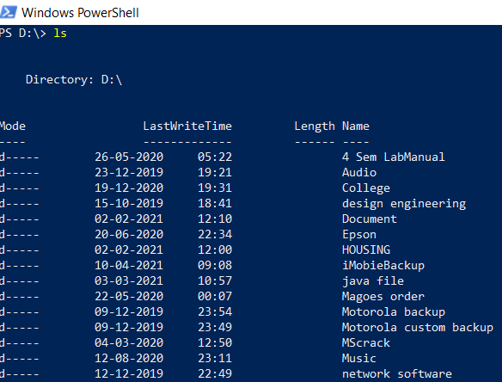

1. **cd:-** cd is used to change the current directory.

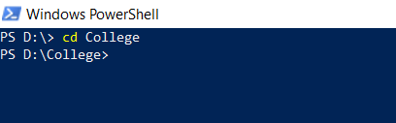

1. **pwd:-**  pwd is used to show current working directory.

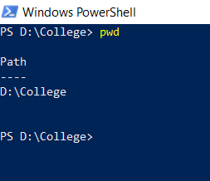

1. **mkdir<filename>:-** mkdir<filename> is used to create a directory.

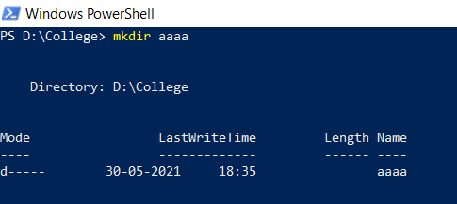

1. **rmdir<filename>:-** rmdir<filename> is used to delete a directory.

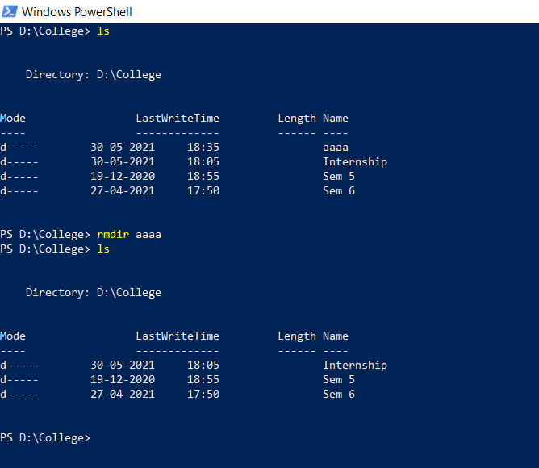

1. **cp:-**  cp is used to copy is a file or directory from one location to other.

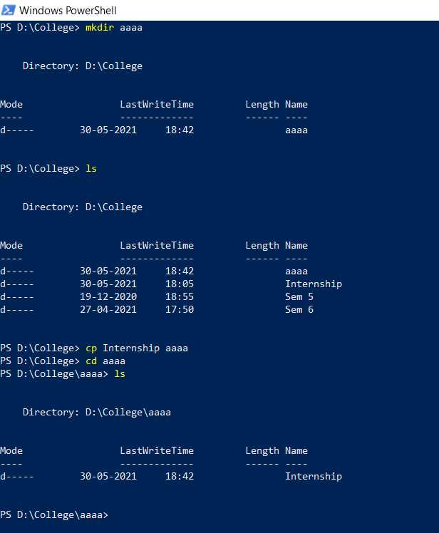

1. **mv:-** mv is used to move a directory or file.

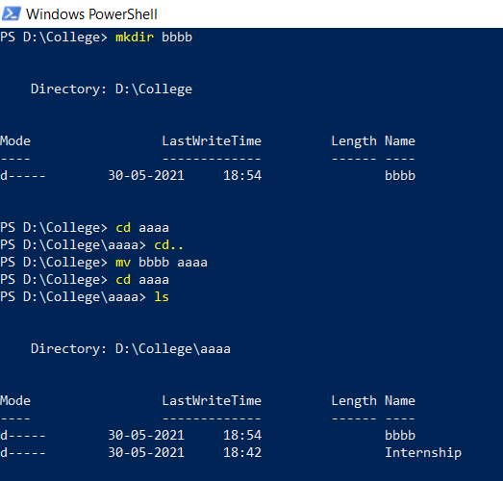

1. **clear:-**  clear is used to clear screen.

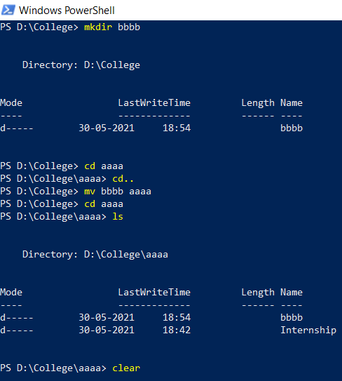

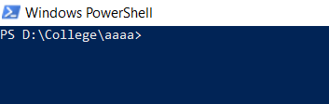

1. **echo:-**  echo is used to print a string on screen.

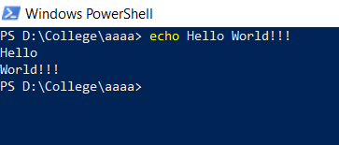

1. **history:-** history is used to display the history of command executed.

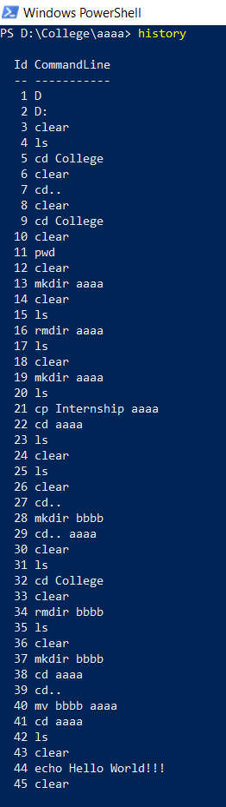

1. **finger:-** display information about user on specified software system running finger service.

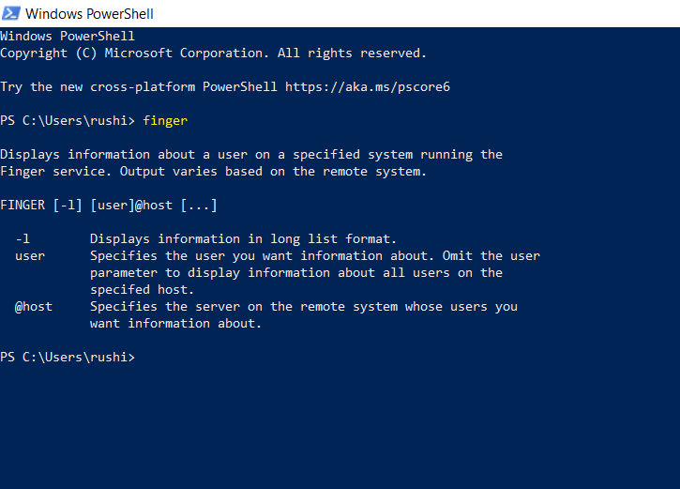

1. **ipconfig:-** it gives the Ip address, default gateway and other information.

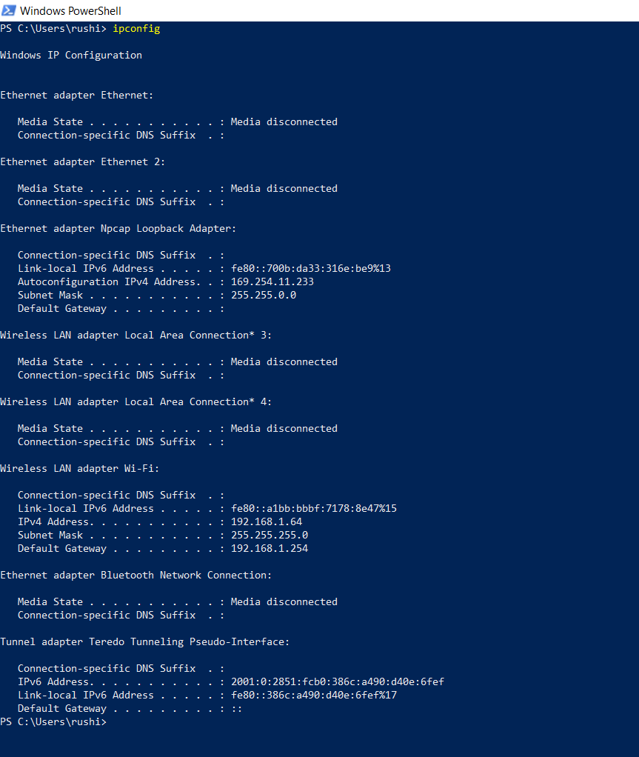

1. **hostname:-** this command gives hostname

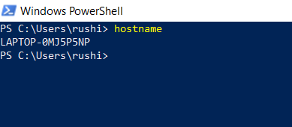

1. **help:-** help will prompt all command

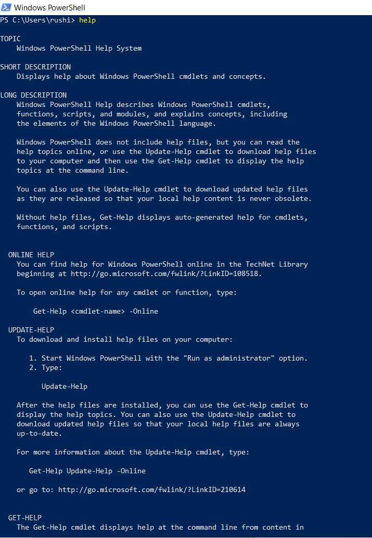

1. **date:-**  date command display current date and time.

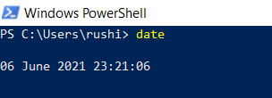

1. **ping:-**  [ing is used to check the reachability of device on internet.

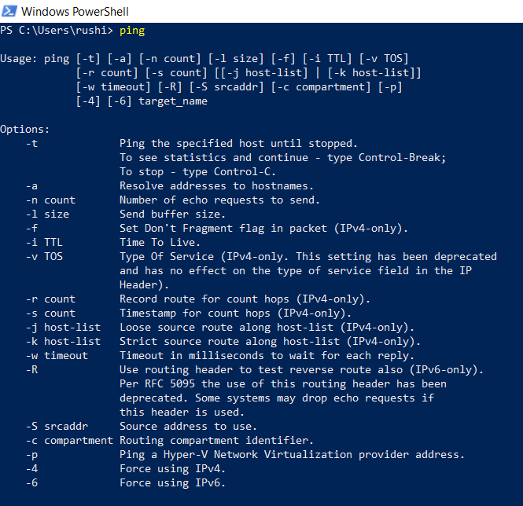

1. **del:-** del is used to delete a directory or file.

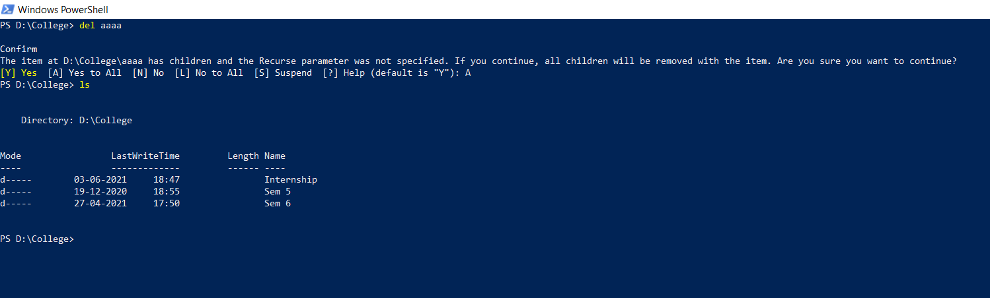

1. **route:-** route command displays all route

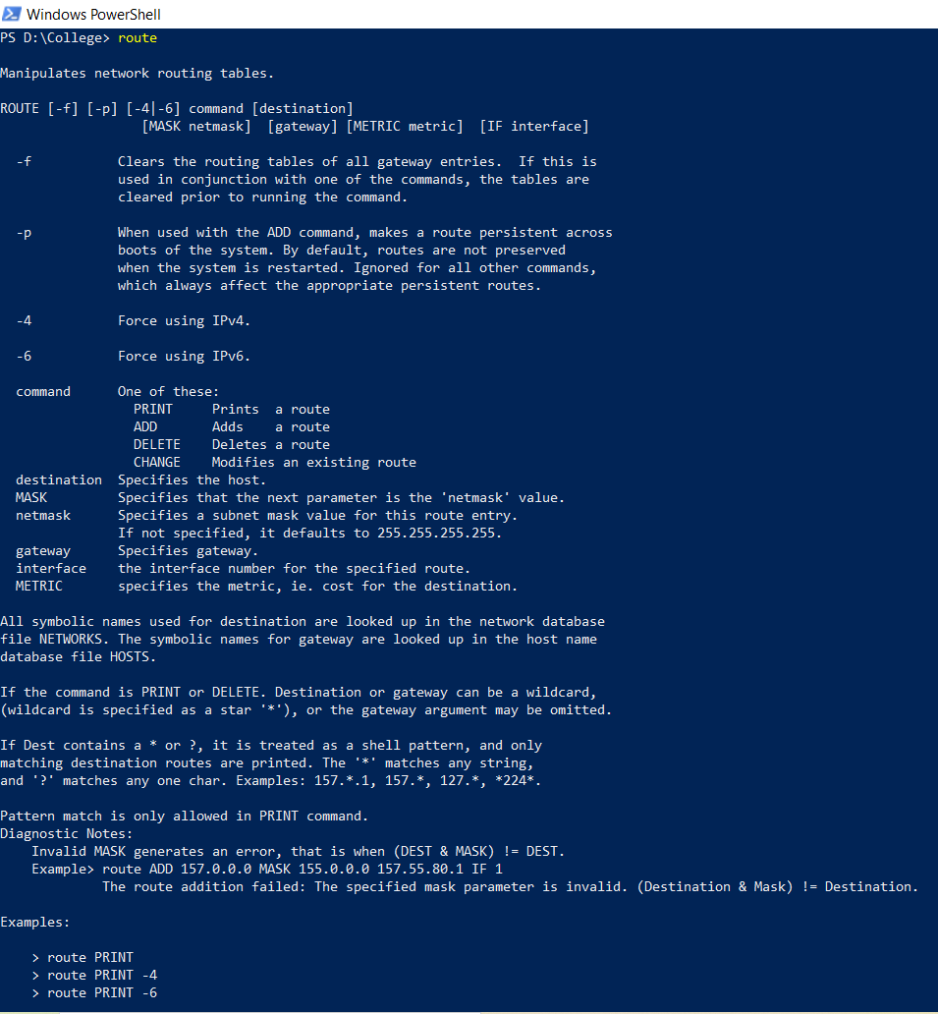

1. **Notepad:-** notepad is used to launch notepad program using command

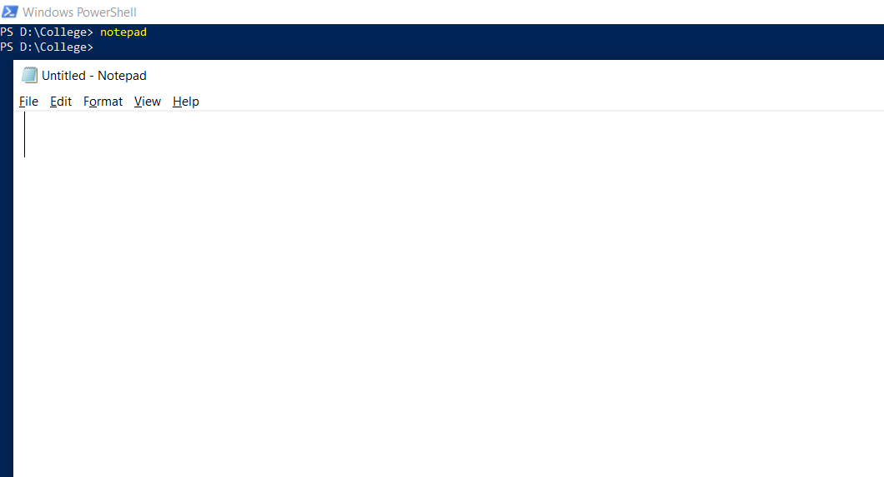

1. **Exit:-** exit command is used to close powershell.

* **Task 2:** Data structure of python with methods.
* **1. List**
* **List Methods**
* append() - Add an element to the end of the list extend() - Add all elements of a list to the another list insert() - Insert an item at the defined index remove() - Removes an item from the list pop() - Removes and returns an element at the given index clear() - Removes all items from the list index() - Returns the index of the first matched item count() - Returns the count of the number of items passed as an argument sort() - Sort items in a list in ascending order reverse() - Reverse the order of items in the list copy() - Returns a shallow copy of the list
* 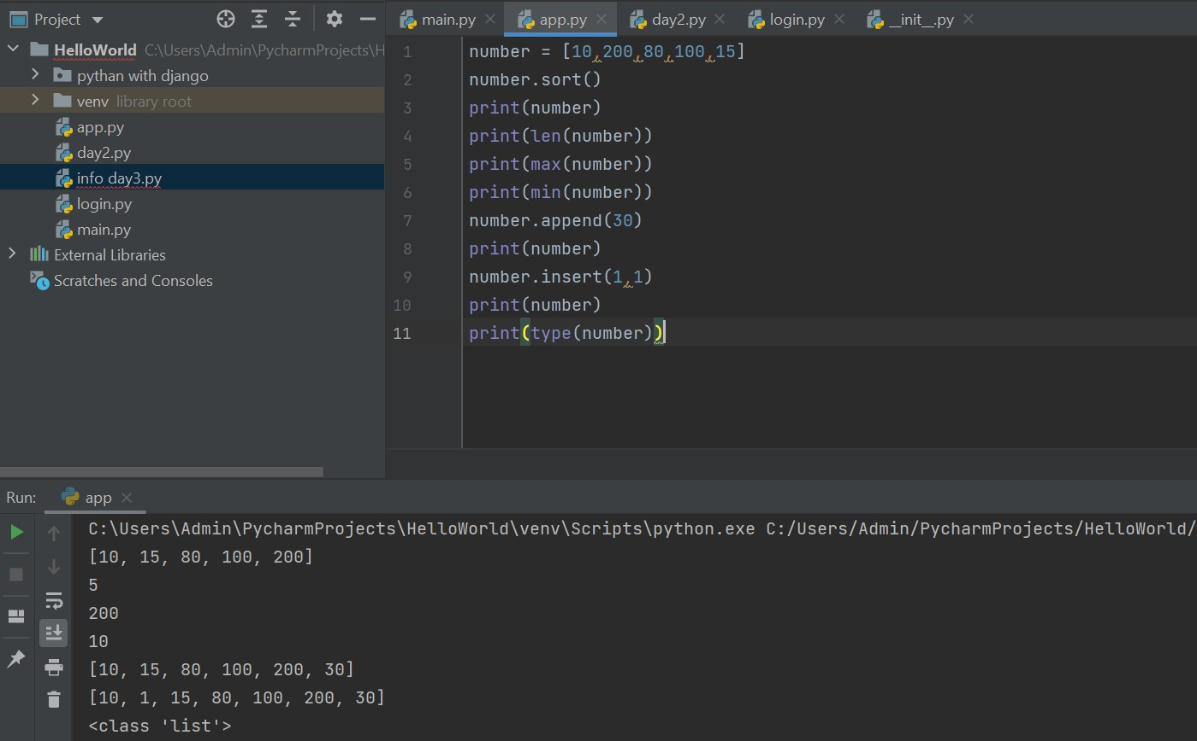
* **2.Tuple**
* **Tuple Methods** count()-Returns the number of times a specified value occurs in a tuple index()-Searches the tuple for a specified value and returns the position of where it was found
* 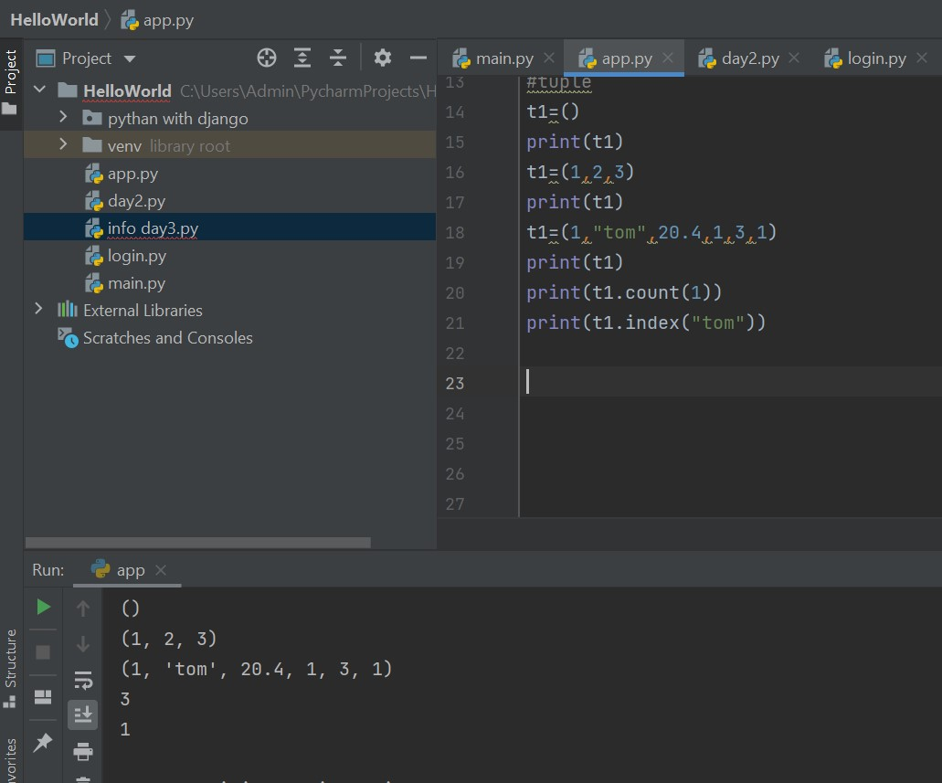
* **3.Set**
* **Set Methods** add()-Adds an element to the set clear()- Removes all the elements from the set copy() -Returns a copy of the set difference()- Returns a set containing the difference between two or more sets
* difference_update()- Removes the items in this set that are also included in another, specified set discard()-Remove the specified item isdisjoint()-Returns whether two sets have a intersection or not
* issubset()-Returns whether another set contains this set or not issuperset()- Returns whether this set contains another set or not pop()- Removes an element from the set remove()-Removes the specified element union()-Return a set containing the union of sets update()-Update the set with another set, or any other iterable

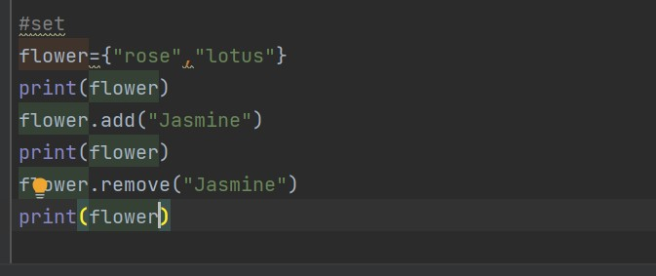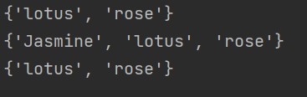

* **4.Dictinory**
* **Dictinory Methods**

|  |  |
| --- | --- |
| clear() - | Removes all the elements from the dictionary |
| copy() - | Returns a copy of the dictionary |
| fromkeys()- | Returns a dictionary with the specified keys and value |
| get()- | Returns the value of the specified key |
| items()- | Returns a list containing a tuple for each key value pair |
| keys() - | Returns a list containing the dictionary's keys |

* pop() - Removes the element with the specified key popitem()- Removes the last inserted key-value pair
* setdefault()- Returns the value of the specified key. If the key does not exist: insert the key, with the specified value update()- Updates the dictionary with the specified key-value pairs values()- Returns a list of all the values in the dictionary

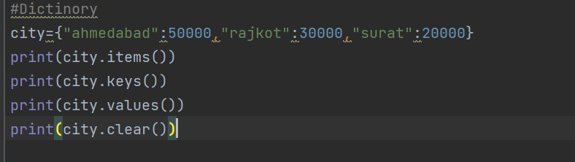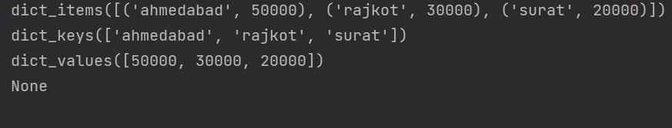

**Day-2 task**

1. **Create list from user:**
2. **Find even value from list:**
3. **Find odd value from list:**
4. **Find largest value from list:**
5. **Find smallest value from list:**

**Code:-**

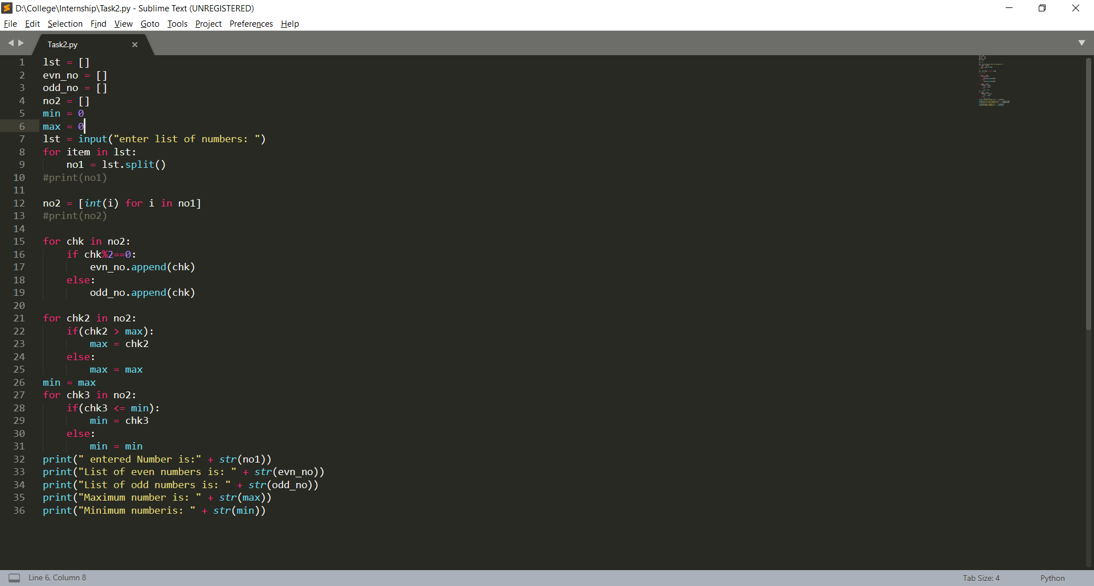

**Output:-**

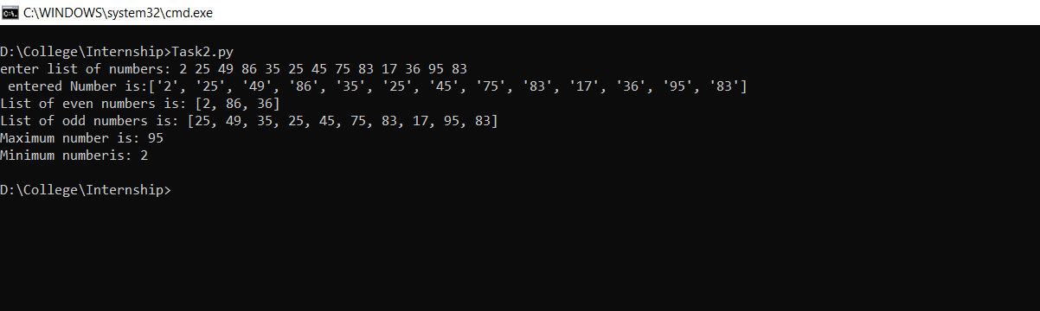

**DAY-3 TASK**

* **Create Demo 1 To Demo 10 Django Projects**
* **Task Screenshots of –**
* **Django- admin startproject <project name>**
* **Python manage.py migrate**
* **Python manage.py createsuperuser**
* **Python manage.py runserver**
* **Setting.py intall_app**
* **Main urls.py**
* **Run code browser image**
* Create Project

Command: Django-admin startproject <ProjectName>

This command creates the project( it creates the required directory and files for the projects)

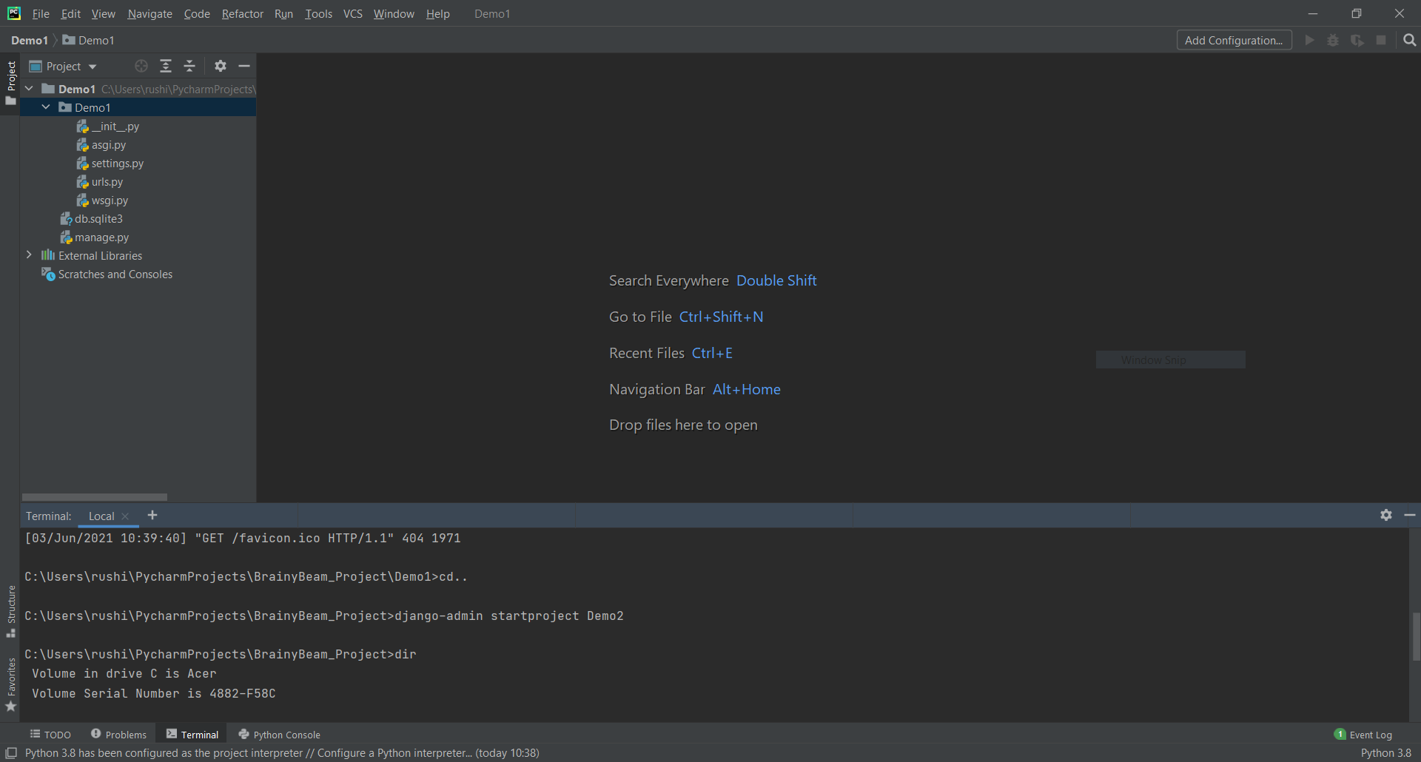

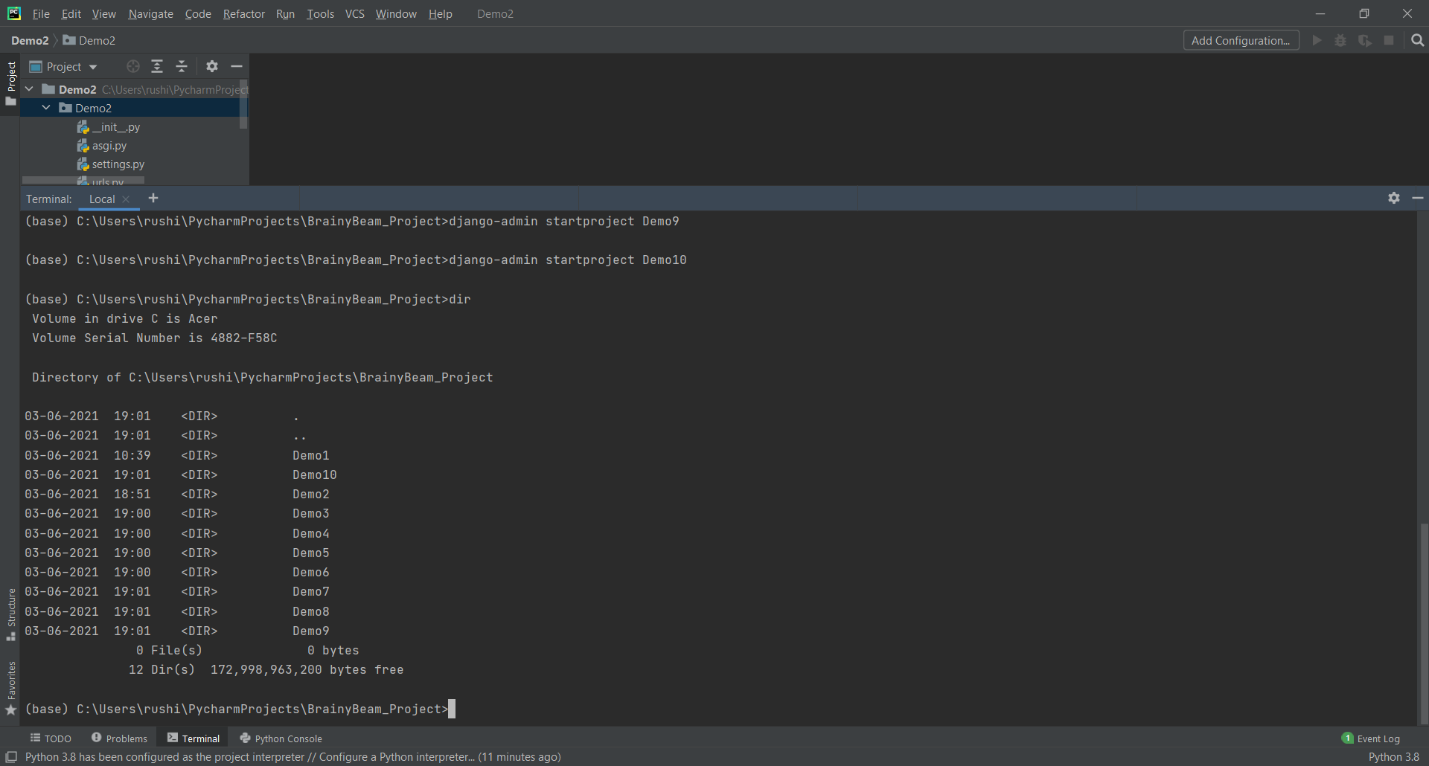

* Migrate

Command: python manage.py migrate

This command initializes the database in the project.

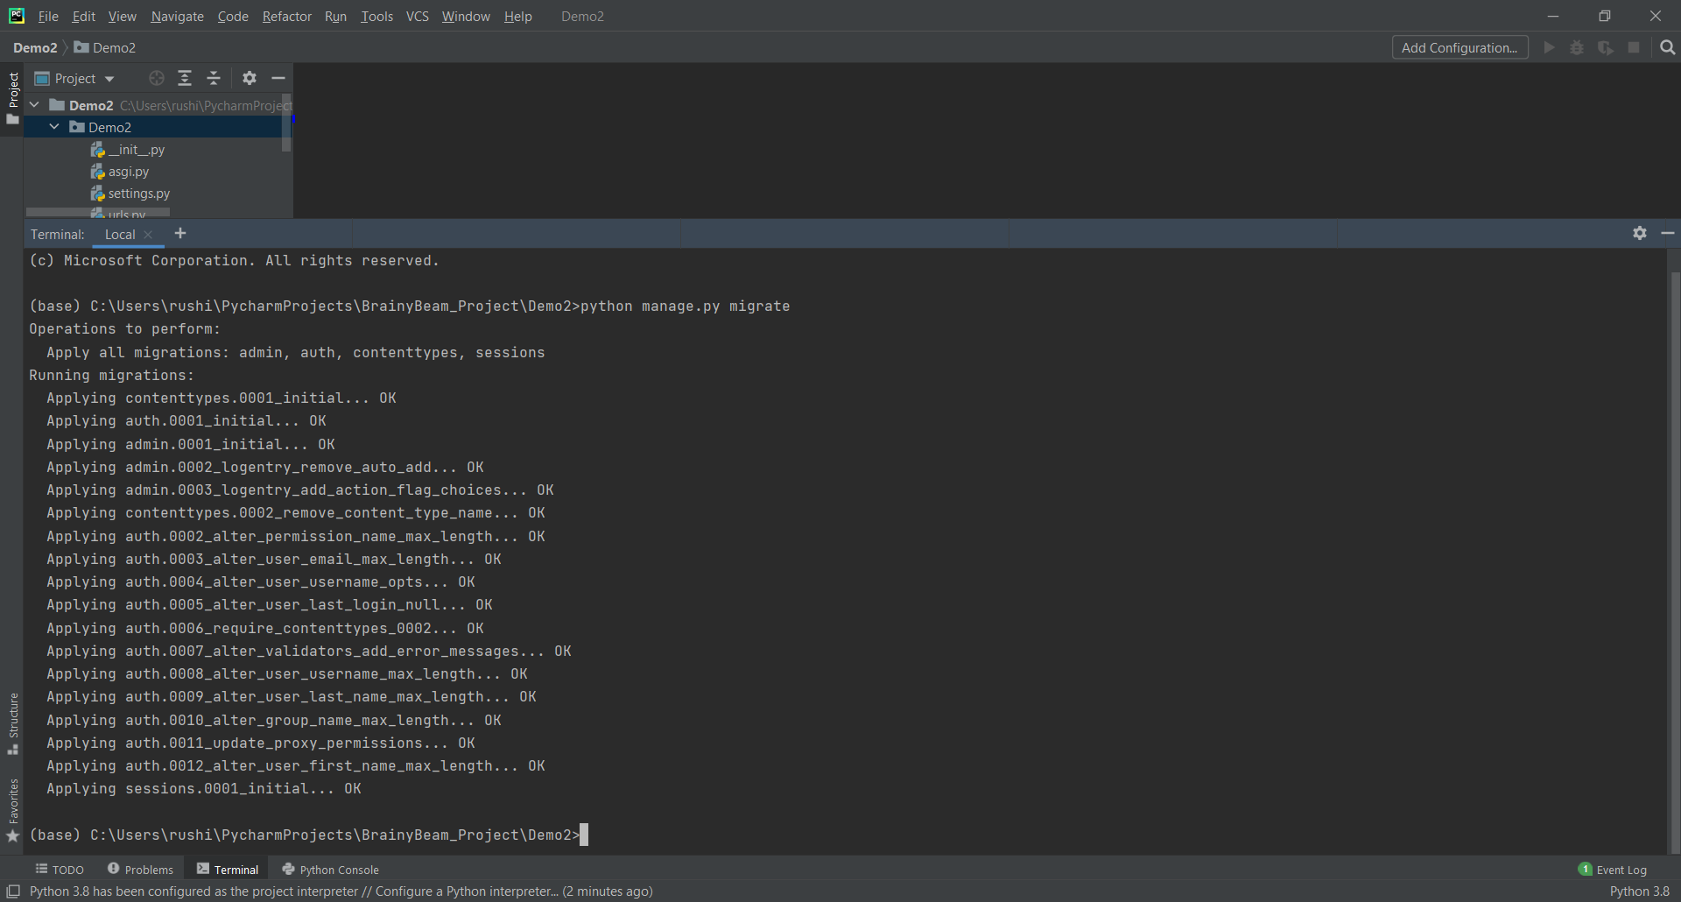

* Superuser

Command: python manage.py creatsuperuser

This command is use to create a superuser in project

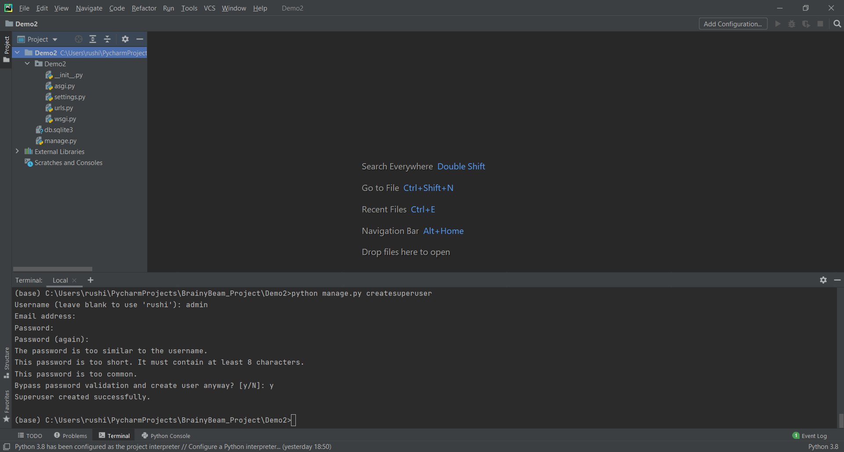

* Startapp

Command: python manage.py startapp

This command creates an app in the project( at least 1 app is needed).

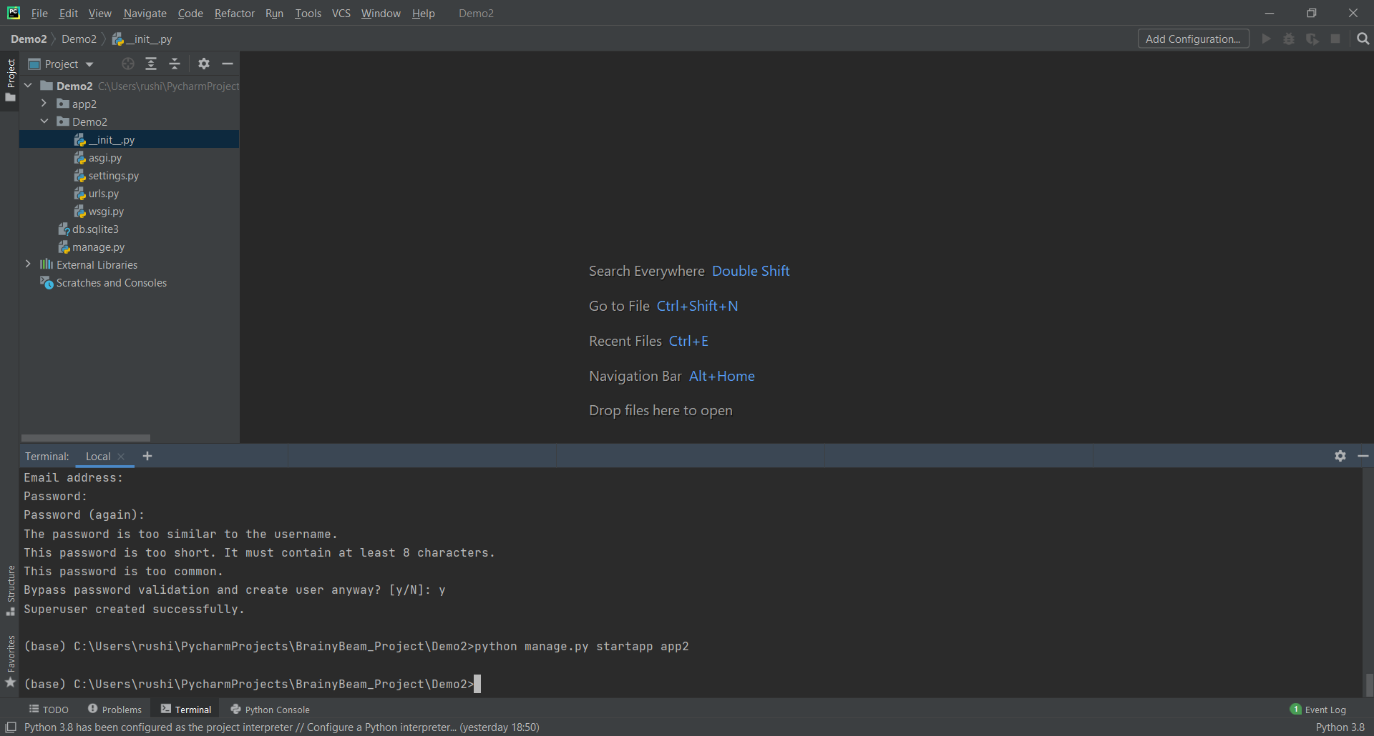

* Registering app in settings.py

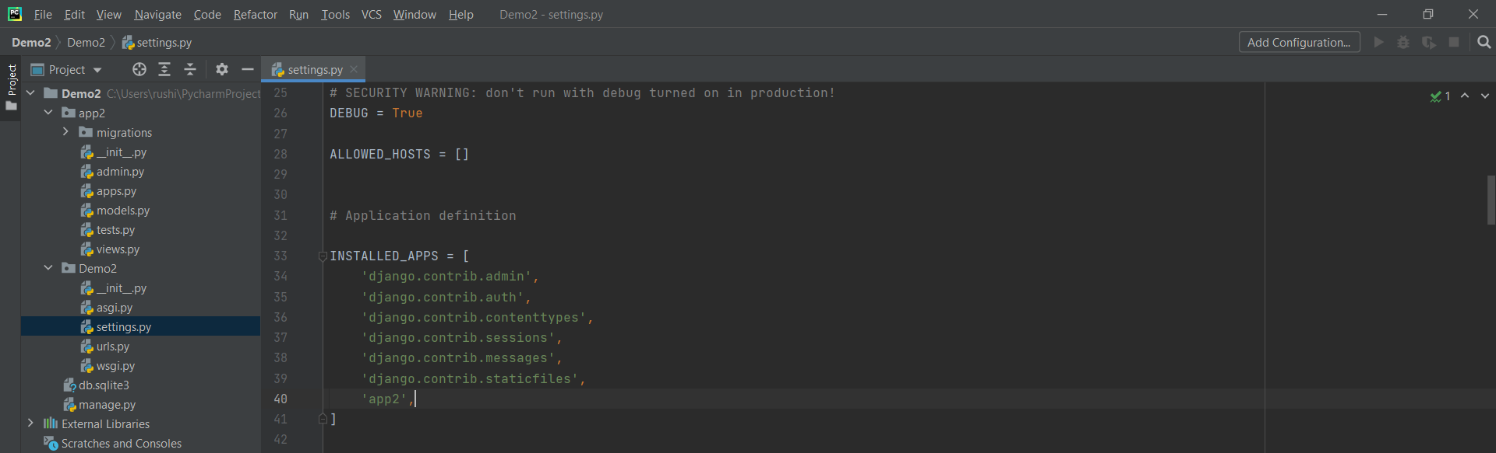

* Main urls.py

This is the file of main url

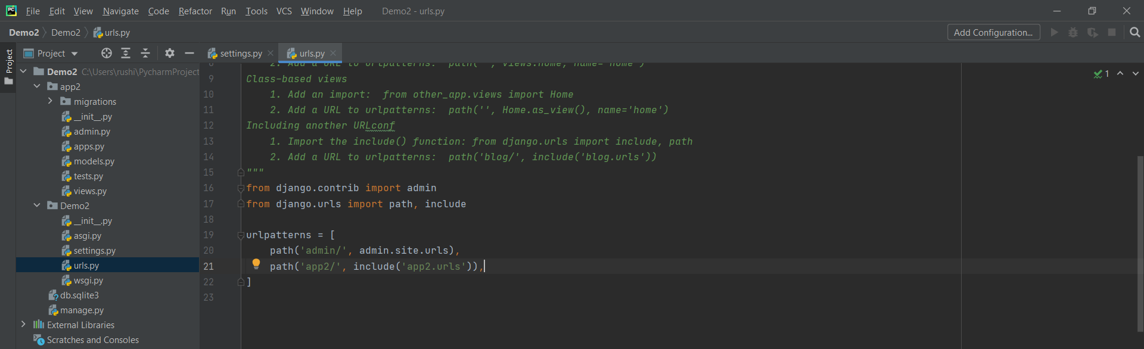

* App url

This is the file for url in app

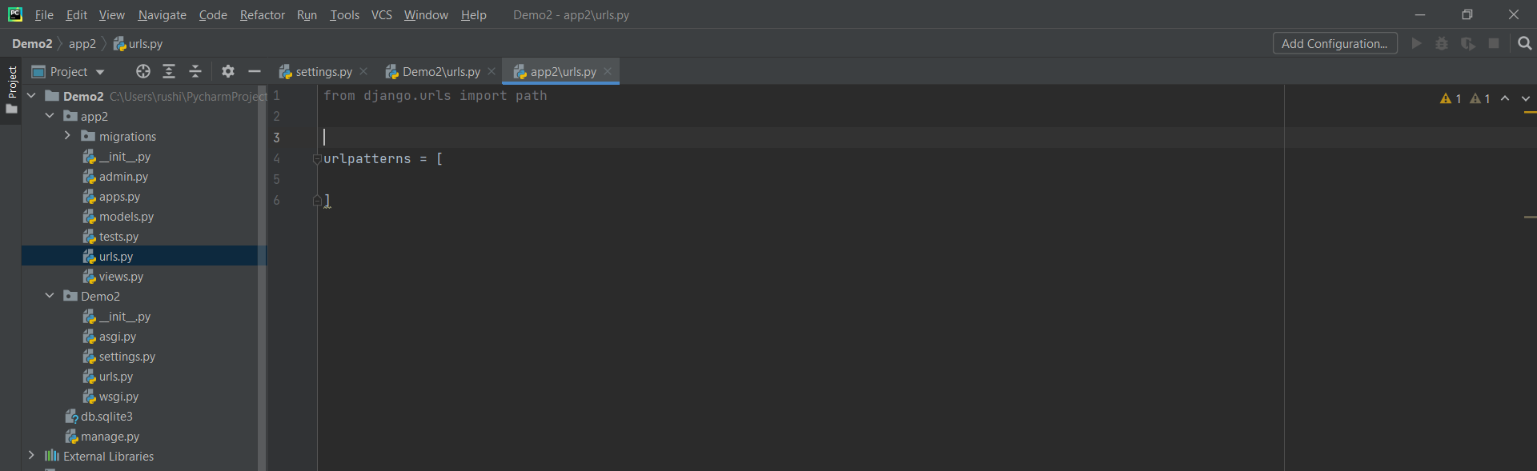

* Runserver

Command: python manage.py runserver

This command starts the server for website

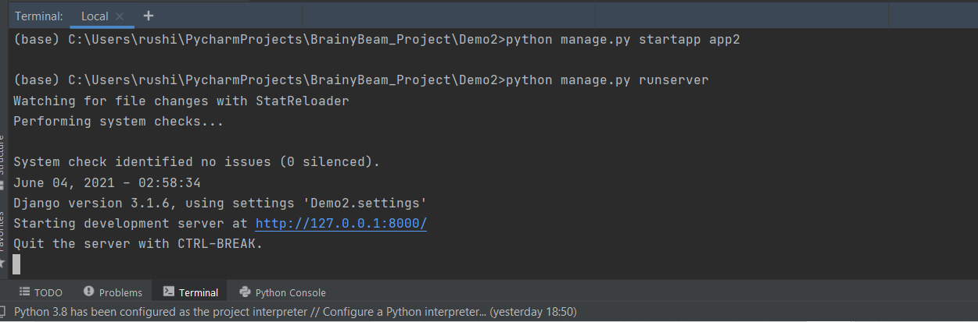

* Chrome View

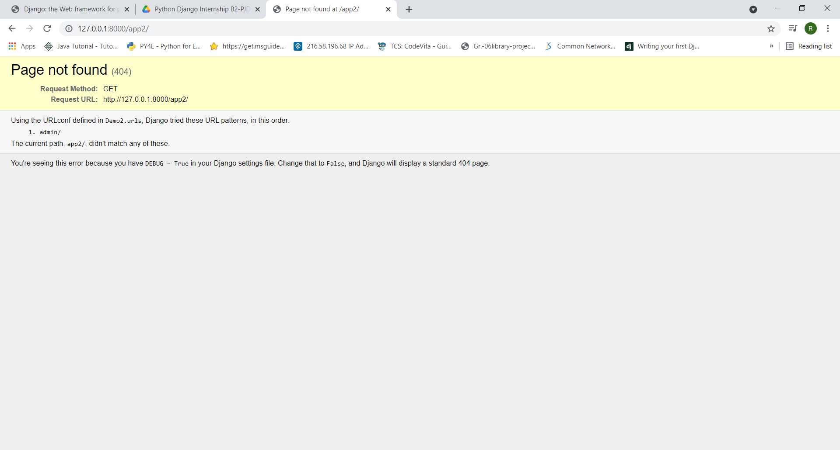

**DAY -4 TASK**

* **Take screenshot of :-**
* **Setting.py**
* **Main urls.py**
* **Any views.py and urls.py**
* **Main screen webpage**
* **Apps webpage image**

**Demo 1**

* Settings.py

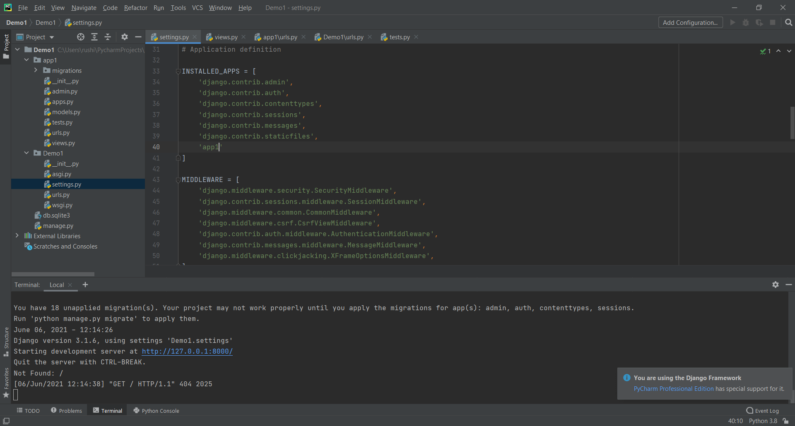

* Main urls.py

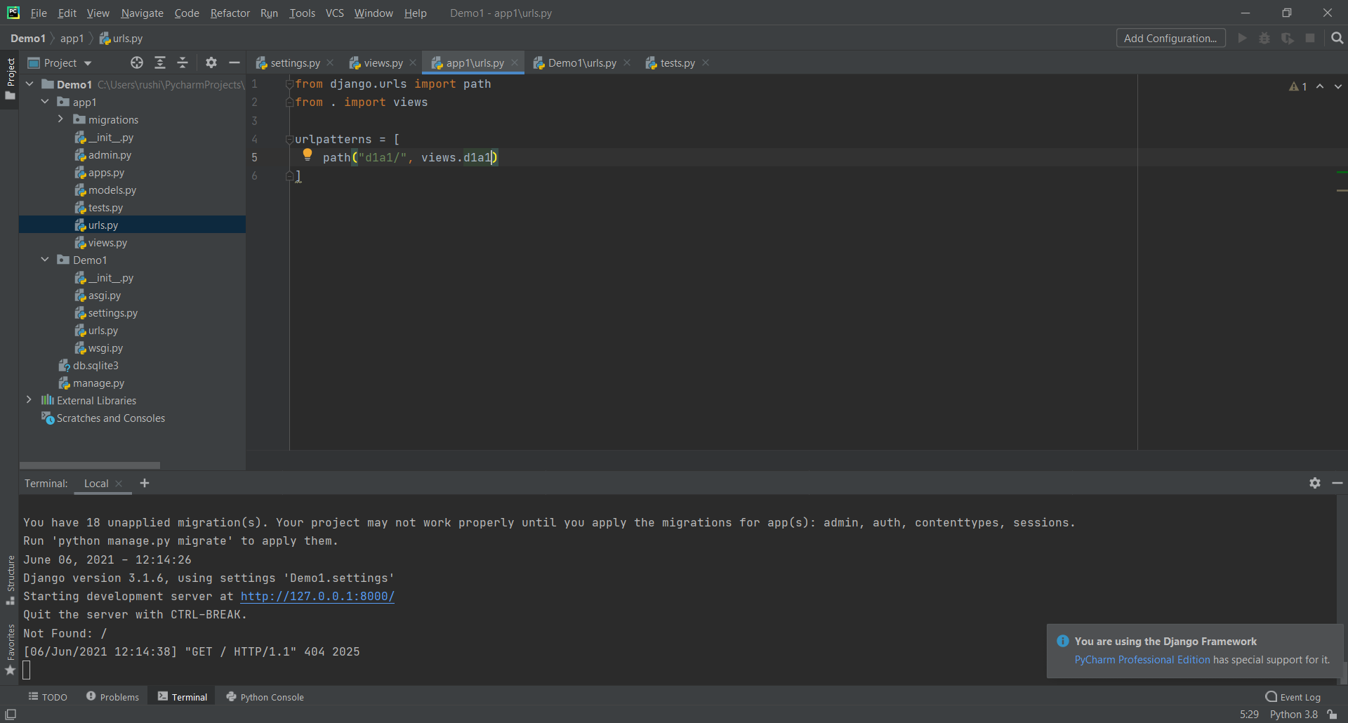

* Views.py

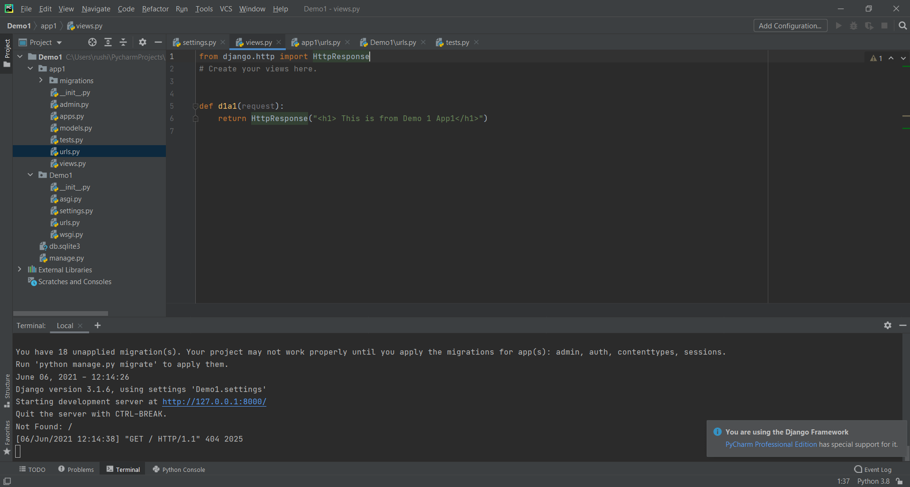

* App urls.py

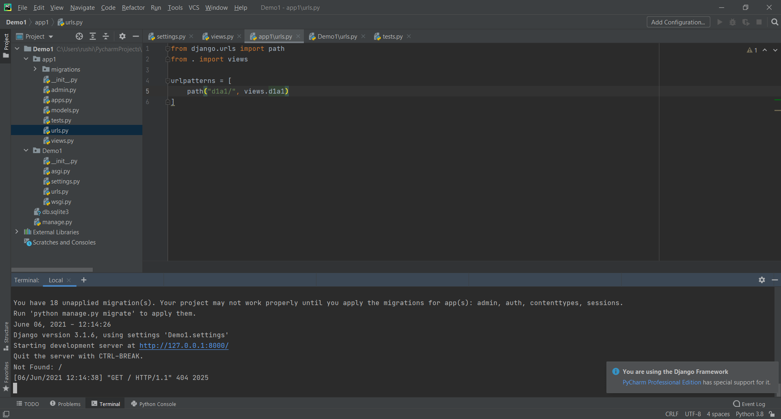

* Web view

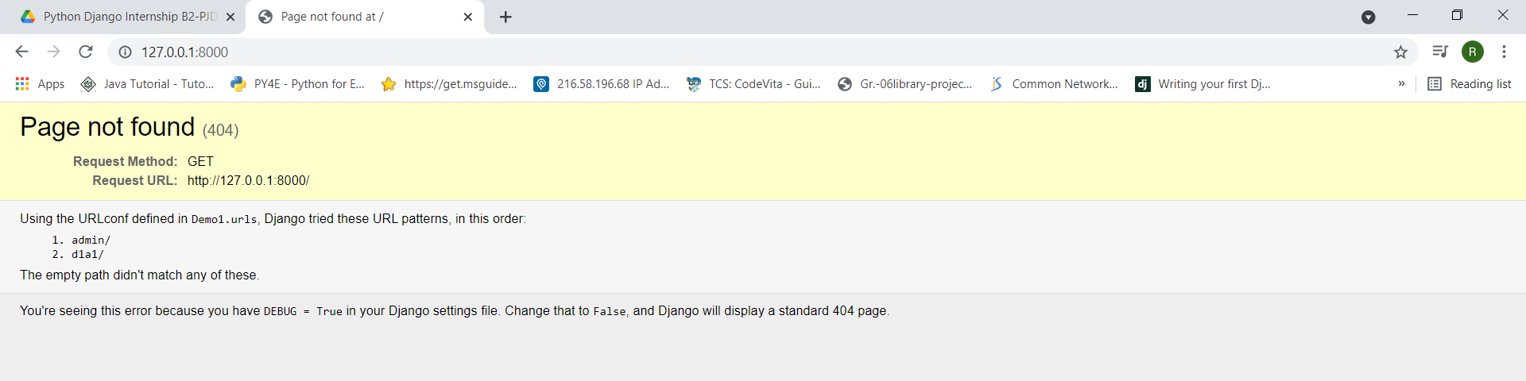

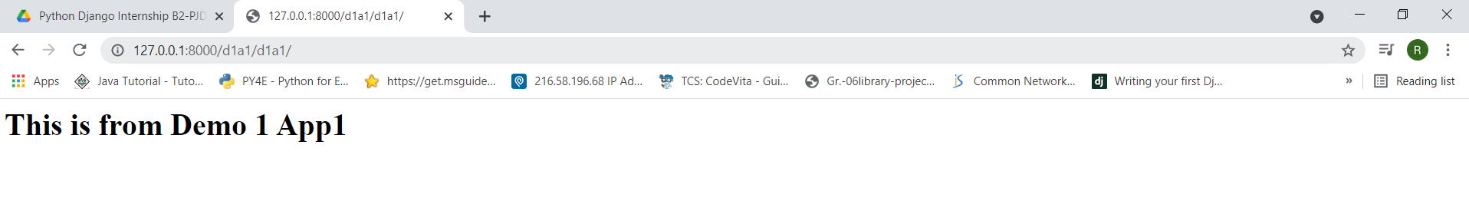

**Demo 2**

* Settings.py

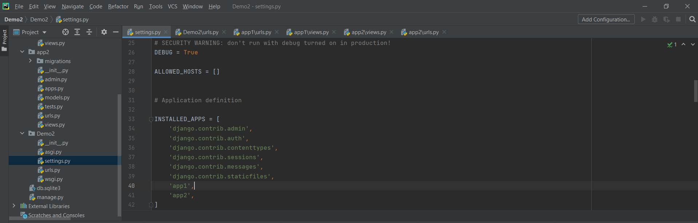

* Main urls.py

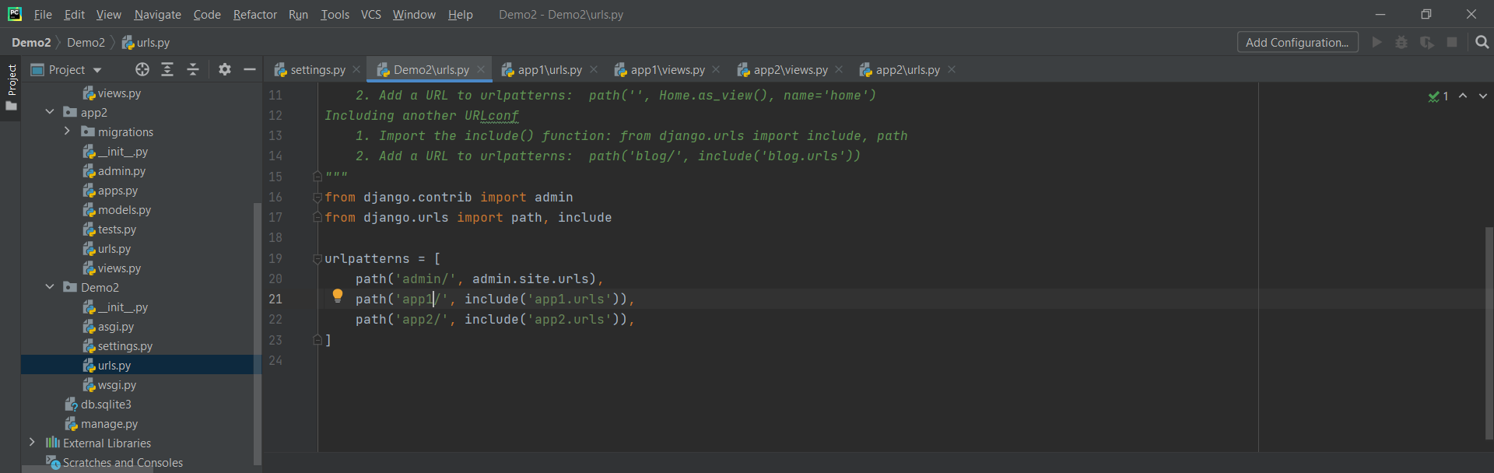

* Views.py

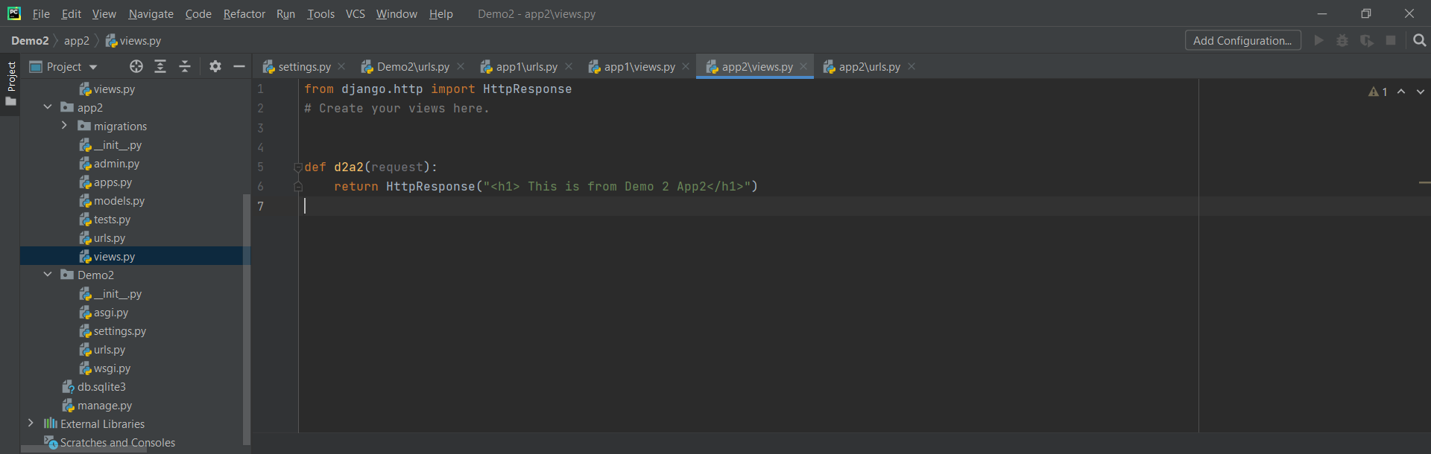

* App urls.py

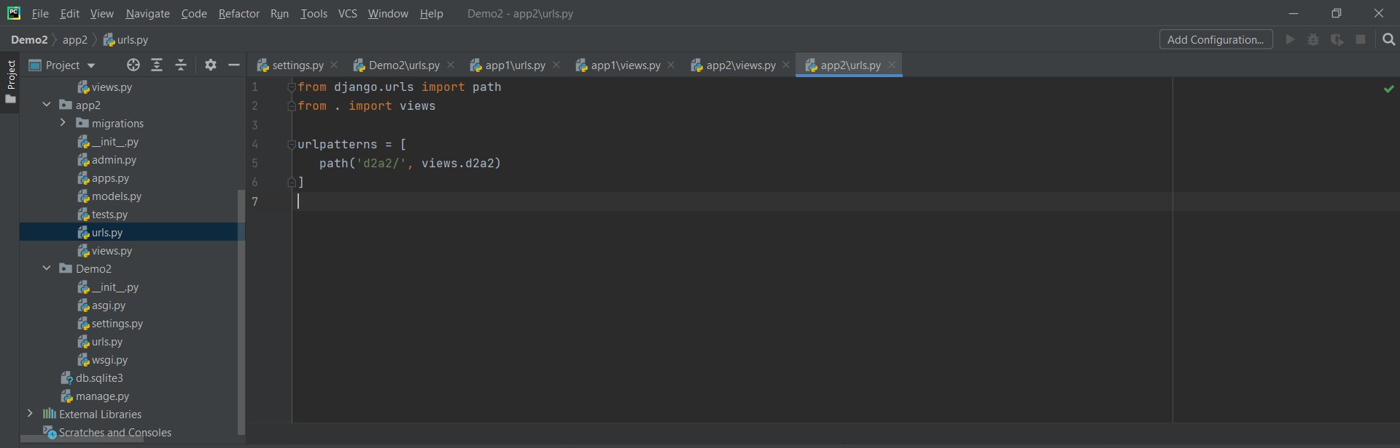

* Web view

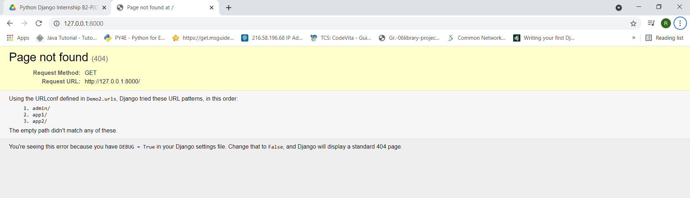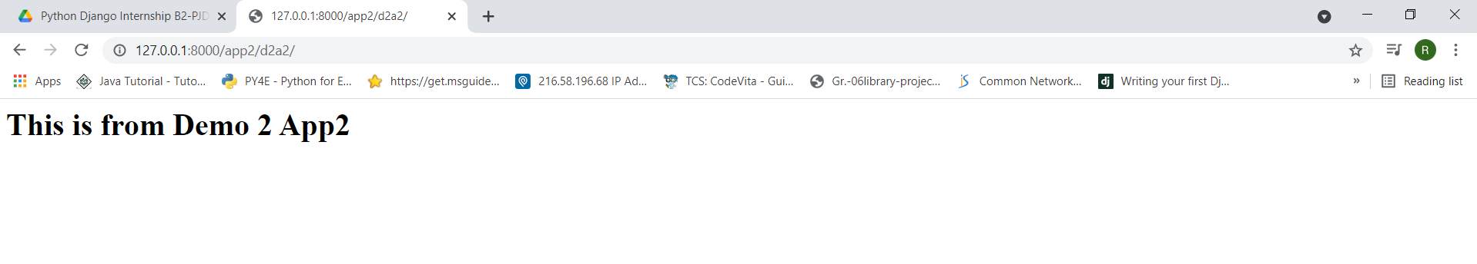

**Demo 3**

* Settings.py

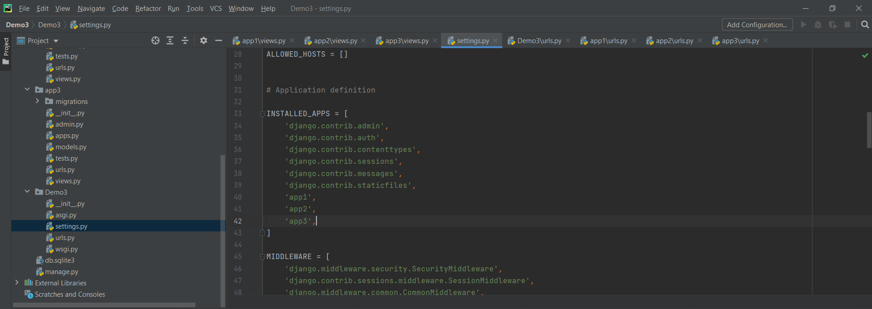

* Main urls.py

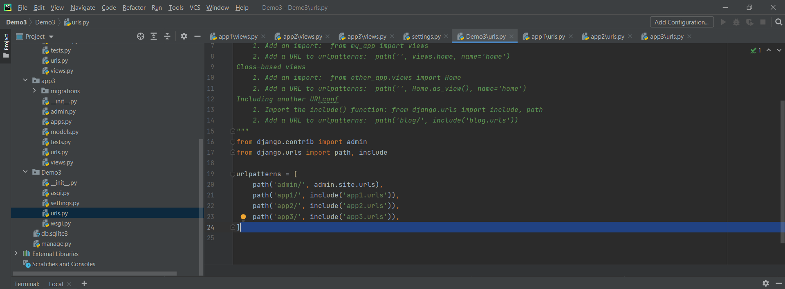

* Views.py

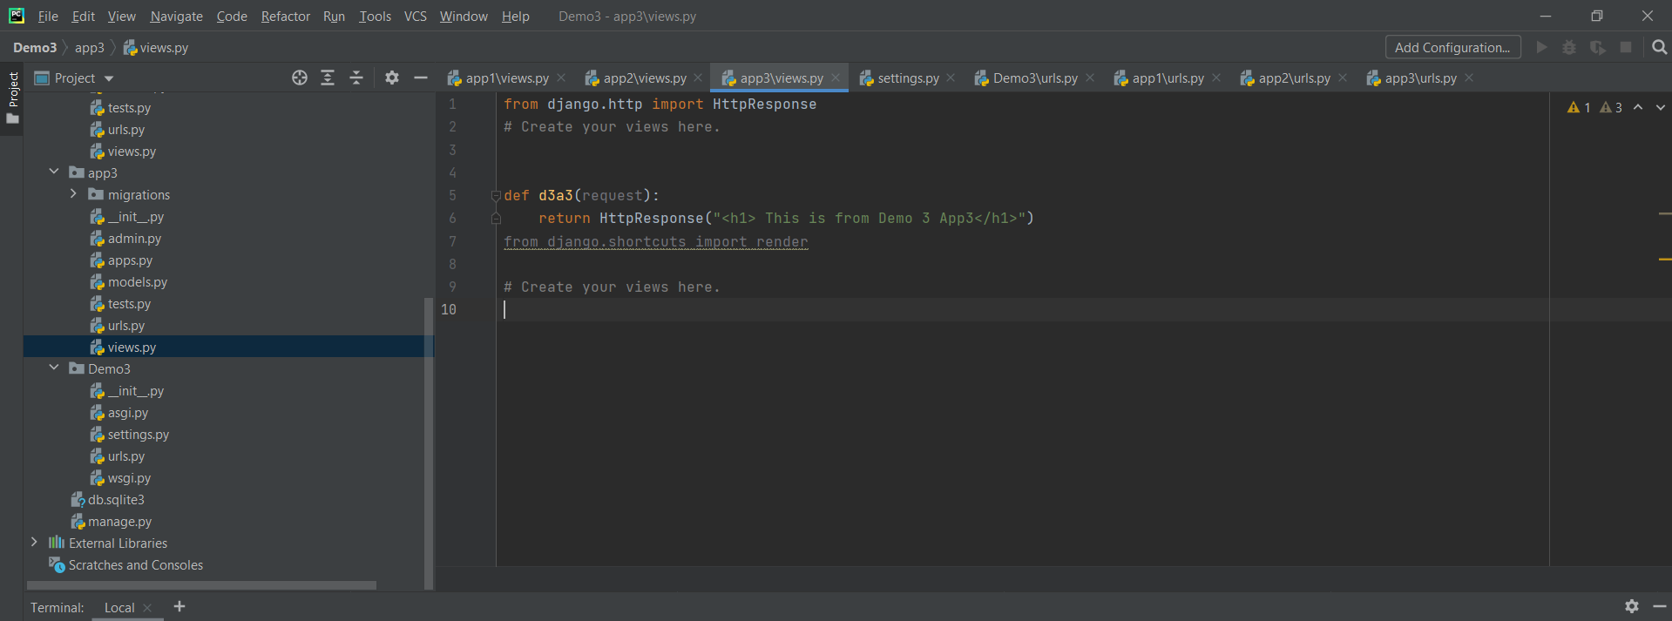

* App urls.py

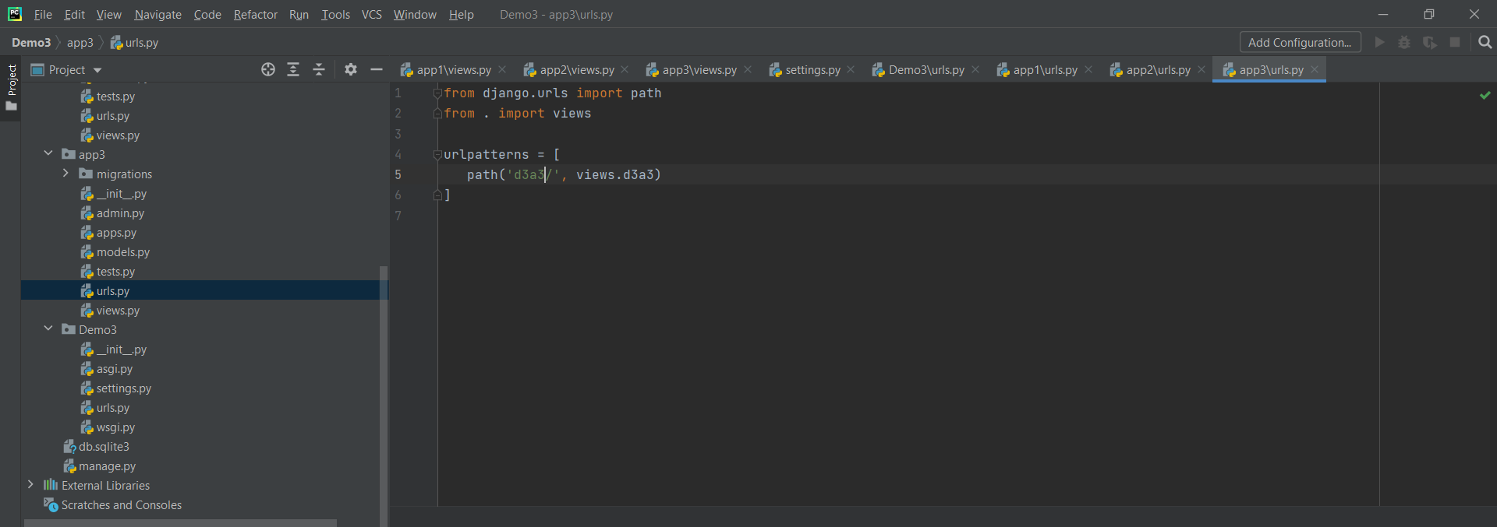

* Web view

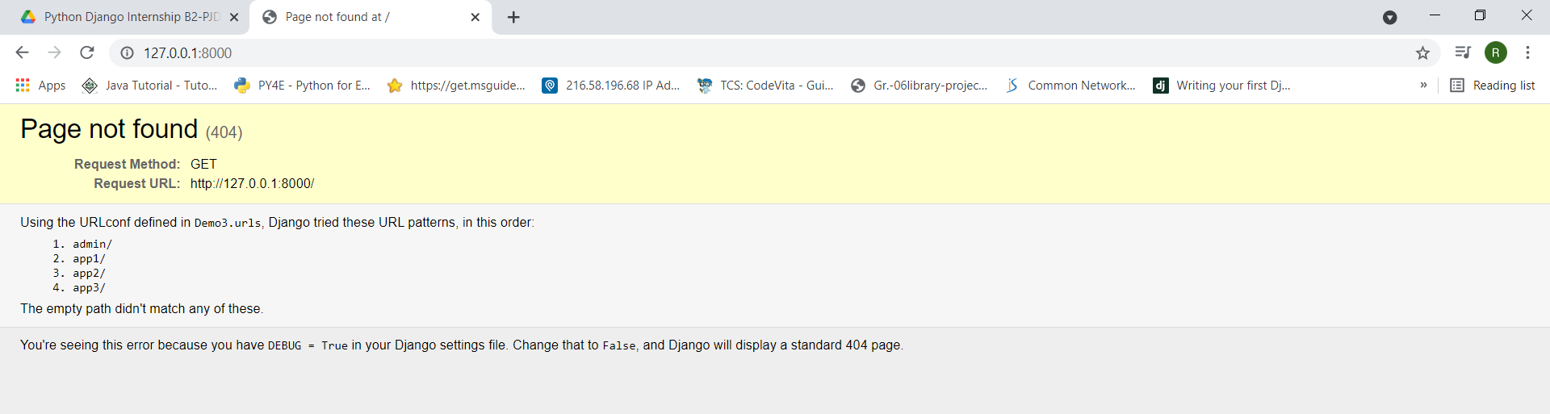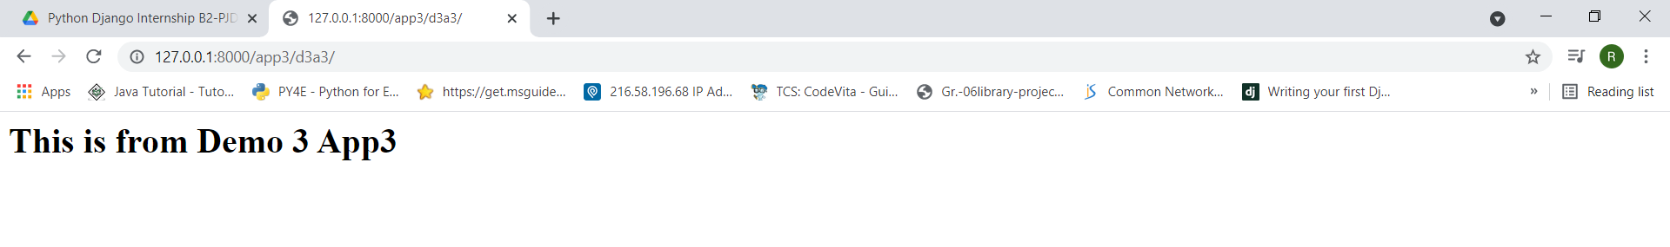

**Demo 4**

* Settings.py

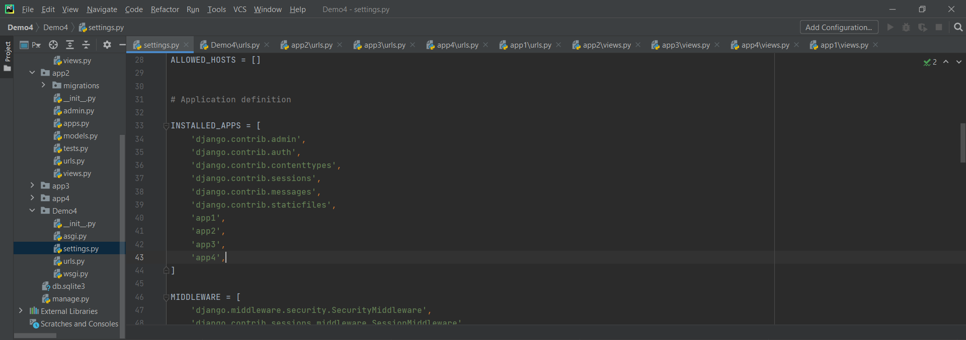

* Main urls.py

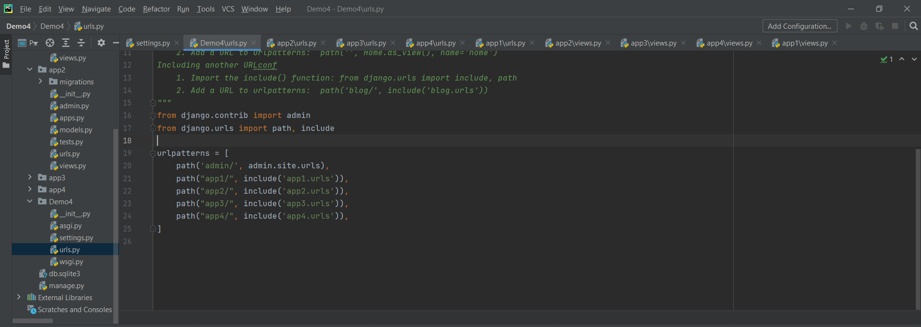

* Views.py

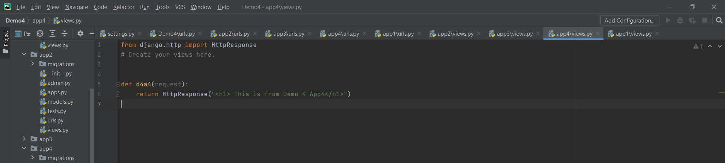

* App urls.py

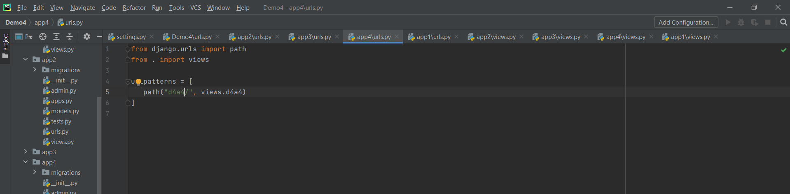

* Web view

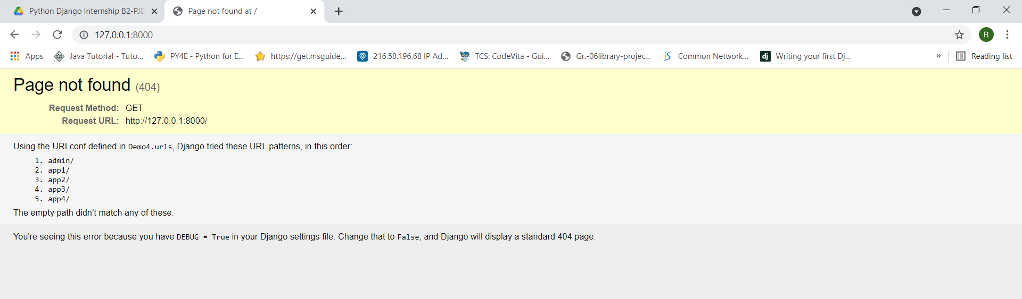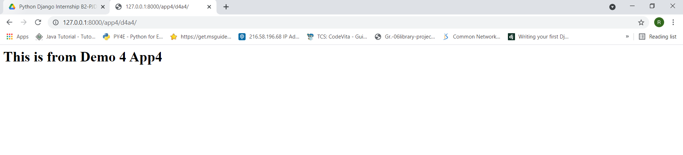

**Demo 5**

* Settings.py

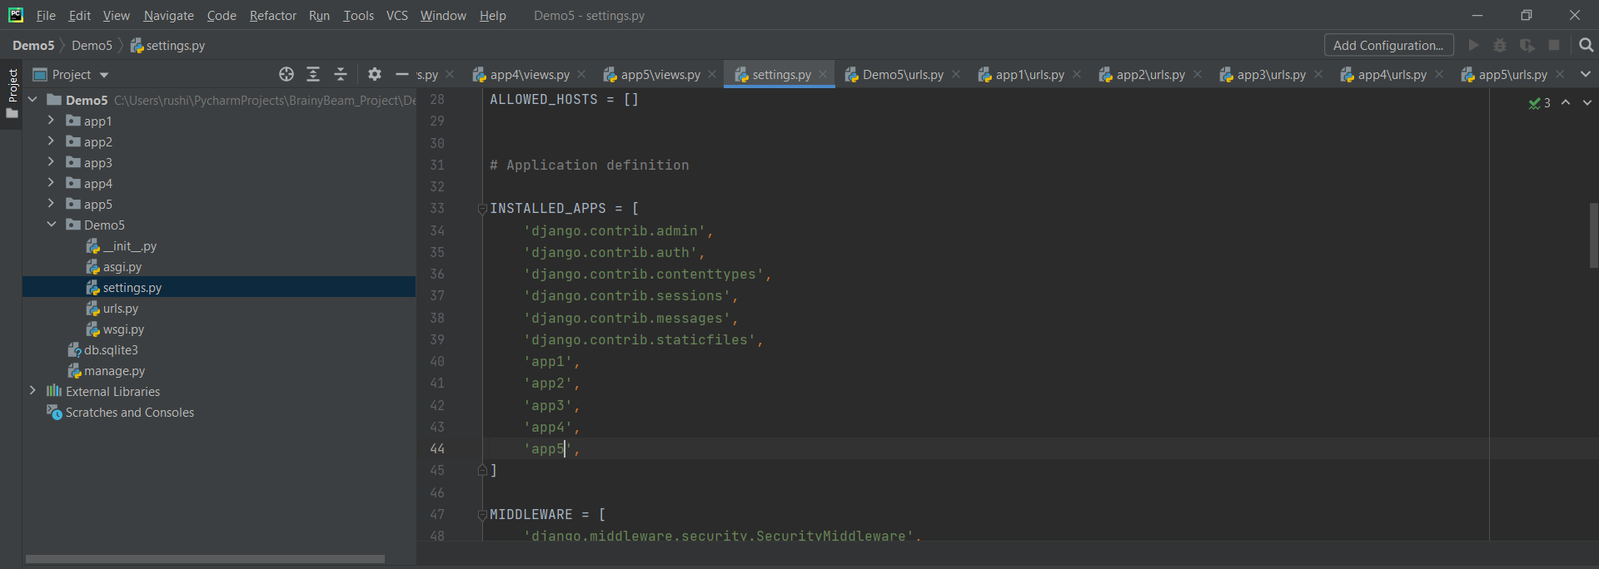

* Main urls.py
* 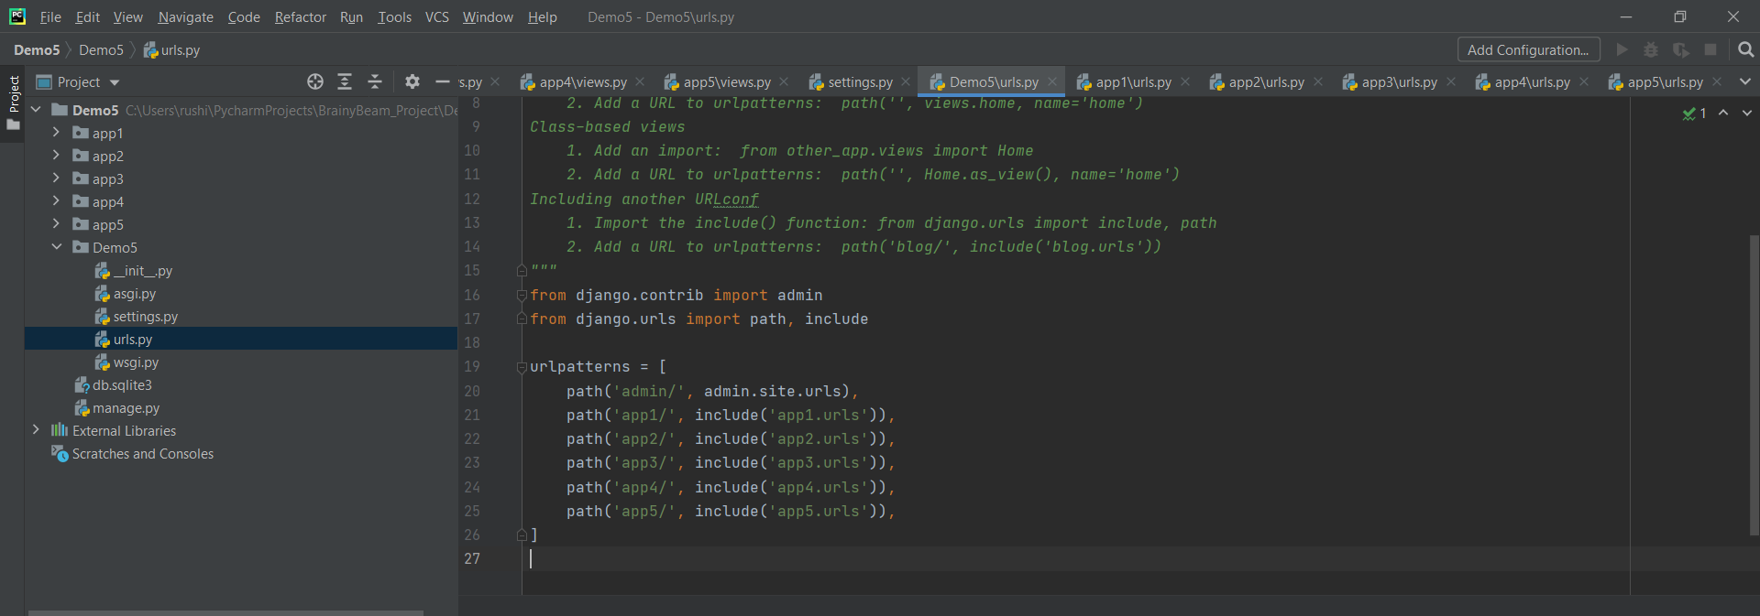
* Views.py

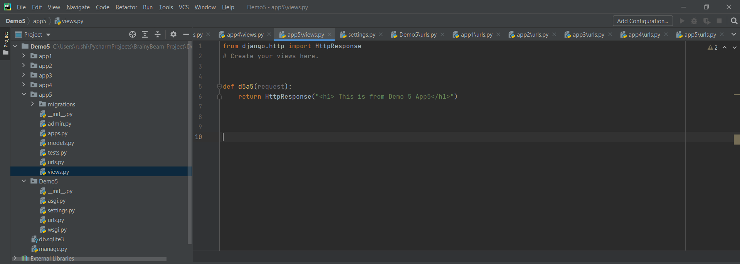

* App urls.py

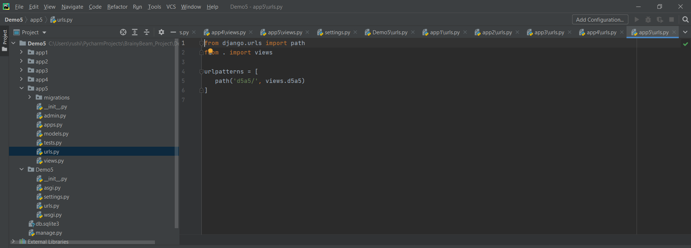

* Web view

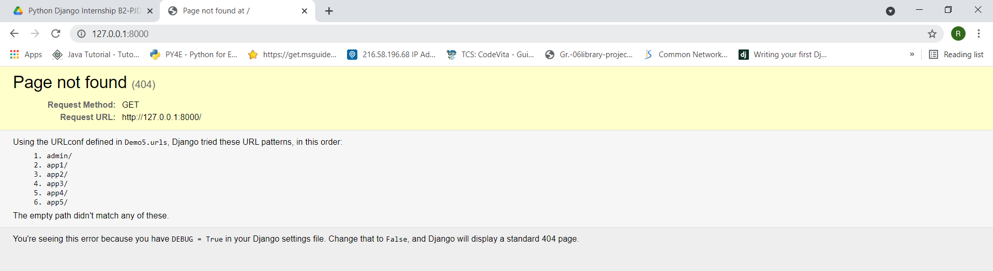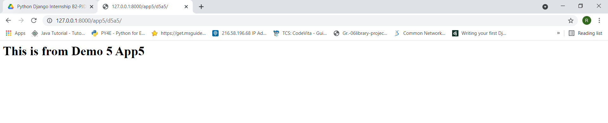

**Demo 6**

* Settings.py

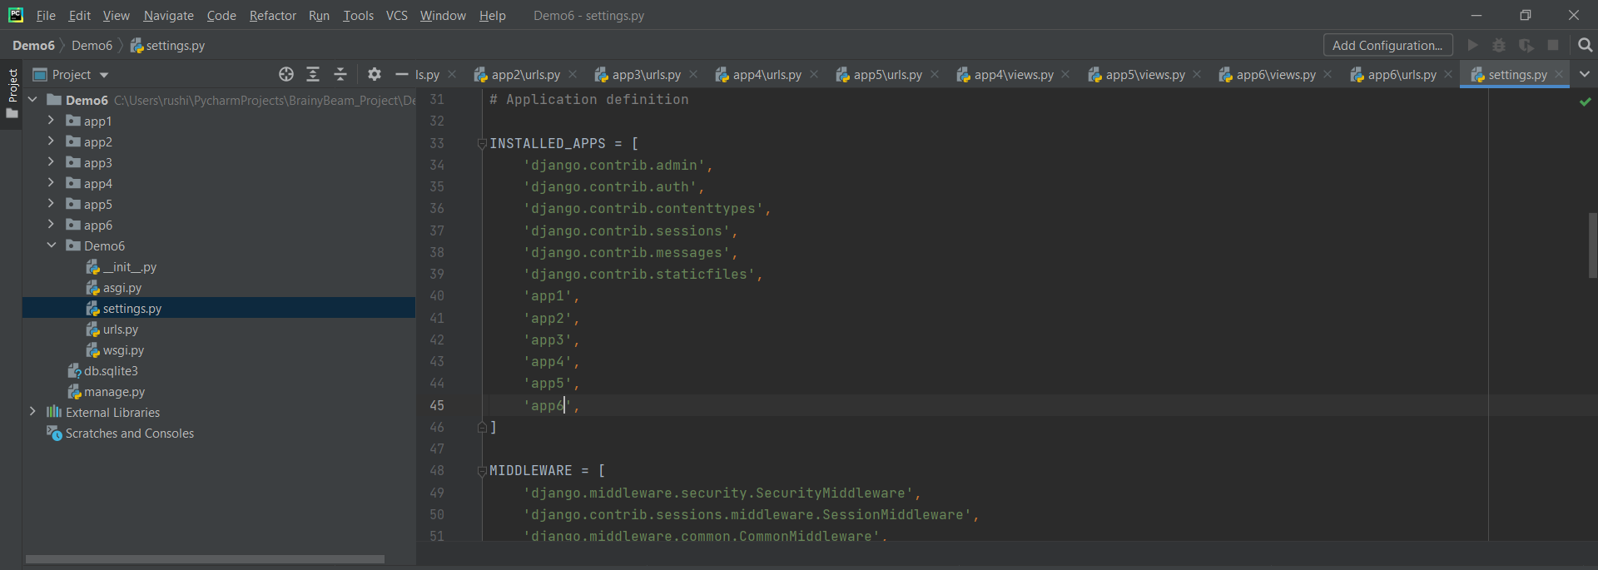

* Main urls.py

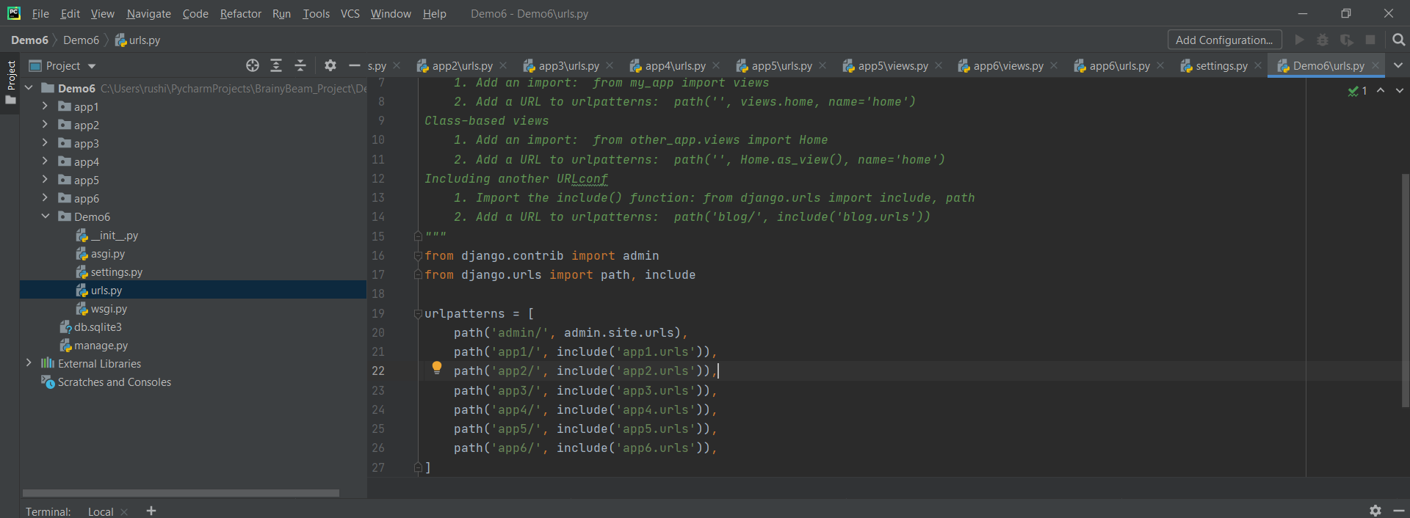

* Views.py

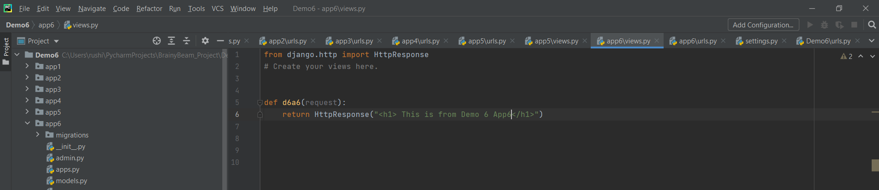

* App urls.py

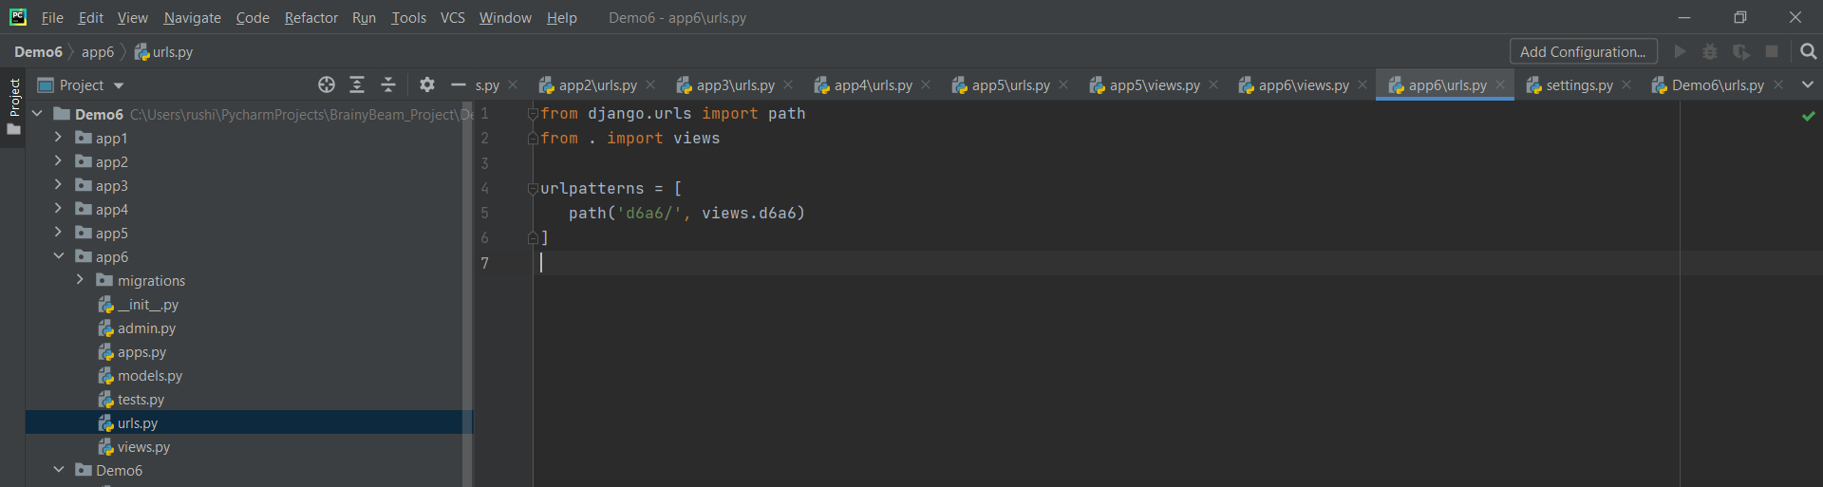

* Web view

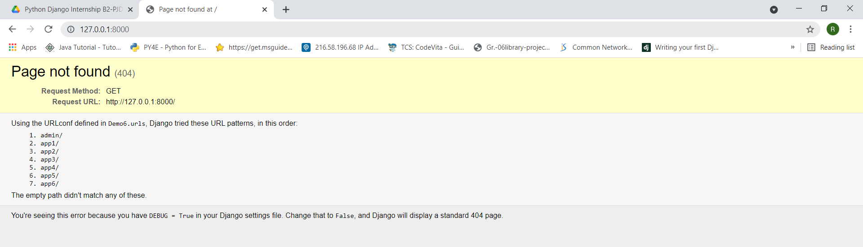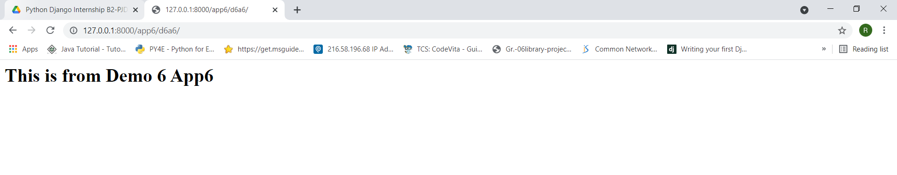

**Demo 7**

* Settings.py

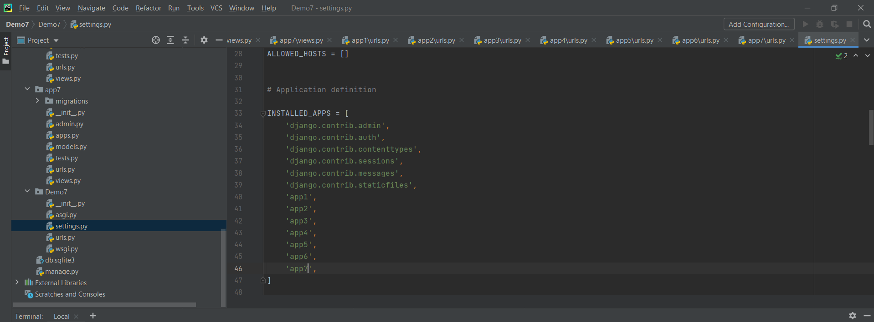

* Main urls.py

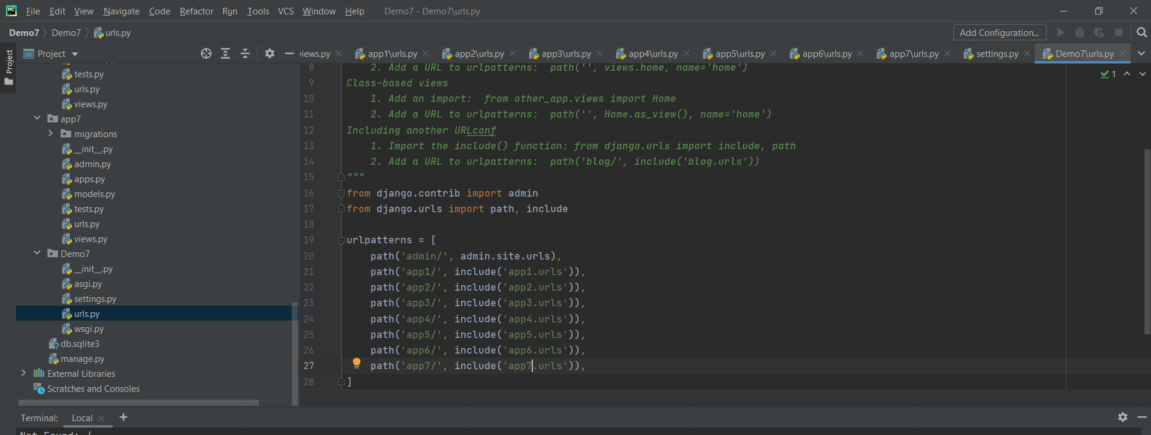

* Views.py

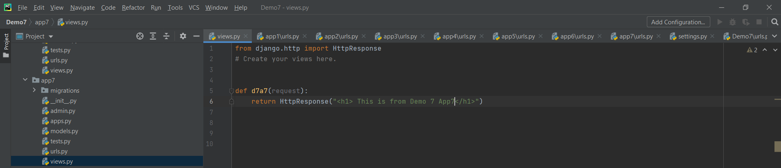

* App urls.py

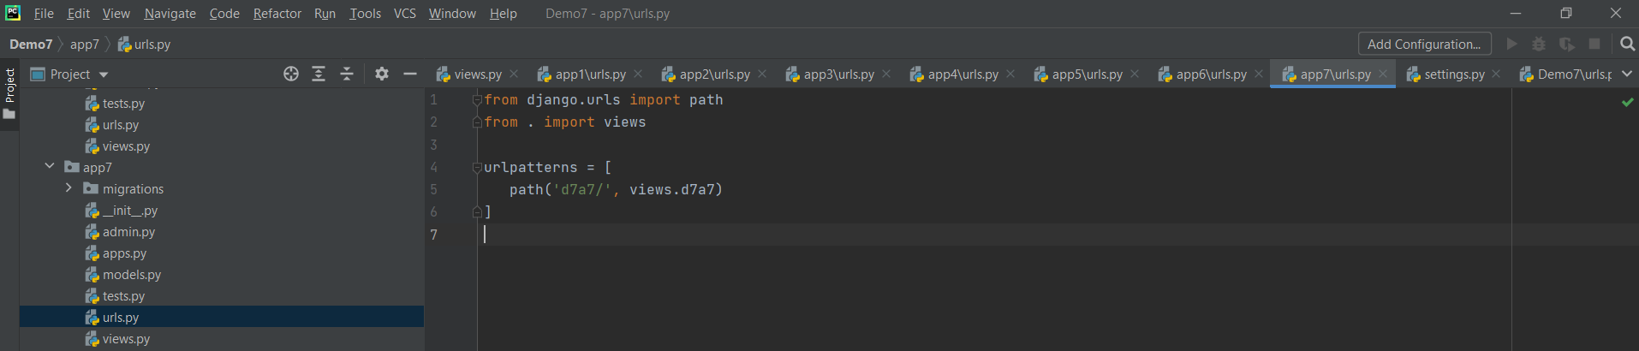

* Web view

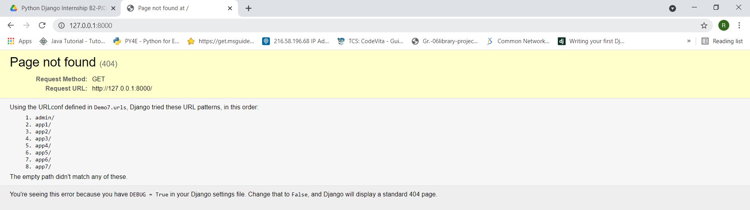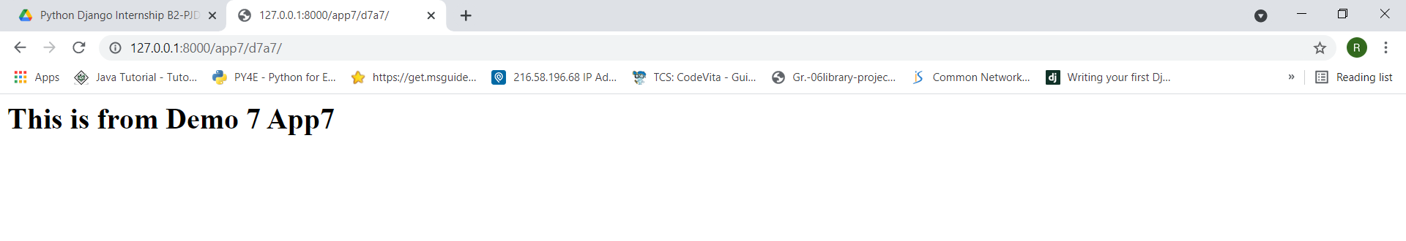

**Demo 8**

* Settings.py

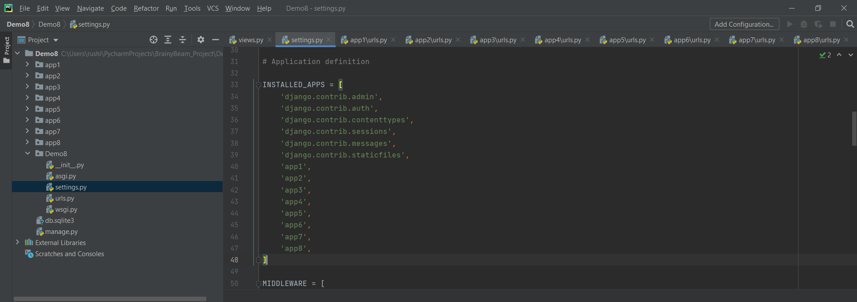

* Main urls.py

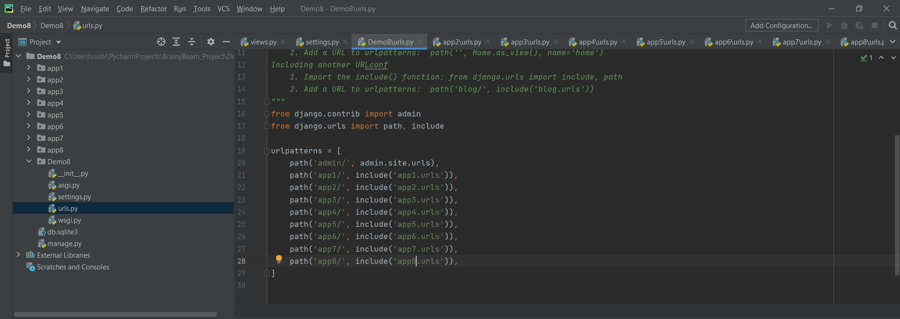

* Views.py

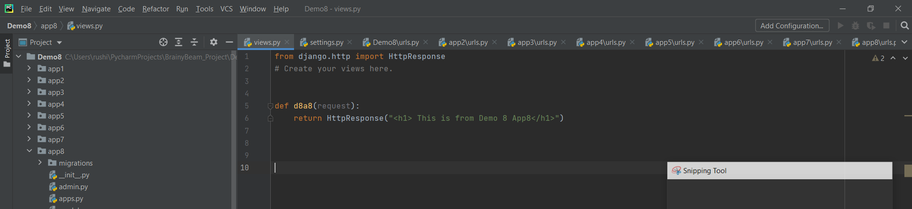

* App urls.py

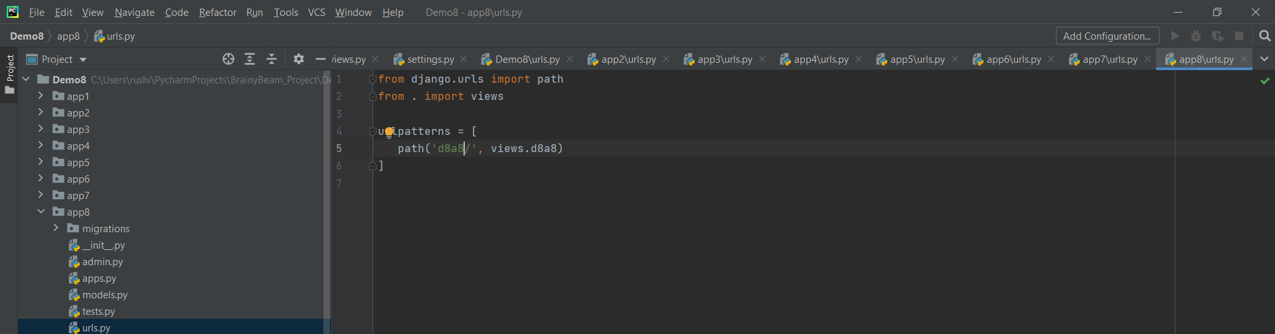

* Web view

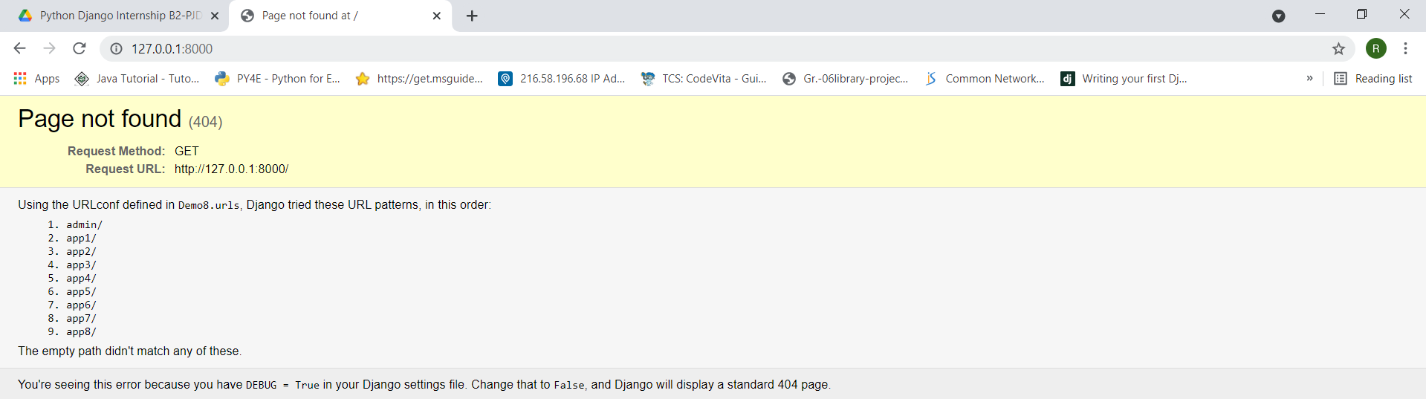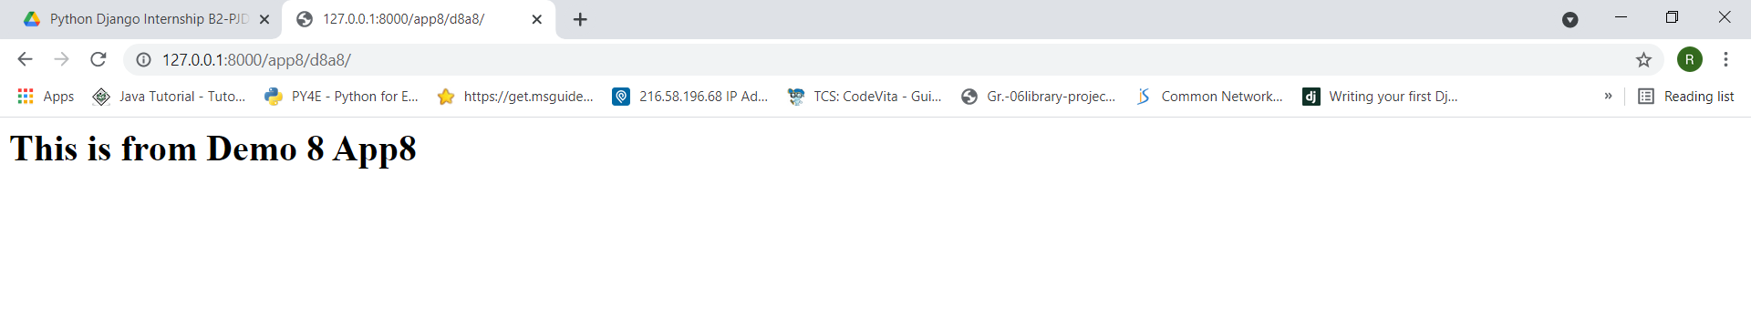

**Demo 9**

* Settings.py

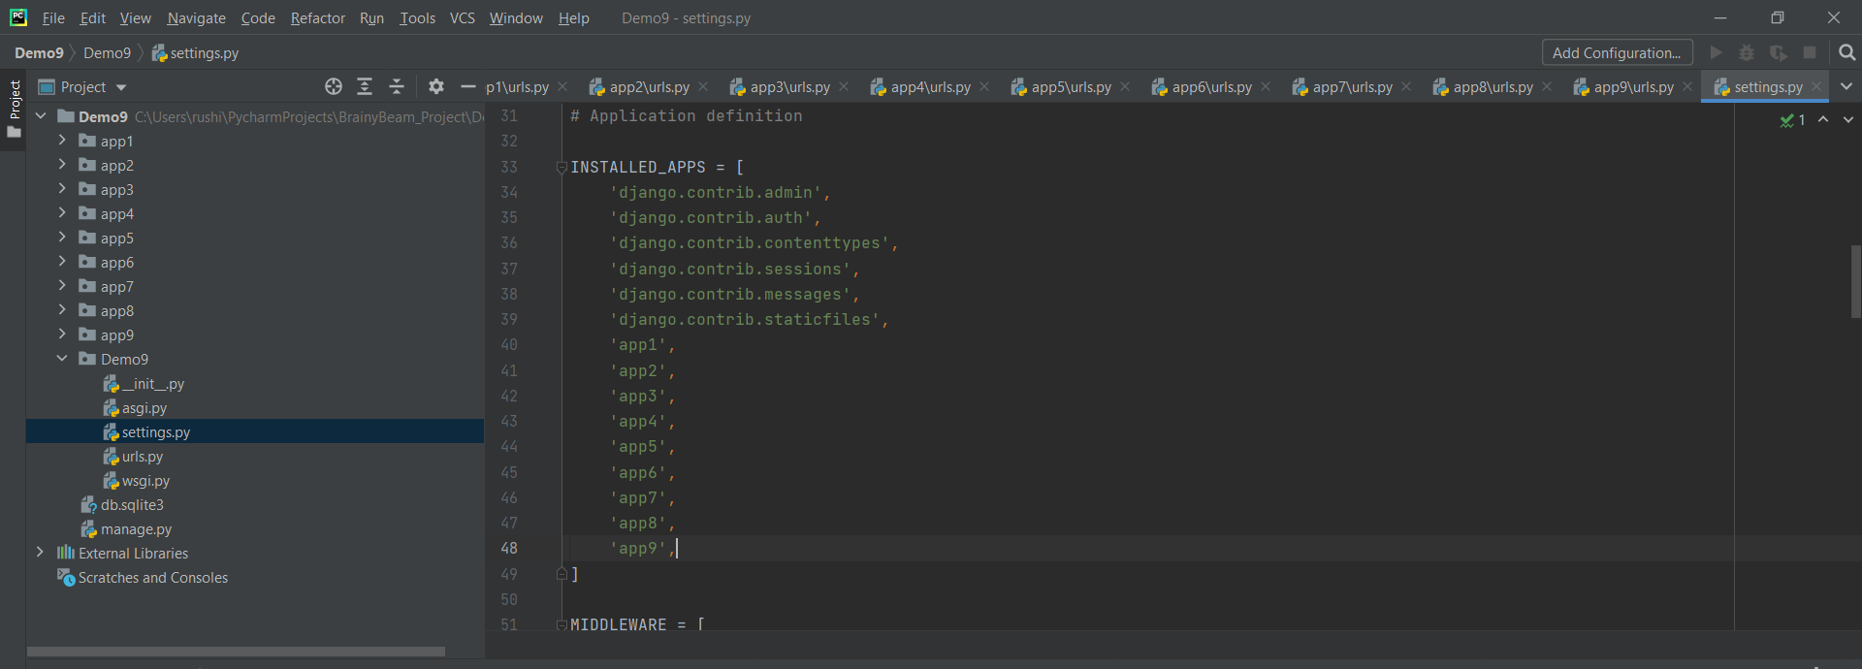

* Main urls.py

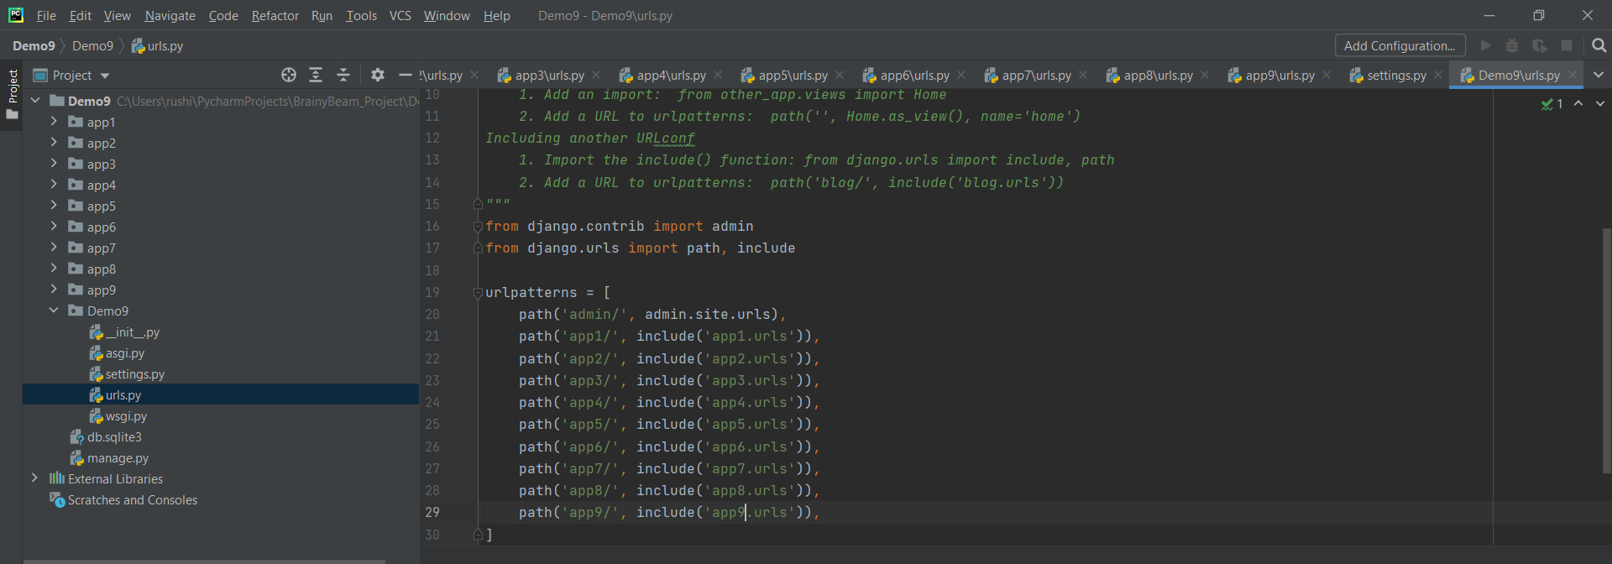

* Views.py

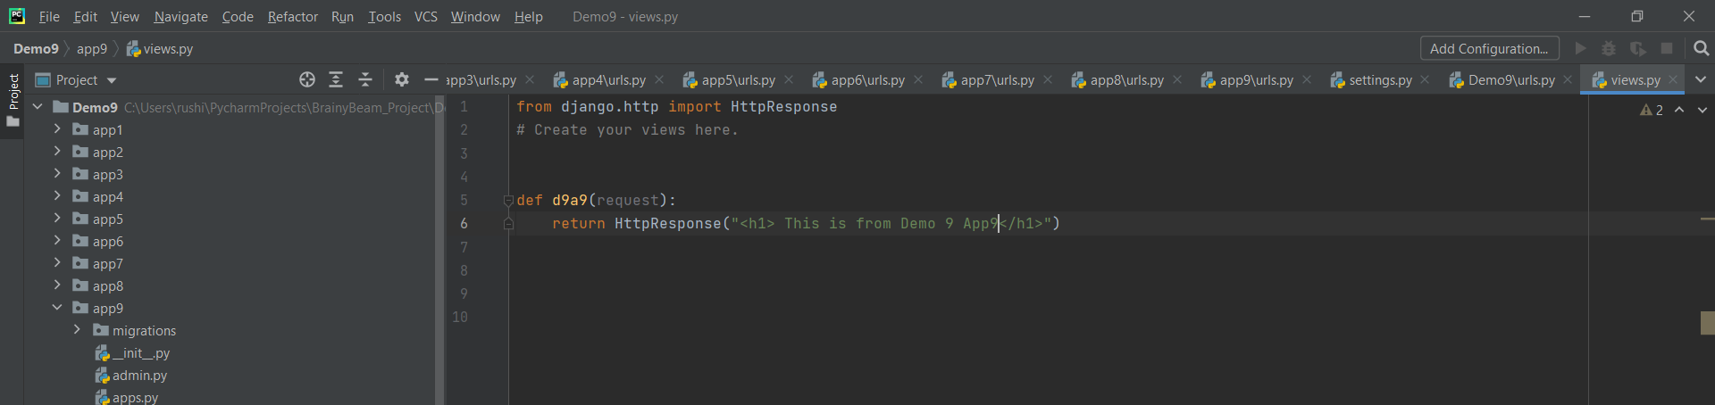

* App urls.py

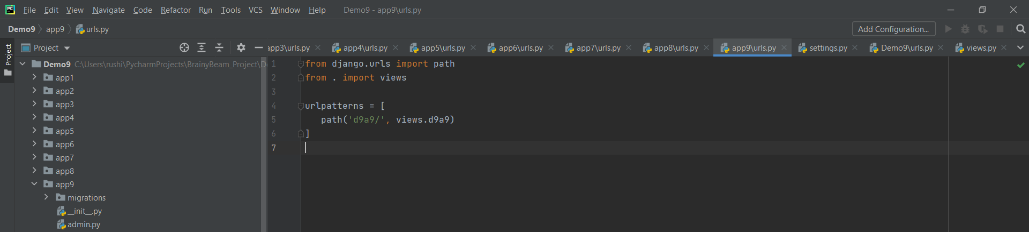

* Web view

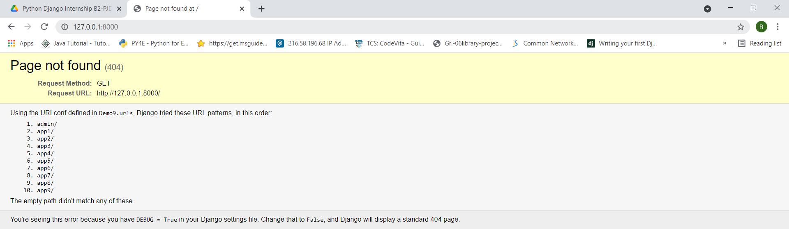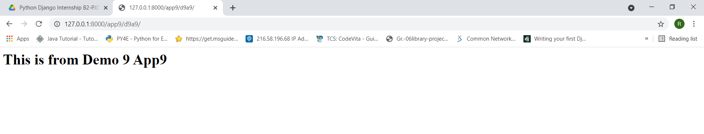

**Demo 10**

* Settings.py

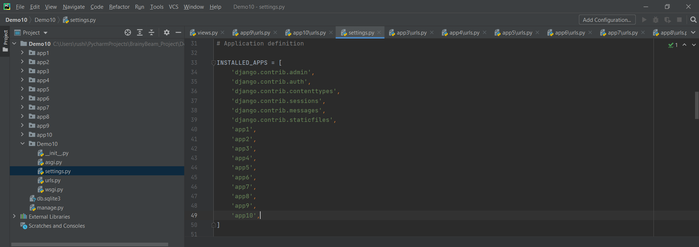

* Main urls.py

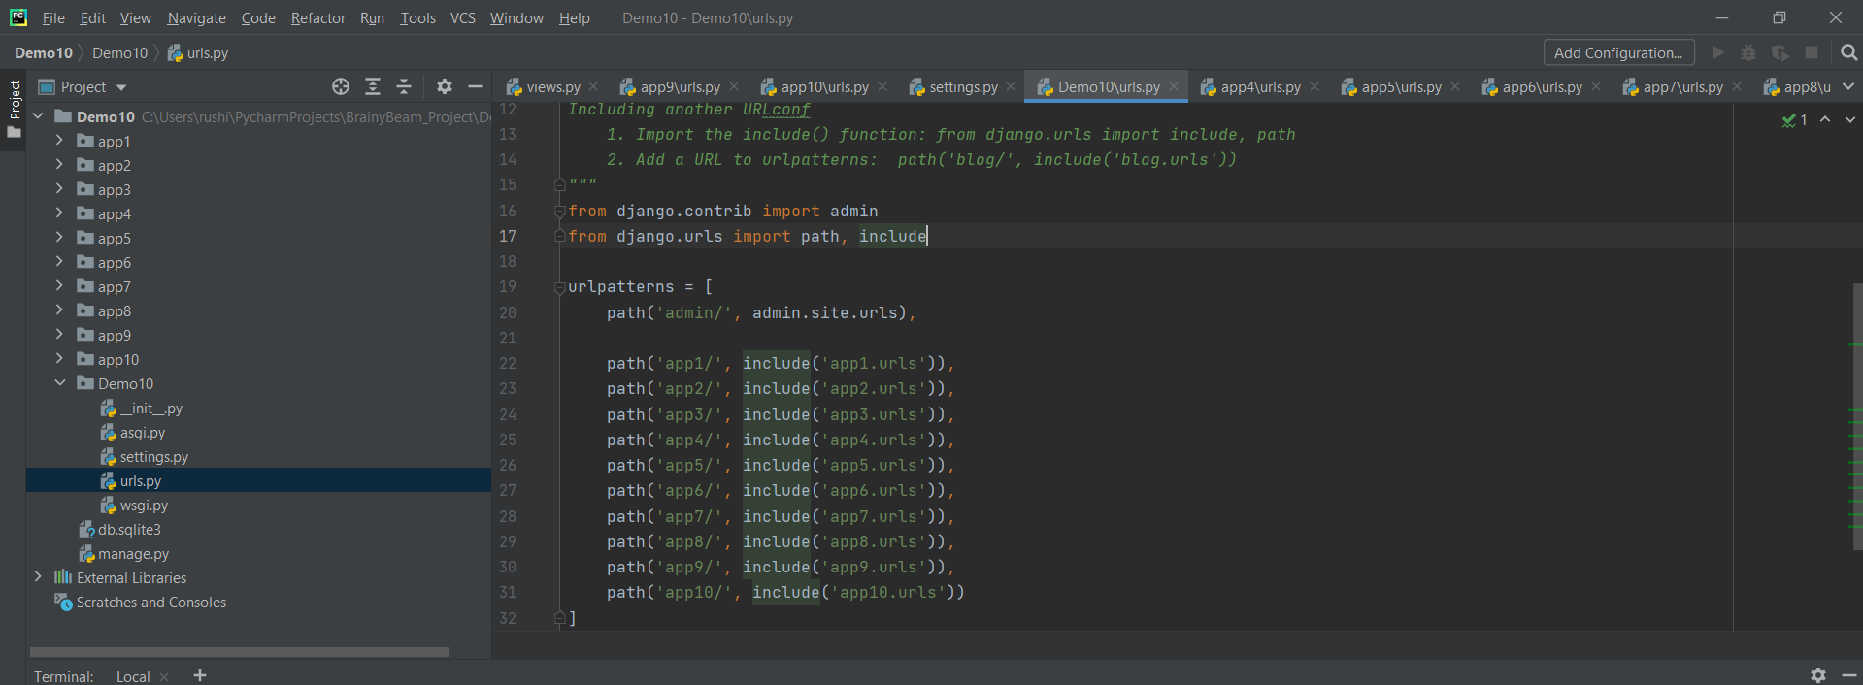

* Views.py

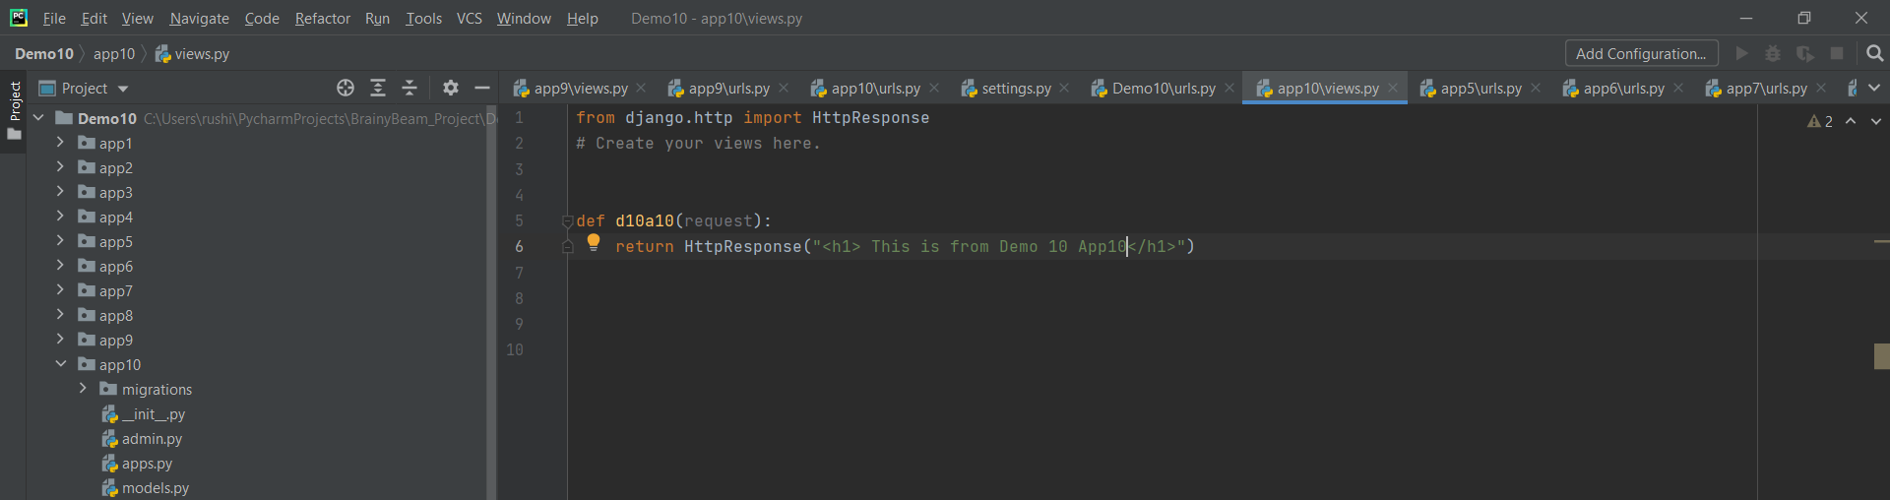

* App urls.py

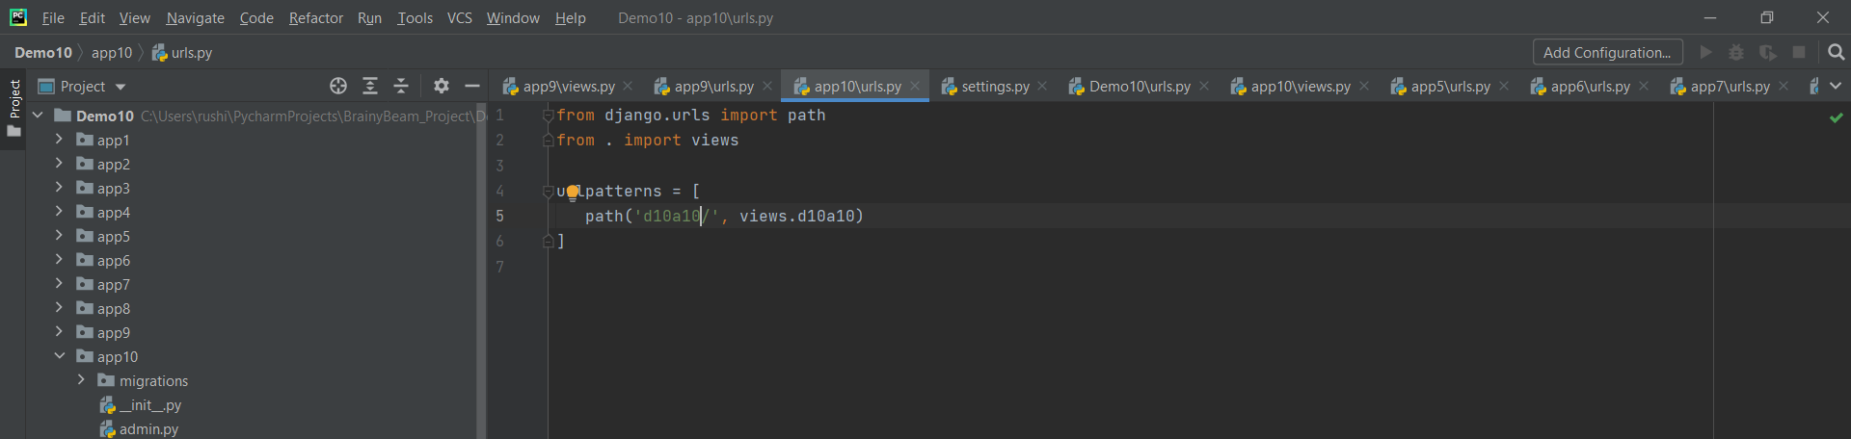

* Web view

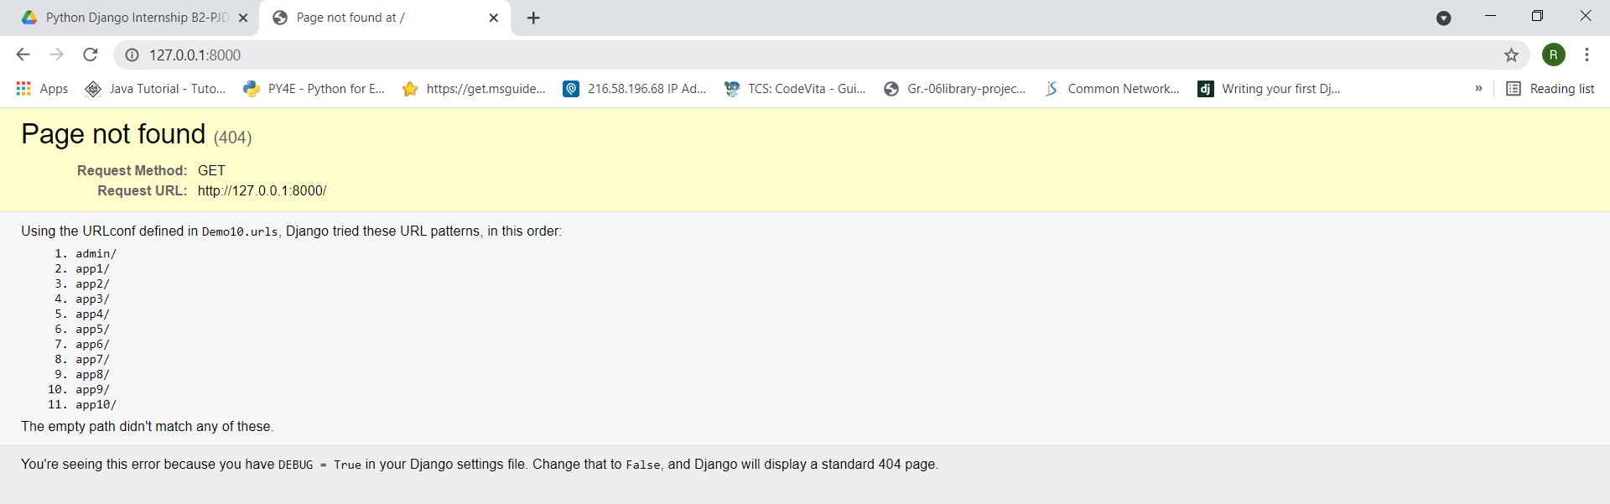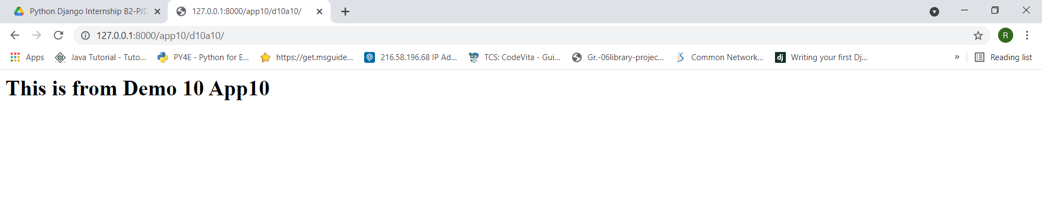

**DAY-5 TASK**

1. Create calculator.
2. Templet Integration.
3. Calculator:

* Main urls.py(calculator is created inside app1)

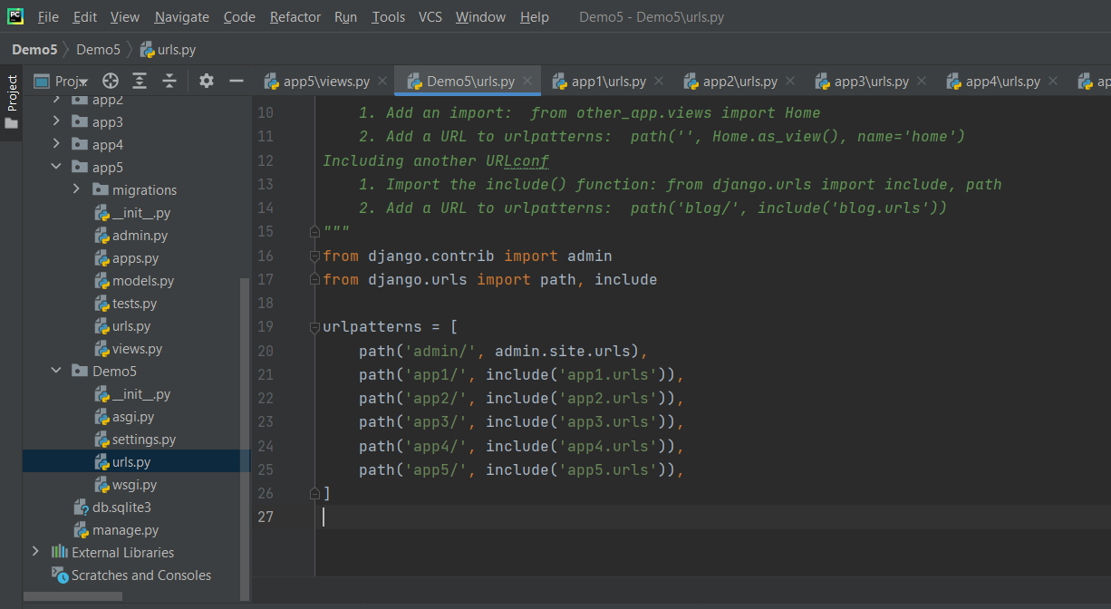

* Settings.py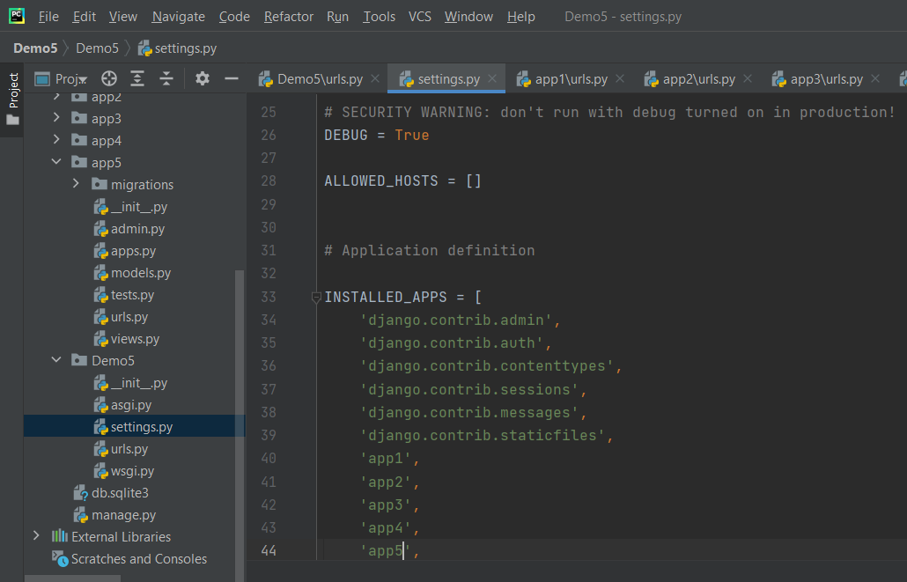
* Cal.html( app1-> templates-> cal.html)

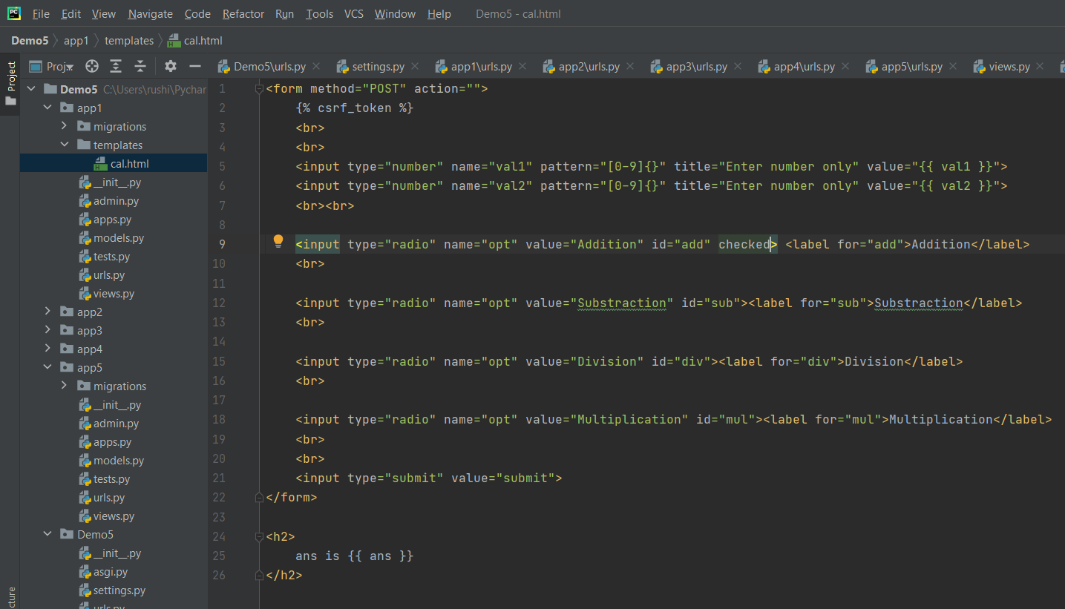

* Views.py

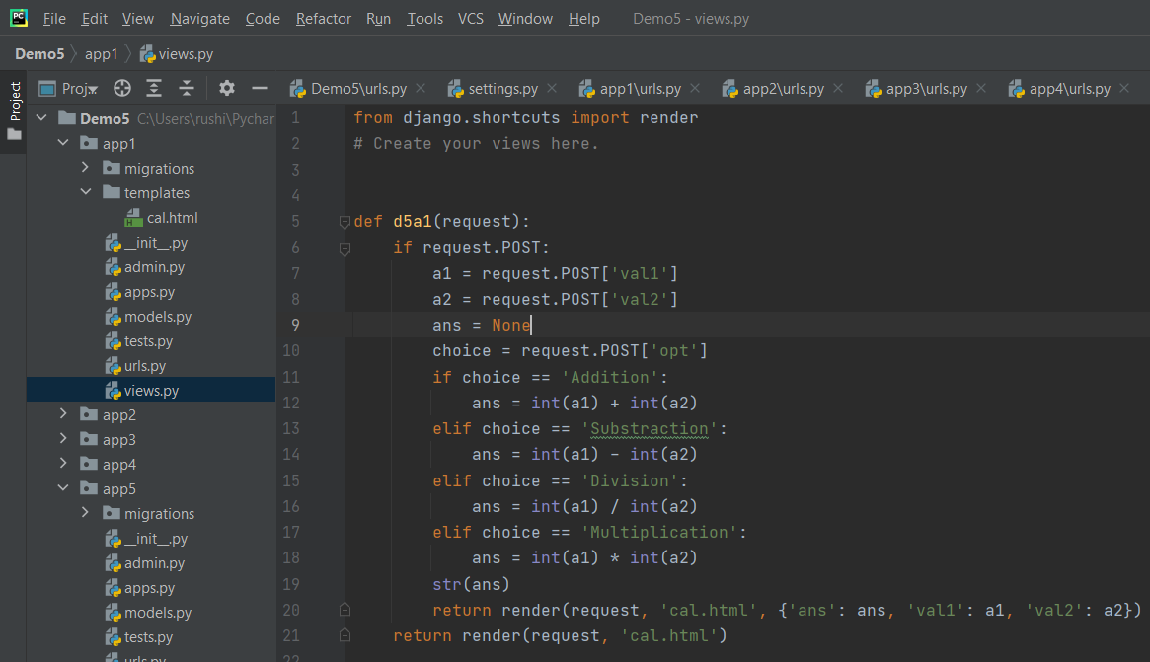

* Webview

|  |  |
| --- | --- |
| Addition | Substration |

|  |  |
| --- | --- |
| Division | Multiplication |

1. Templet Integration:

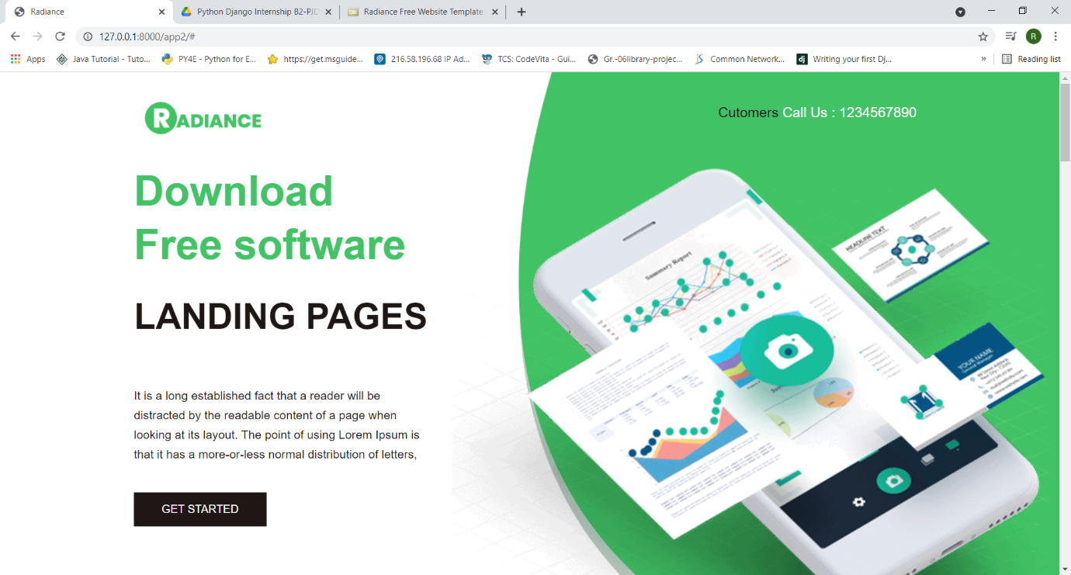

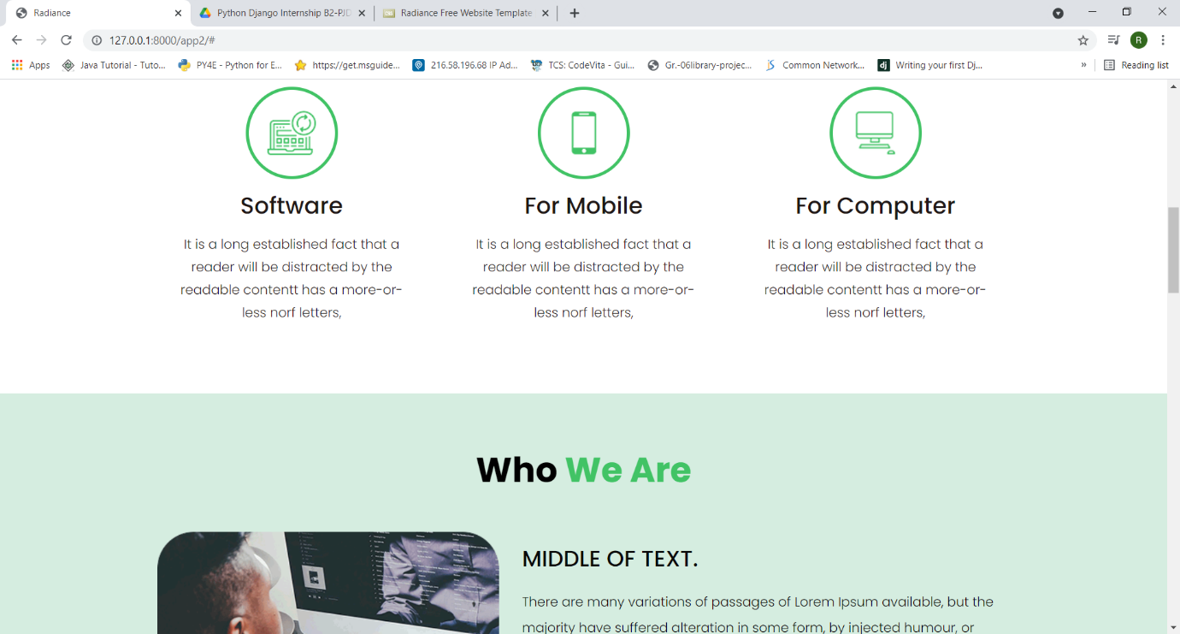

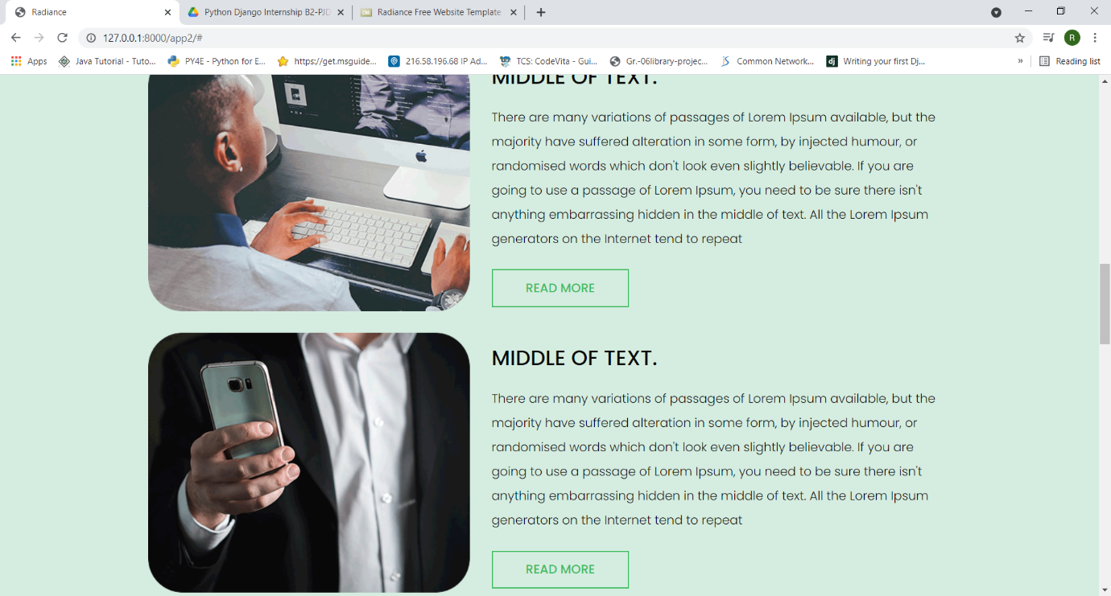

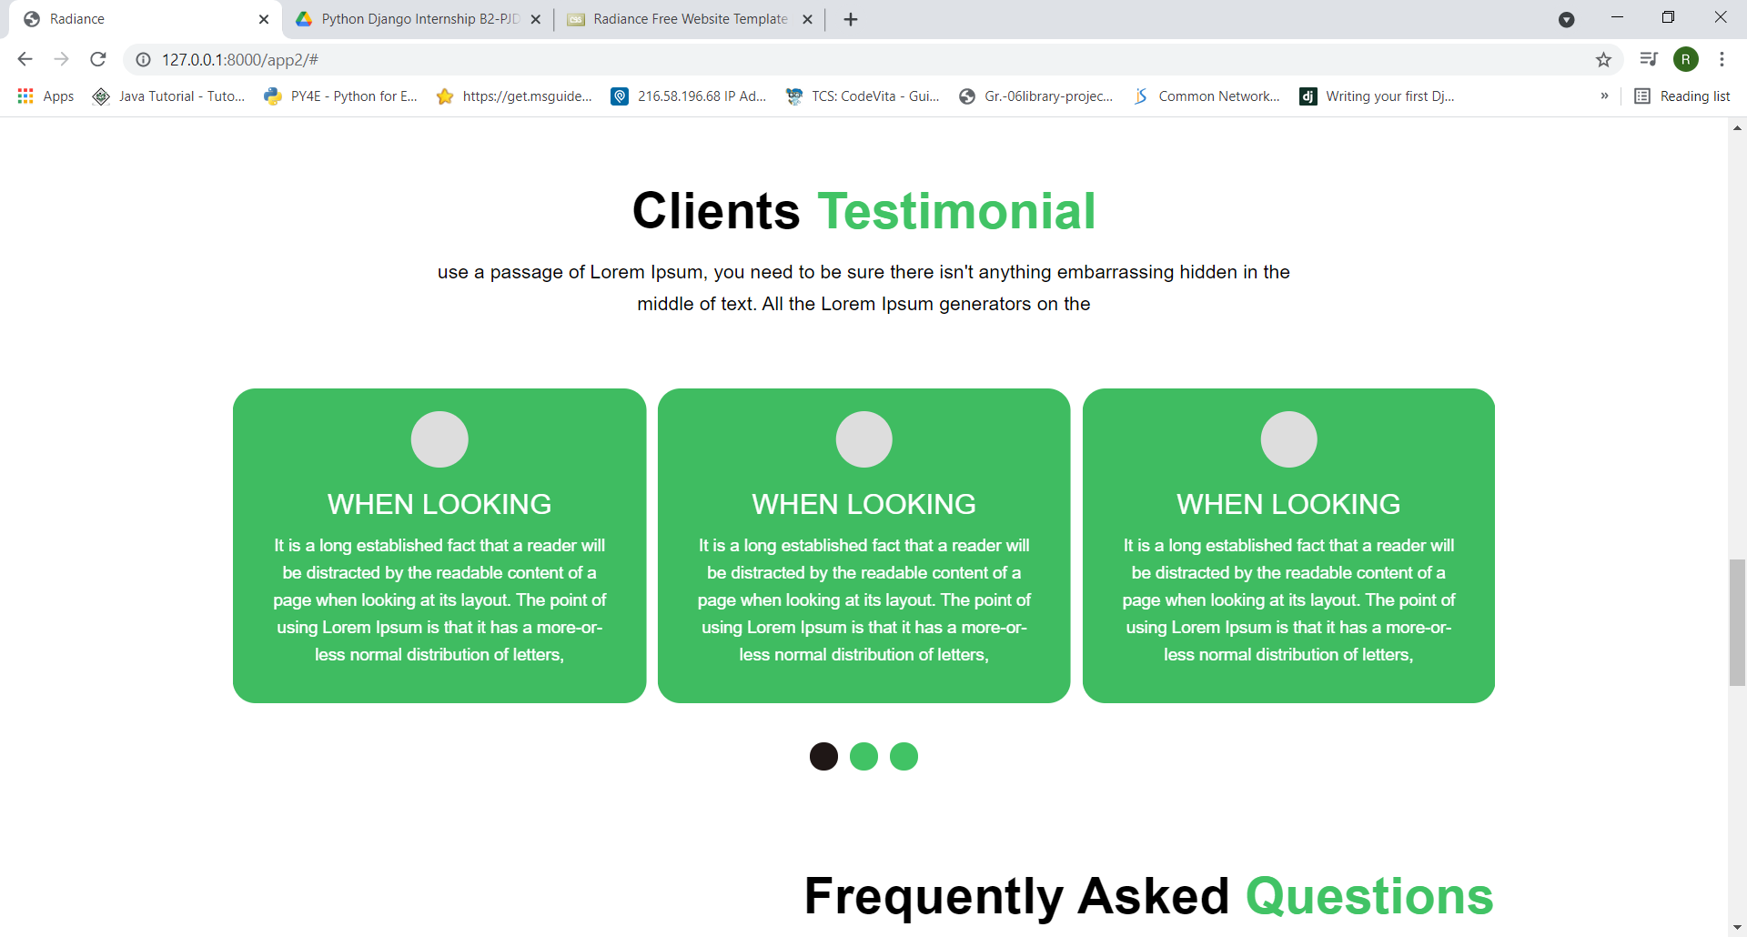

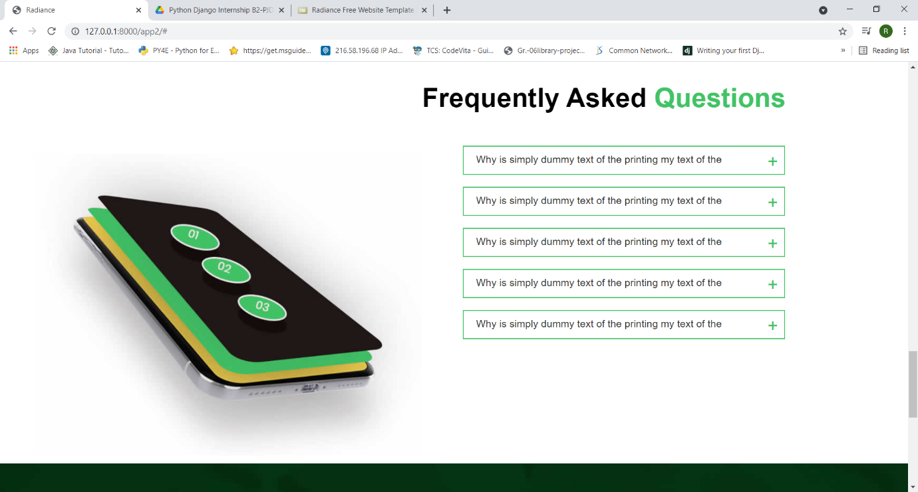

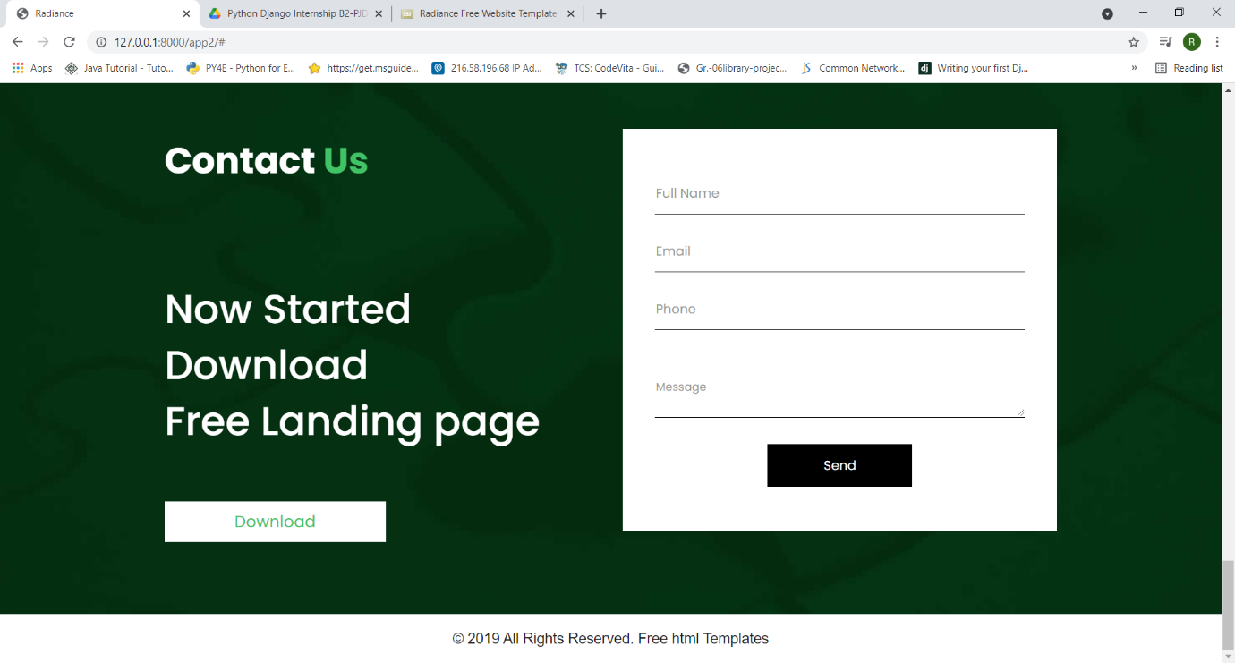

**DAY-6 TASK**

1. create list of fields of django model

Djngo treats table of database as a object of class.

**Basic model data types and fields list**

| Field Name | Description |
| --- | --- |
| AutoField | It An IntegerField that automatically increments. |
| BigAutoField | It is a 64-bit integer, much like an AutoField except that it is guaranteed to fit numbers from 1 to 9223372036854775807. |
| BigIntegerField | It is a 64-bit integer, much like an IntegerField except that it is guaranteed to fit numbers from -9223372036854775808 to 9223372036854775807. |
| BinaryField | A field to store raw binary data. |
| BooleanField | A true/false field.  The default form widget for this field is a CheckboxInput. |
| CharField | A field to store text based values. |
| DateField | A date, represented in Python by a datetime.date instance |
|  | It is used for date and time, represented in Python by a datetime.datetime instance. |
| DecimalField | It is a fixed-precision decimal number, represented in Python by a Decimal instance. |
| DurationField | A field for storing periods of time. |
| EmailField | It is a CharField that checks that the value is a valid email address. |
| FileField | It is a file-upload field. |
| FloatField | It is a floating-point number represented in Python by a float instance. |
| ImageField | It inherits all attributes and methods from FileField, but also validates that the uploaded object is a valid image. |
| IntegerField | It is an integer field. Values from -2147483648 to 2147483647 are safe in all databases supported by Django. |
| GenericIPAddressField | An IPv4 or IPv6 address, in string format (e.g. 192.0.2.30 or 2a02:42fe::4). |
| NullBooleanField | Like a BooleanField, but allows NULL as one of the options. |
| PositiveIntegerField | Like an IntegerField, but must be either positive or zero (0). |
| PositiveSmallIntegerField | Like a PositiveIntegerField, but only allows values under a certain (database-dependent) point. |
| SlugField | Slug is a newspaper term. A slug is a short label for something, containing only letters, numbers, underscores or hyphens. They’re generally used in URLs. |
| SmallIntegerField | It is like an IntegerField, but only allows values under a certain (database-dependent) point. |
| TextField | A large text field. The default form widget for this field is a Textarea. |
| TimeField | A time, represented in Python by a datetime.time instance. |
| URLField | A CharField for a URL, validated by URLValidator. |
| UUIDField | A field for storing universally unique identifiers. Uses Python’s UUID class. When used on PostgreSQL, this stores in a uuid datatype, otherwise in a char(32). |

**Relationship Fields**

Django also defines a set of fields that represent relations.

| Field Name | Description |
| --- | --- |
| ForeignKey | A many-to-one relationship. Requires two positional arguments: the class to which the model is related and the on_delete option. |
| ManyToManyField | A many-to-many relationship. Requires a positional argument: the class to which the model is related, which works exactly the same as it does for ForeignKey, including recursive and lazy relationships. |
| OneToOneField | A one-to-one relationship. Conceptually, this is similar to a ForeignKey with unique=True, but the “reverse” side of the relation will directly return a single object. |

Reference:- <https://www.geeksforgeeks.org/django-model-data-types-and-fields-list/>

**DAY-7 TASK**

* **Write Some Details About ORM In Django:-**

1. ORM stands for Object Relational Mapper. It is just a fancy word describing how to access the data stored in the database in Object Oriented fashion. Start Django shell using the shell command.
2. Secondly, what is the use of ORM? An object-relational mapper (ORM) is a code library that automates the transfer of data stored in relational databases tables into objects that are more commonly used in application code.
3. Object Relational Mappers or ORMs are a layer of software that sits between web developers and the database backend. For instance if you're using Ruby as your web development language, you'll interact with MySQL through an ORM layer called ActiveRecord. If you're using Java, you may be fond of the ORM called Hibernate.
4. Object-relational mapping (ORM, O/RM, and O/R mapping tool) in computer science is a programming technique for converting data between incompatible type systems using object-oriented programming languages. This creates, in effect,a "virtual object database" that can be used from within the programming language
5. Django is shipped with its own ORM. It is a very efficient ORM and is tightly coupled with the Django framework. Django ORM is suitable for handling low-medium complexity queries. Although, some consider SQLAlchemy ORM to be a better option. The migrations feature by Django is also a part of Django ORM. The ORM has many benefits engulfing those of migrations and Querysets. Django is the only framework which is complete in itself.
6. This is totally a developer’s choice. Although there are certain benefits of ORM, there are some downsides too. It is beneficial for developers as it allows faster development. Sometimes ORMs generate more complex queries then they should. This can result in a performance decrease. Therefore, it is totally the developer’s choice and the level of work they are doing. For example – Django ORM is efficient for working with low-medium complexity models.
7. In most cases, people prefer SQLAlchemy over Django ORM. The reason being SQLAlchemy is more adept to work with high-complexity data structures. Django ORM is powerful in its own way. The ORM provides features integrated with Django which are more important than just performance improvement.
8. Currently, Django ORM is not swappable with SQLAlchemy. There are some hacks to do it but it’s unofficial. Django’s future releases are expected to provide this functionality. Also, both SQLAlchemy and Django ORM is actively developed.
9. So, there is no clear winner and it totally depends on the type of project you are working on.

**DAY-8 TASK**

* **Write Details About Random Module:-**

Python has become so popular among developers because it offers a massive number of tools that help to accelerate the software development process. Thanks to modules and libraries, a development team doesn’t have to build features from scratch, saving plenty of time it can dedicate to focusing on the business logic and other key aspects of the project

**seed()**

Initialize the random number generator.

**getstate()**

Returns the current internal state of the random number generator.

**setstate()**

Restores the internal state of the random number generator.

**getrandbits()**

Returns a number representing the random bits.

**randrange()**

Returns a random number between the given range.

**randint()**

Returns a random number between the given range.

**choice()**

Returns a random element from the given sequence.

**choices()**

Returns a list with a random selection from the given sequence.

**shuffle()**

Takes a sequence and returns the sequence in a random order.

**sample()**

Returns a given sample of a sequence.

**random()**

Returns a random float number between 0 and 1.

**uniform()**

Returns a random float number between two given parameters.

**triangular()**

Returns a random float number between two given parameters, you can also set a mode parameter to specify the midpoint between the two other parameters.

**betavariate()**

Returns a random float number between 0 and 1 based on the Beta distribution (used in statistics).

**expovariate()**

Returns a random float number based on the Exponential distribution (used in statistics).

**gammavariate()**

Returns a random float number based on the Gamma distribution (used in statistics).

**gauss()**

Returns a random float number based on the Gaussian distribution (used in probability theories).

**lognormvariate()**

Returns a random float number based on a log-normal distribution (used in probability theories).

**normalvariate()**

Returns a random float number based on the normal distribution (used in probability theories).

**vonmisesvariate()**

Returns a random float number based on the von Mises distribution (used in directional statistics).

**paretovariate()**

Returns a random float number based on the Pareto distribution (used in probability theories).

**weibullvariate()**

Returns a random float number based on the Weibull distribution (used in statistics).

* **Write Details About SMTPlib Module:-**

Python's standard library has 'smtplib' module which defines an SMTP client session object that can be used to send mail via Python program.

A mail server is an application that handles and delivers e-mail over the internet. Outgoing mail servers implement SMTP, or Simple MailTransfer Protocol, servers which are an Internet standard for email transmission.

Incoming mail servers come in two main varieties. POP3, or Post office protocol and IMAP, or Internet Message Access Protocol.

**smptlib.SMTP()function**

This function returns an object of SMTP class. It encapsulates and manages a connection to an SMTP or ESMTP server. Following arguments are defined in the signature of this function −

**host**

A string which is the name of the remote host to which to connect.

**port**

A number that specifies the port to which to connect. By default, smtplib.SMTP_PORT is used.

**local_hostname**

used as the FQDN of the local host in the HELO/EHLO command.

**source_address**

a 2-tuple (host, port) object to which the socket to bind

* **support SMTP operations**

**connect() −**

This method establishes a connection to a host on a given port.

**login() −**

This function takes username and password arguments to login to SMTP server.

**quit() −**

This function terminates SMTP session.

**data() −**

The 'message' argument to this function is sent to server.

**docmd()−**

This function sends a command and returns its response code

**ehlo() −**

This function identifies the server.

**starttls() −**

This function starts TLS mode.

**getreply() −**

This function receives reply from the server in the form of response code.

**putcmd() −**

This function sends a command to the server.

**send_message() −**

This function converts the message to a byte string and passes it to send mail.

**sendmail() −**

This command performs an entire mail transaction.

**DAY-9 TASK**

* **Write Details about…..**
* **Objects.all():-**
* **Objects.filter():-**
* **Objects.get():-**
* **Objects.all() method :-**

>>>

Author.objects.all()

<QuerySet [<Author: tom : tom@email.com>, <Author: jerry : jerry@mail.com>, <Aut

hor: spike : spike@mail.com>, <Author: tyke : tyke@mail.com>, <Author: droopy :

droopy@mail.com>]>

>>>

The all() method returns a QuerySet object. A QuerySet object looks a lot like a list, but it is not an actual list, in some ways it behaves just like lists. For example, you can access individual members in a QuerySet objects using an index number.

>>>

>>> r = Author.objects.all()

>>> r

<QuerySet [<Author: tom : tom@email.com>, <Author: jerry : jerry@mail.com>, <Aut

hor: spike : spike@mail.com>, <Author: tyke : tyke@mail.com>, <Author: droopy :

droopy@mail.com>]>

>>>

>>>

>>> r[0]

<Author: tom : tom@email.com>

>>>

>>> r[1]

<Author: jerry : jerry@mail.com>

>>>

>>> r[2]

<Author: spike : spike@mail.com>

>>>

Although r points to an object of type QuerySet but r[0], r[1], r[2] and so on, points to an object of type Author.

>>> type(r[0])

<class 'blog.models.Author'>

>>>

>>> type(r[1])

<class 'blog.models.Author'>

>>>

>>> type(r[3])

<class 'blog.models.Author'>

>>>

It is important to note that some methods of objects manager returns QuerySet while some do not.

QuerySet is iterable just like a list. You can use a for loop to iterate through all of the objects in a QuerySet object.

>>>

>>> r = Author.objects.all()

>>> for a in r:

... print("Author: {0}".format(a.name))

...

Author: tom

Author: jerry

Author: spike

Author: tyke

Author: droopy

>>>

* **Objects.filter() method :-**

Most of the time you would only want to work with a subset of data. Django provides a filter() method which returns a subset of data. It accepts field names as keyword arguments and returns a QuerySet object.

>>>

>>> Author.objects.filter(name='tom')

<QuerySet [<Author: tom : tom@email.com>]>

>>>

>>> Author.objects.filter(name='johnny')

<QuerySet []>

>>>

SELECT * from blog_author

where name = 'tom'

As database has only one record where name is 'tom', the QuerySet object contains only a single record. If we had two records where name is 'tom' then filter() would have returned a QuerySet object containing two Author objects.

Similarly, Author.objects.filter(name='johnny') translates to SQL rougly as follows:

SELECT * from blog_author

where name = 'johnny'

As there are no records where name is 'johnny' an empty QuerySet is returned.

We can also directly print the raw SQL django uses to query the database using the query attribute of the QuerySet object.

>>>

>>> print(Author.objects.filter(name='tom').query)

SELECT "blog_author"."id", "blog_author"."name", "blog_author"."email", "blog_au

thor"."active", "blog_author"."created_on", "blog_author"."last_logged_in" FROM

"blog_author" WHERE "blog_author"."name" = tom

>>>

Matching performed using keyword arguments are case-sensitive

>>>

>>> Author.objects.filter(email='jerry@mail.com')

<QuerySet [<Author: jerry : jerry@mail.com>]>

>>>

>>> Author.objects.filter(email='JERRY@mail.com')

<QuerySet []>

>>>

The last query returns an empty QuerySet because there are no records where email is "JERRY@mail.com", although there is a record where name is "jerry@mail.com".

You can also pass multiple keyword arguments to the filter() method.

>>>

>>> Author.objects.filter(name='spike', email='spike@mail.com')

<QuerySet [<Author: spike : spike@mail.com>]>

>>>

SELECT * from blog_author

where name = 'spike' and email ='spike@mail.com'

* **objects.get() method :-**

The filter() method described in the above section returns a QuerySet, sometimes we just want to fetch a single record from the table. To handle these situations objects manager provides a get()method. The get() method accepts same parameters as filter() method but it returns only a single object. If it finds multiple objects it raises a MultipleObjectsReturned exception. If it doesn't find any object it raises DoesNotExist exception.

>>>

>>> Author.objects.get(name="tom")

<Author: tom : tom@email.com>

>>>

>>> Author.objects.filter(name="tom")

<QuerySet [<Author: tom : tom@email.com>]>

>>>

The difference between the output of get() and filter() method. For the same parameter they both two different results. The get() method returns a instance of Author while filter() methods returns a QuerySet object.

Lets see what happens, if get() method encounters multiple records.

>>>

>>> Author.objects.filter(name__contains="ke")

<QuerySet [<Author: spike : spike@mail.com>, <Author: tyke : tyke@mail.com>]>

>>>

>>>

>>> Author.objects.get(name__contains="ke")

Traceback (most recent call last):

File "<console>", line 1, in <module>

File "C:\Users\K\TGDB\env\lib\site-packages\django\db\models\manager.py", line

85, in manager_method

return getattr(self.get_queryset(), name)(*args, **kwargs)

File "C:\Users\K\TGDB\env\lib\site-packages\django\db\models\query.py", line 3

89, in get

(self.model._meta.object_name, num)

blog.models.MultipleObjectsReturned: get() returned more than one Author -- it r

eturned 2!

>>>

Here get() method raises a MultipleObjectsReturned because there are multiple objects in the database that matches the given parameter.

Similarly, if you try to access an object which do not exists then the get() method will raise an

DoesNotExist exception.

>>>

>>> Author.objects.get(name__contains="captain planet")

Traceback (most recent call last):

File "<console>", line 1, in <module>

File "C:\Users\K\TGDB\env\lib\site-packages\django\db\models\manager.py", line

85, in manager_method

return getattr(self.get_queryset(), name)(*args, **kwargs)

File "C:\Users\K\TGDB\env\lib\site-packages\django\db\models\query.py", line 3

85, in get

self.model._meta.object_name

blog.models.DoesNotExist: Author matching query does not exist.

**DAY-10 TASK**

* **Write Details About objects.save() and objects.delete():-**
* **Objects.save():-**

To save changes to an object that’s already in the database, use save().

Given a Blog instance b5 that has already been saved to the database, this example changes its name and updates its record in the database:

>>> b5.name = 'New name'

>>> b5.save()

This performs an UPDATE SQL statement behind the scenes. Django doesn’t hit the database until you explicitly call save()

* **Objects.delete():-**

The delete method, conveniently, is named delete(). This method immediately deletes the object and returns the number of objects deleted and a dictionary with the number of deletions per object type. Example:

>>> e.delete()

(1, {'weblog.Entry': 1})

You can also delete objects in bulk. Every QuerySet has a delete() method, which deletes all members of that QuerySet.

For example, this deletes all Entry objects with a pub_date year of 2005:

>>> Entry.objects.filter(pub_date__year=2005).delete()

(5, {'webapp.Entry': 5})

Keep in mind that this will, whenever possible, be executed purely in SQL, and so the delete() methods of individual object instances will not necessarily be called during the process. If you’ve provided a custom delete() method on a model class and want to ensure that it is called, you will need to “manually” delete instances of that model (e.g., by iterating over a QuerySet and calling delete() on each object individually) rather than using the bulk delete() method of a QuerySet.

When Django deletes an object, by default it emulates the behavior of the SQL constraint ON DELETE CASCADE – in other words, any objects which had foreign keys pointing at the object to be deleted will be deleted along with it. For example:

b = Blog.objects.get(pk=1)

# This will delete the Blog and all of its Entry objects.

b.delete()

This cascade behavior is customizable via the on_delete argument to the ForeignKey.

Note that delete() is the only QuerySet method that is not exposed on a Manager itself. This is a safety mechanism to prevent you from accidentally requesting Entry.objects.delete(), and deleting all the entries. If you do want to delete all the objects, then you have to explicitly request a complete query set:

Entry.objects.all().delete()

**DAY-11 TASK**

* **To make registration system in Django.**

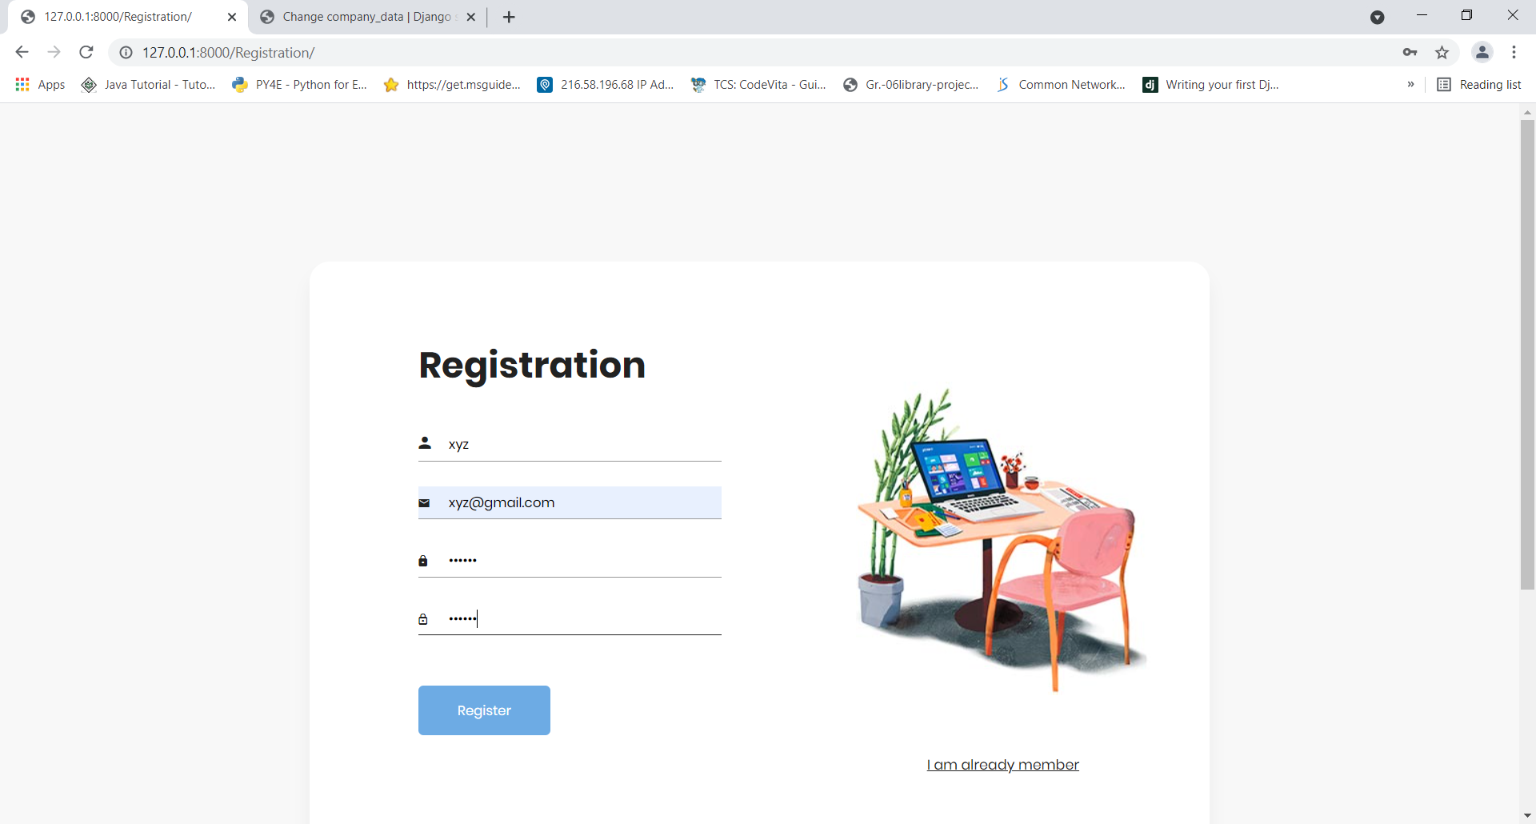

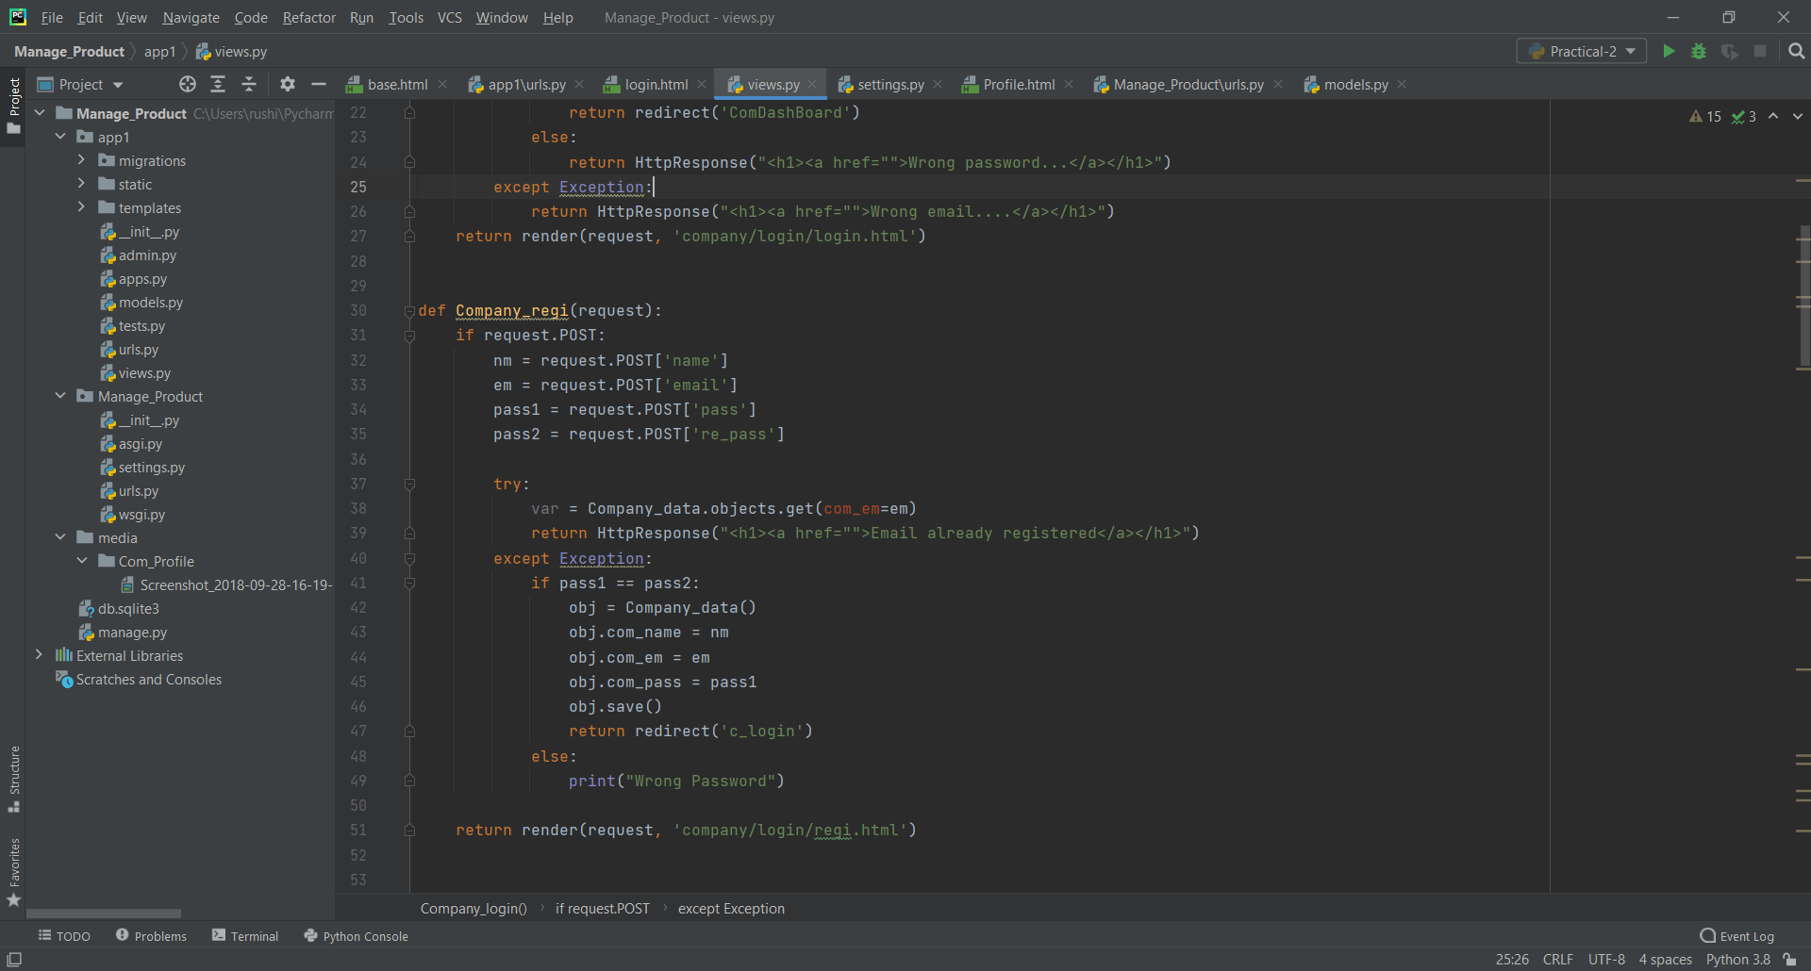

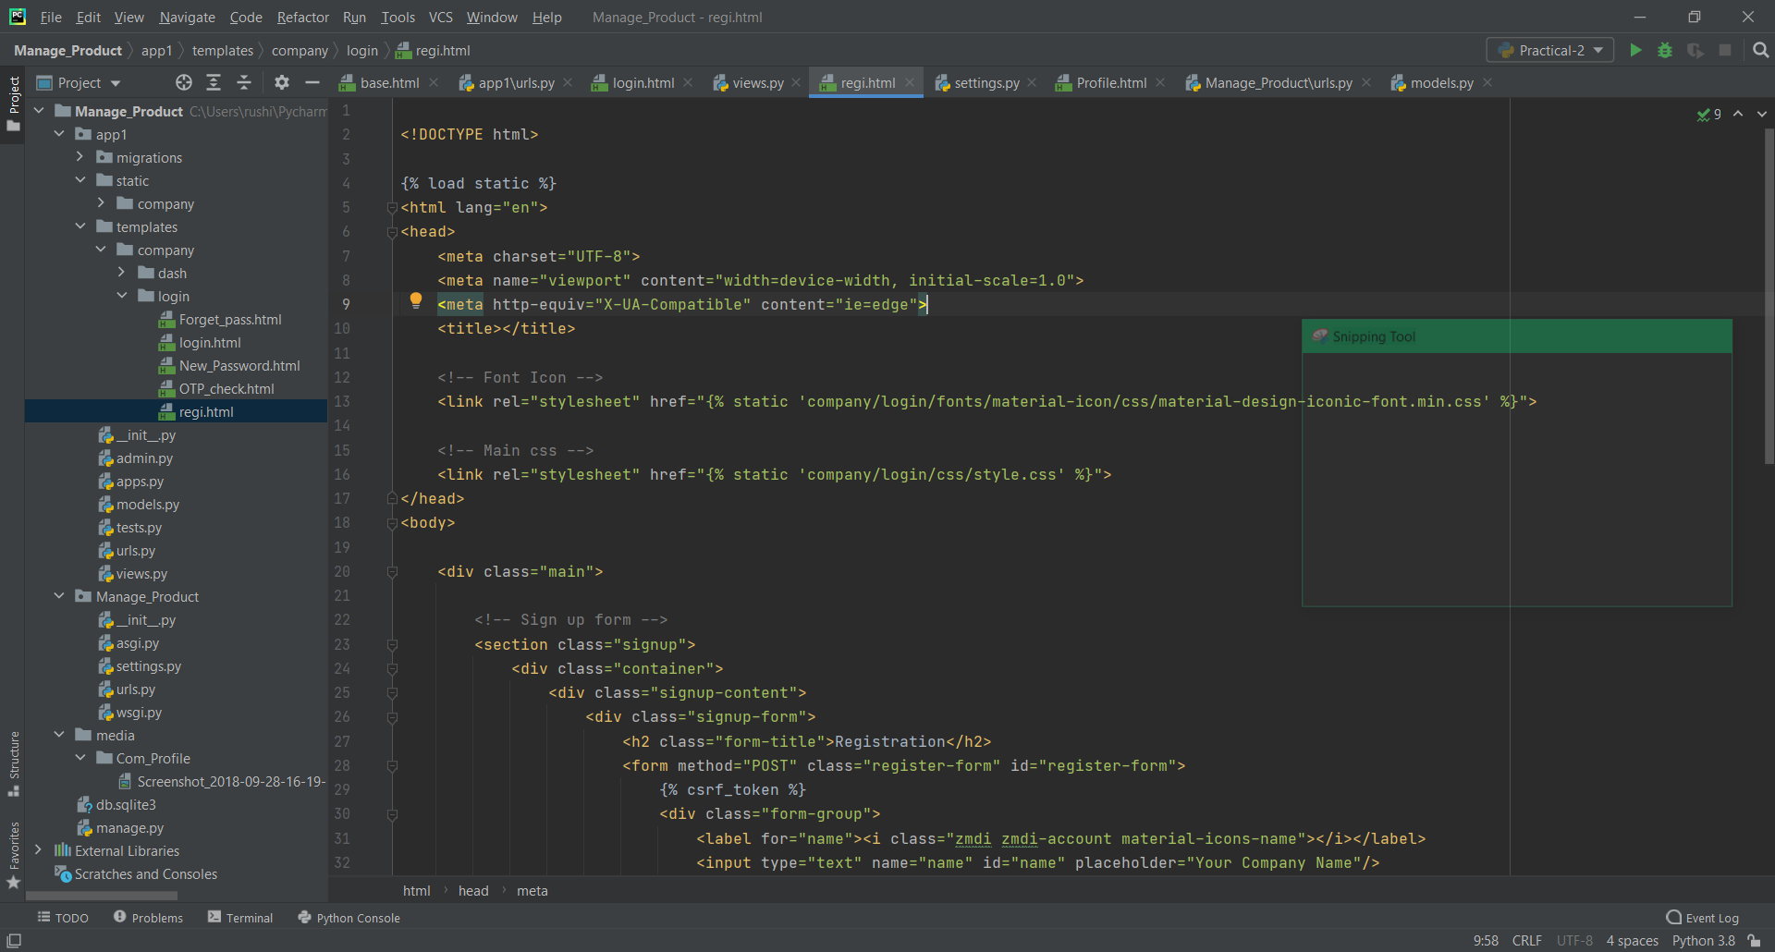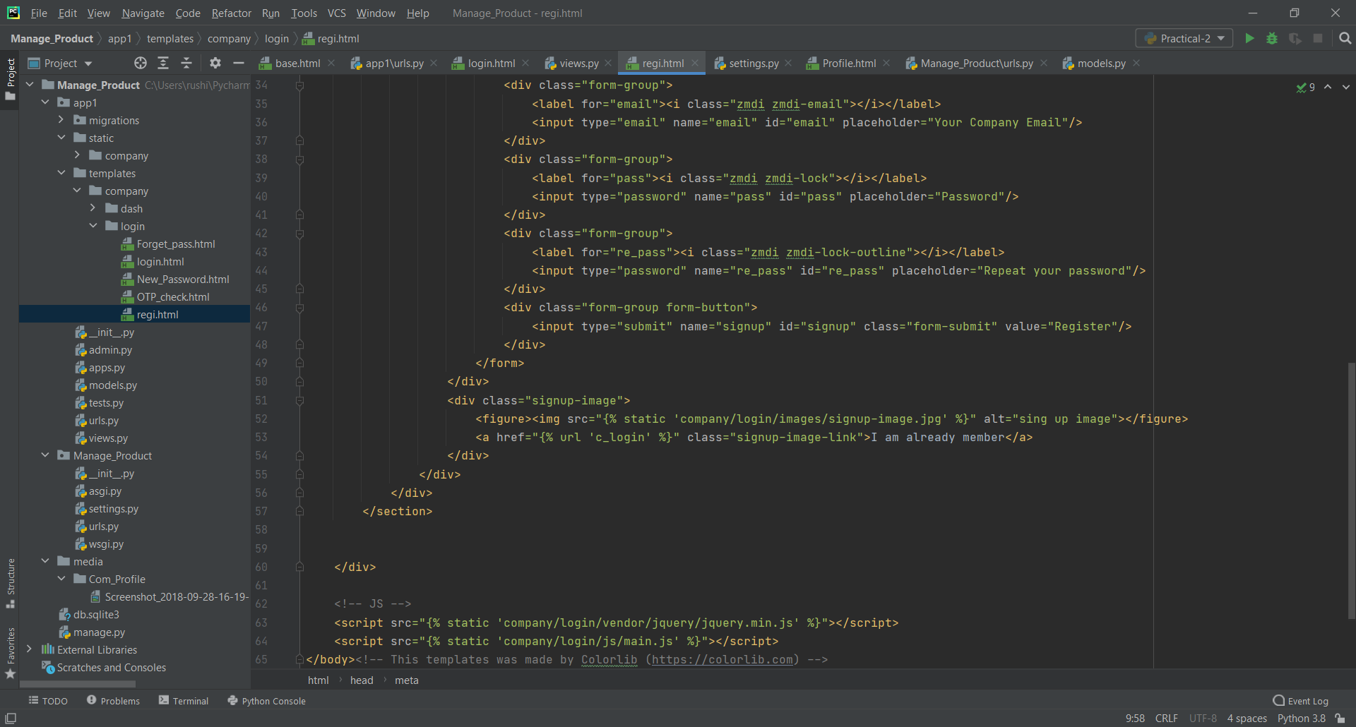

**DAY-12 TASK**

* **To make login system in Django:-**

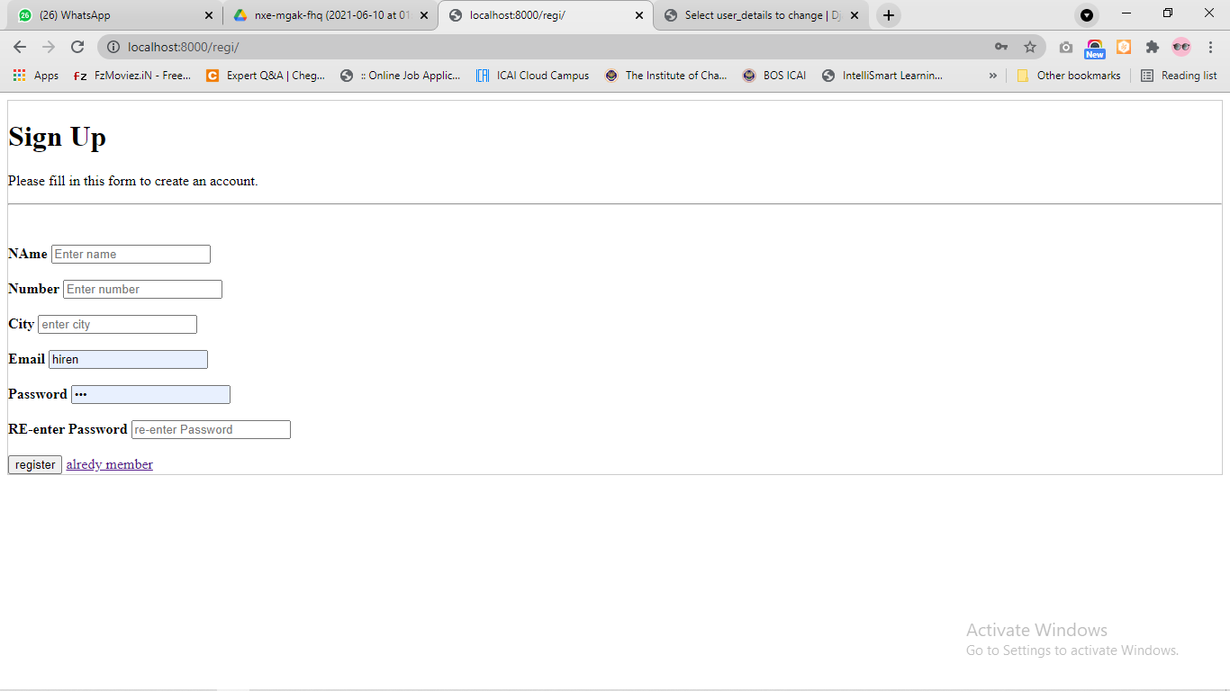

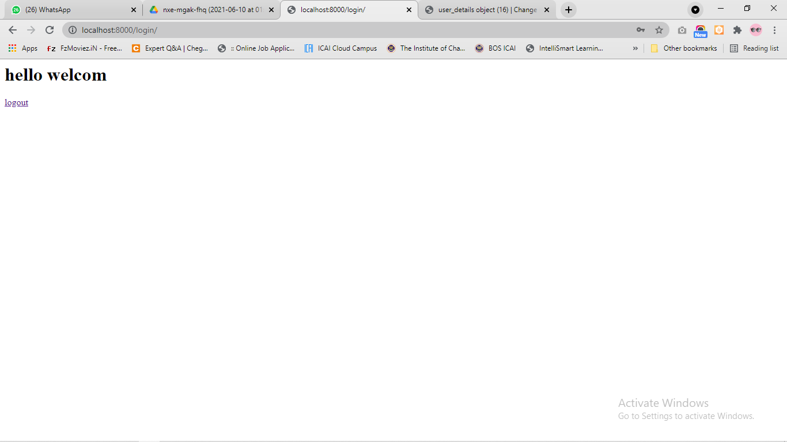

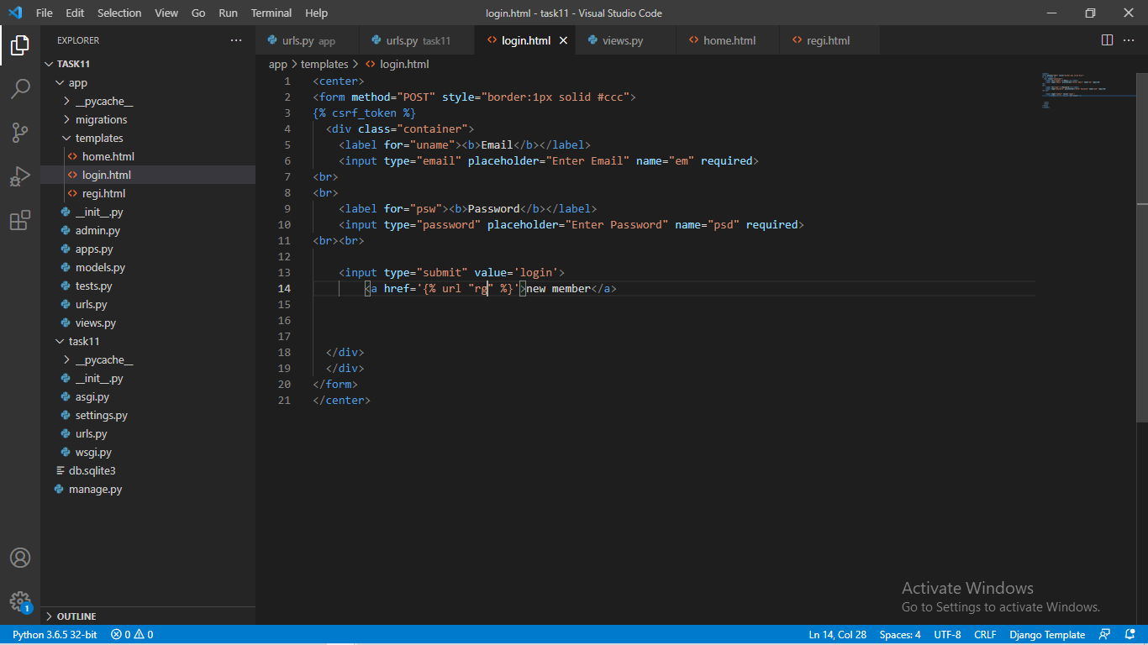

**DAY-13 TASK**

**Task: Perform Insert, Update, Delete operations**

* **Insert :**

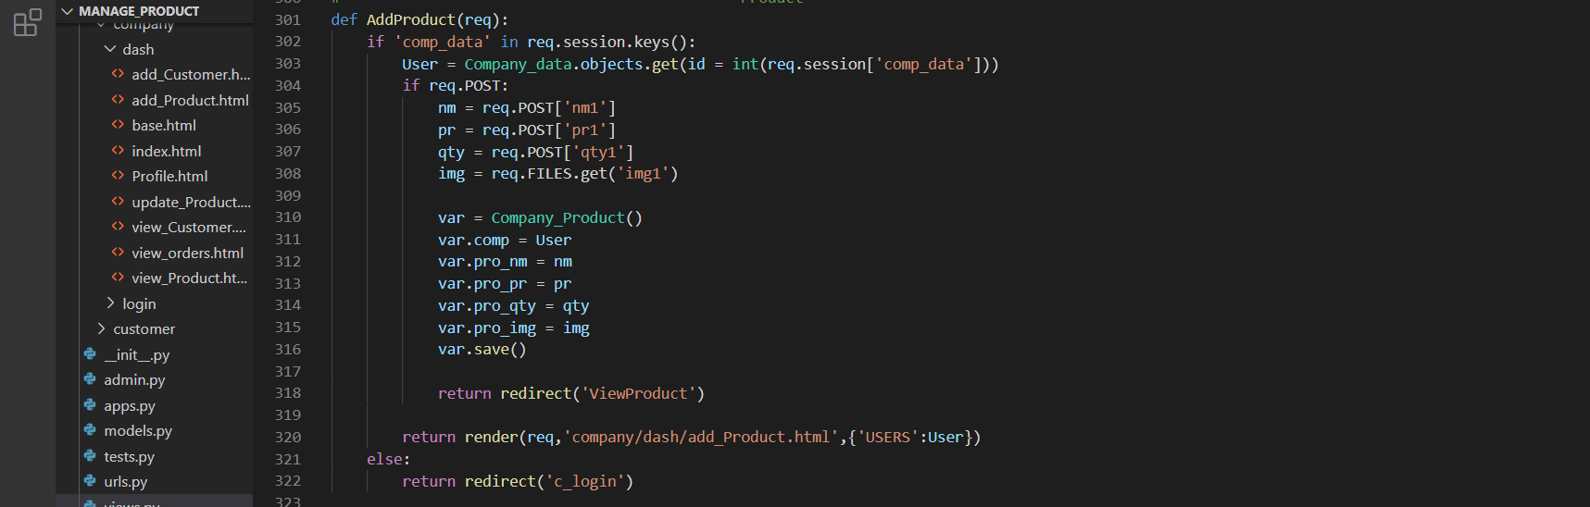

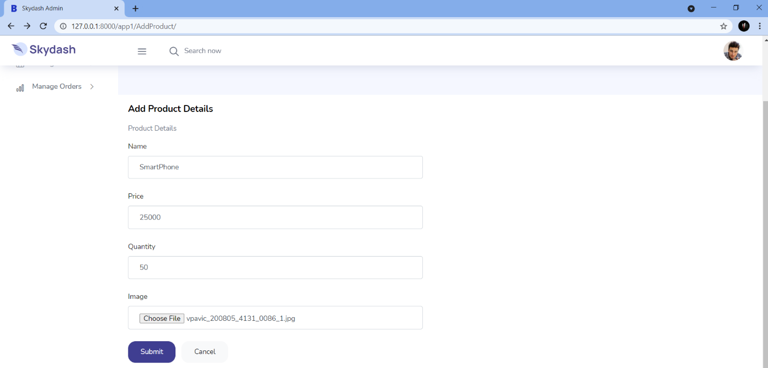

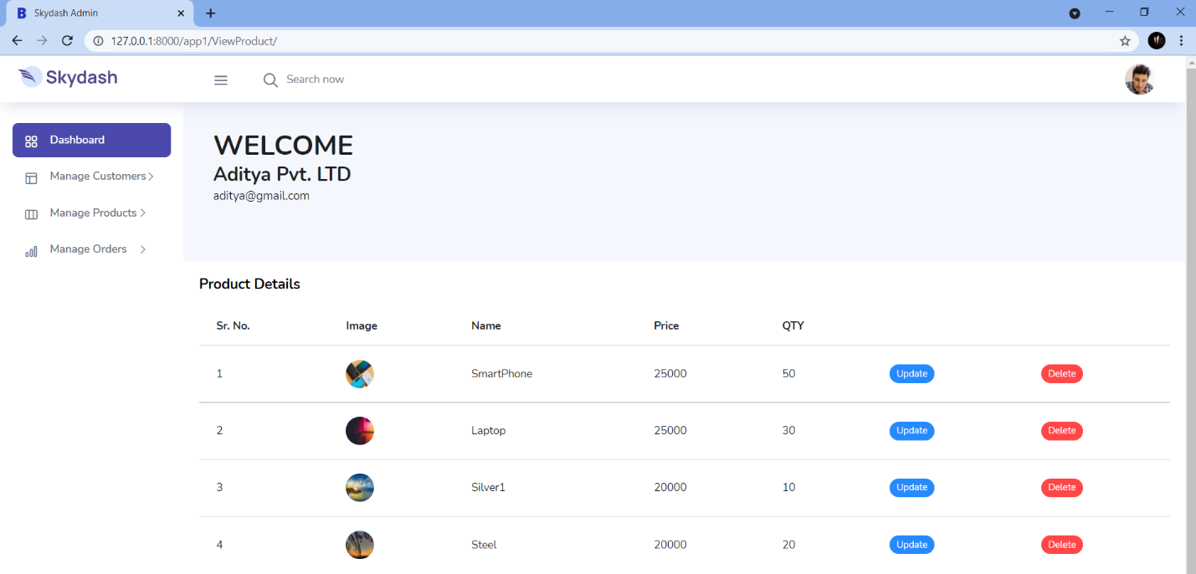

* **Update :**

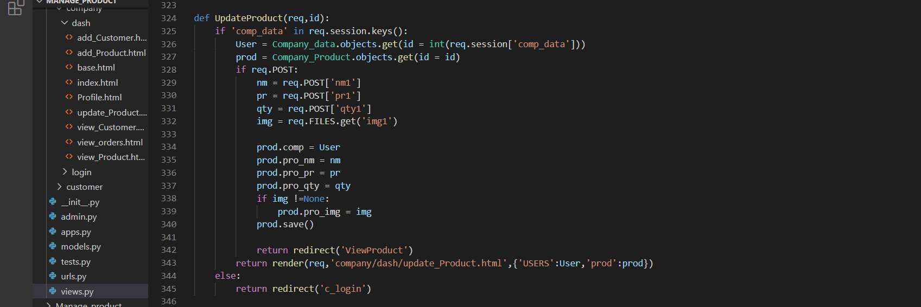

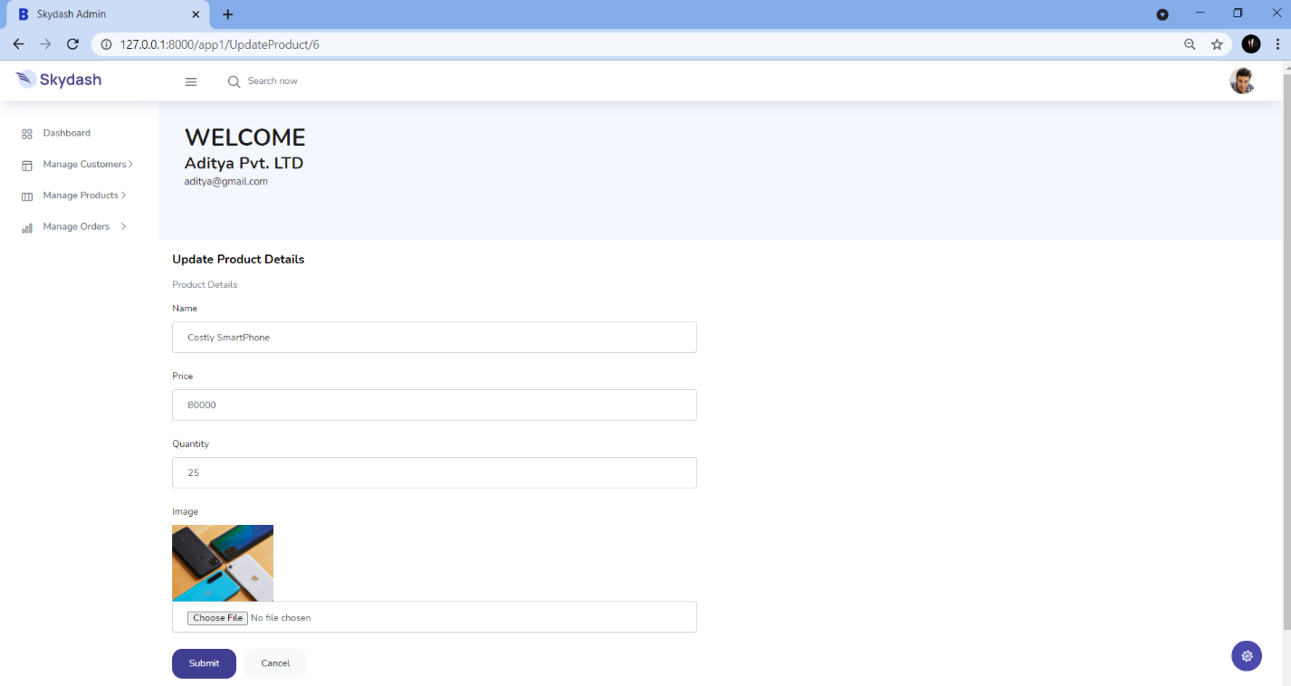

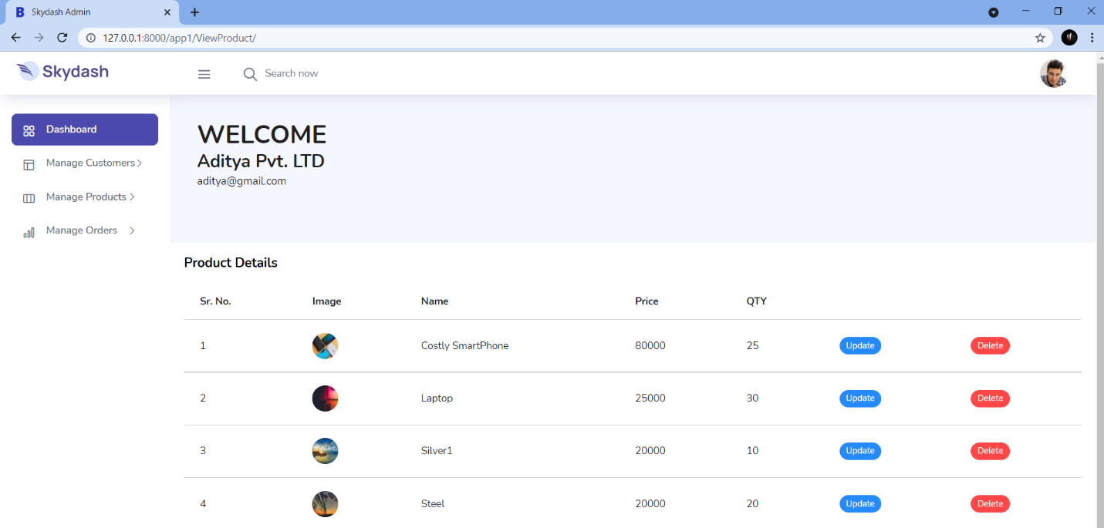

* **Delete :**

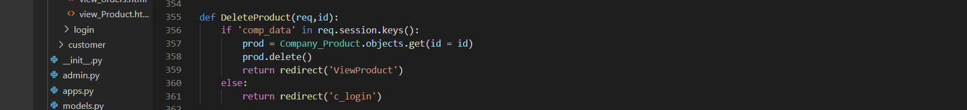

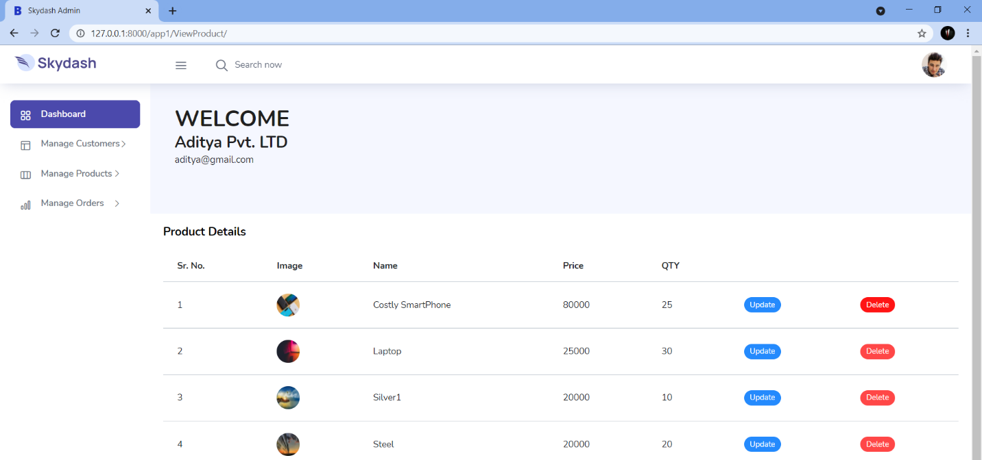

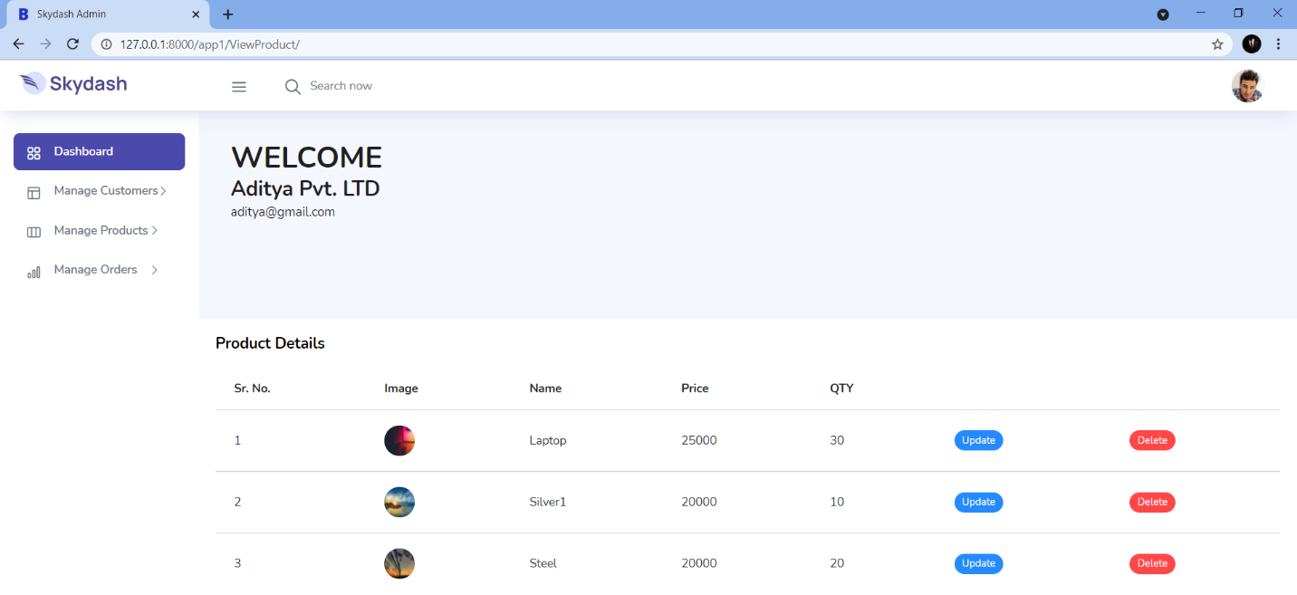

**DAY-14 TASK**

**Task: Implement your own template integration**

* **Company**

**Registration:**

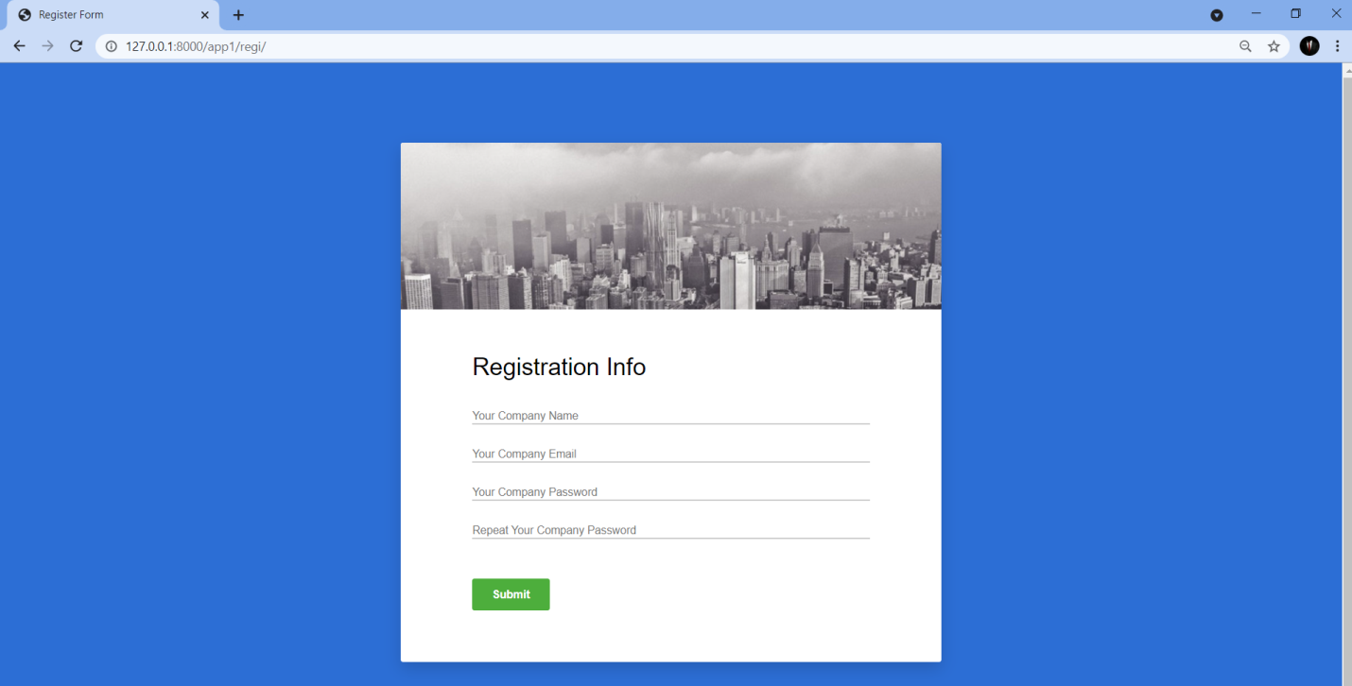

**Login:** 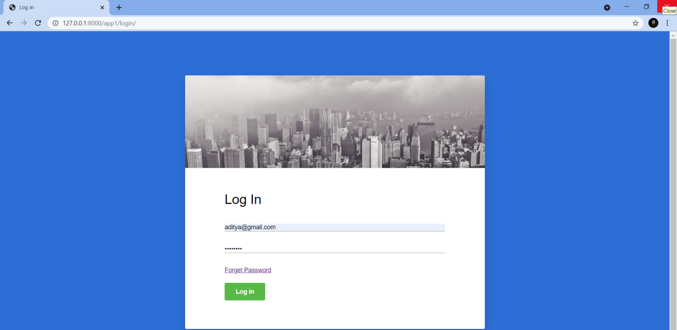

**Dashboard:**

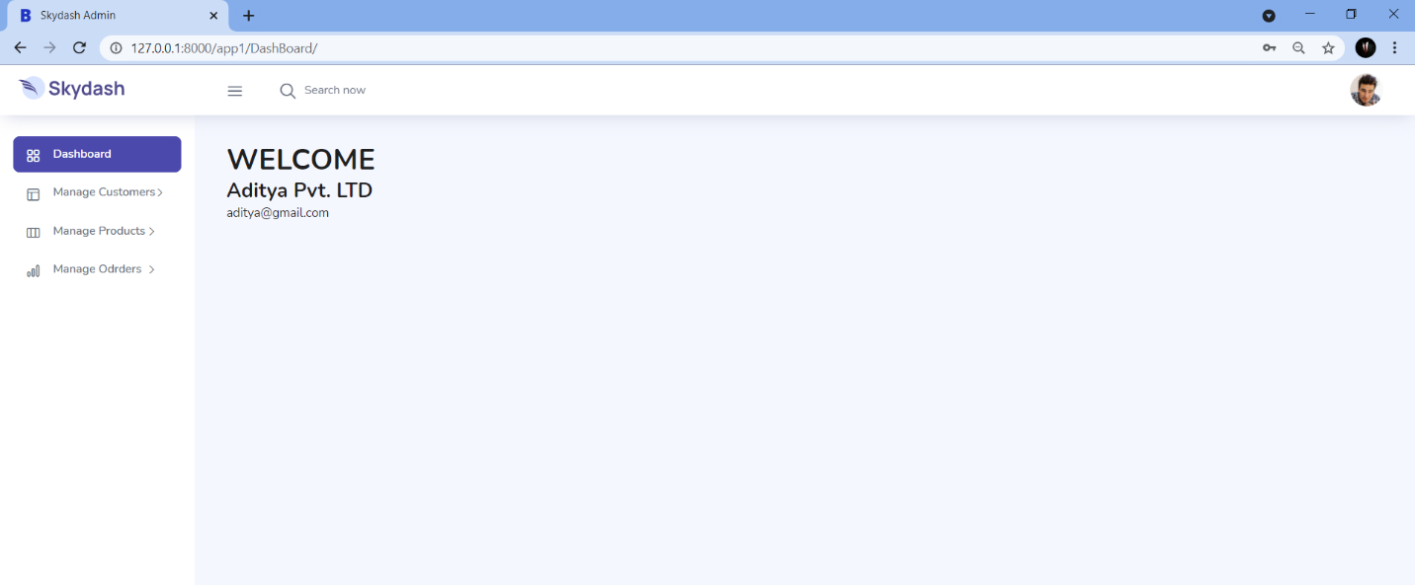

**Update My Profile:**

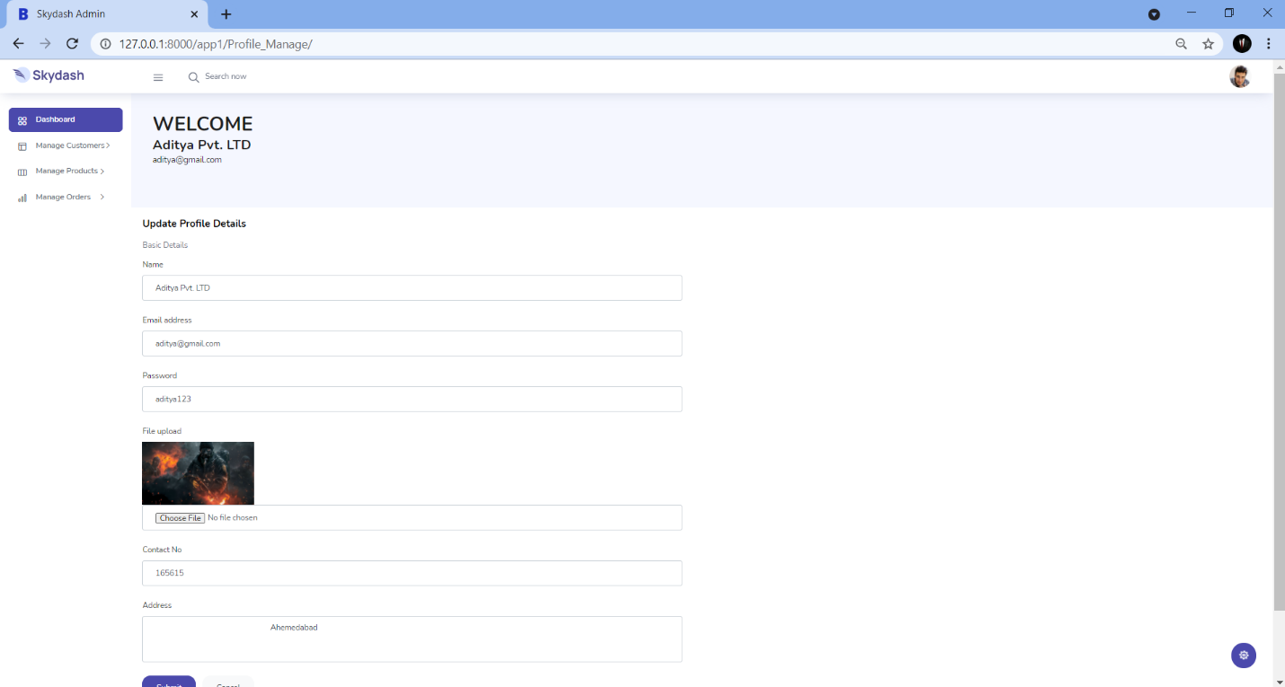

**Manage Customer:**

1. **Add Customer:**

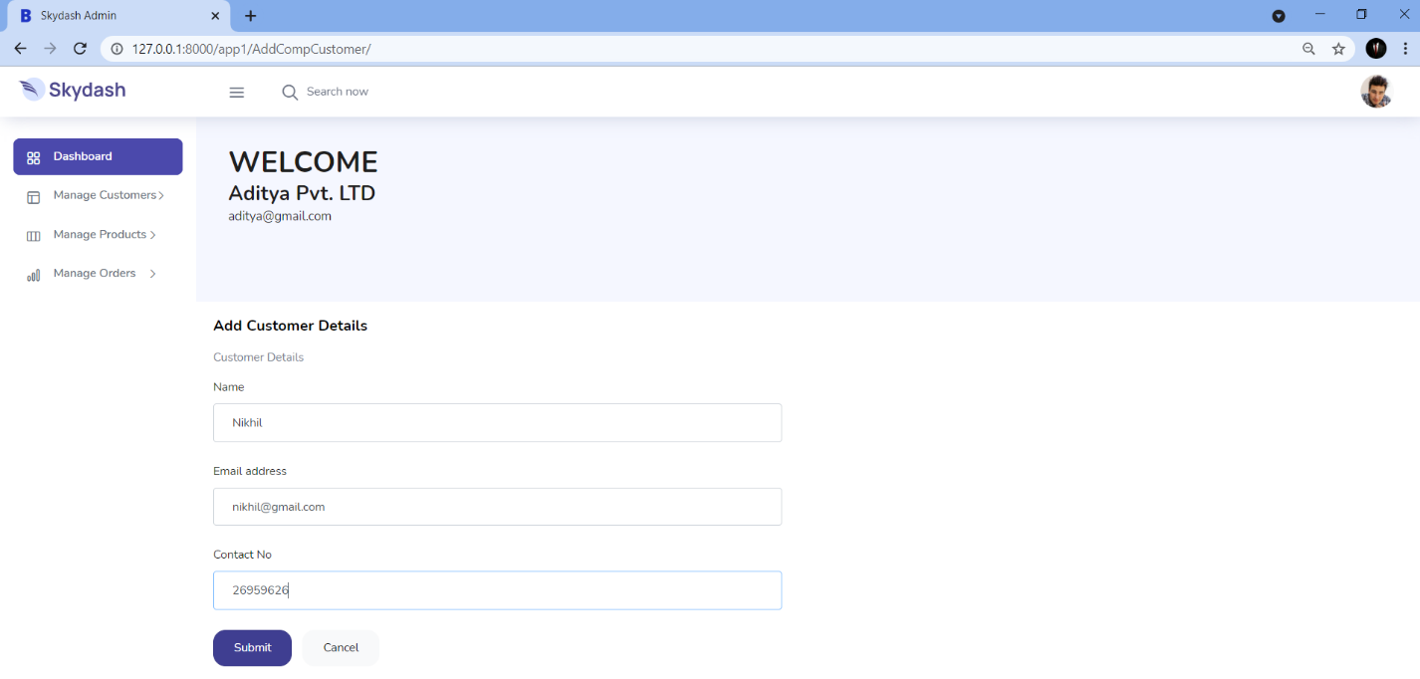

1. **View Customer:**

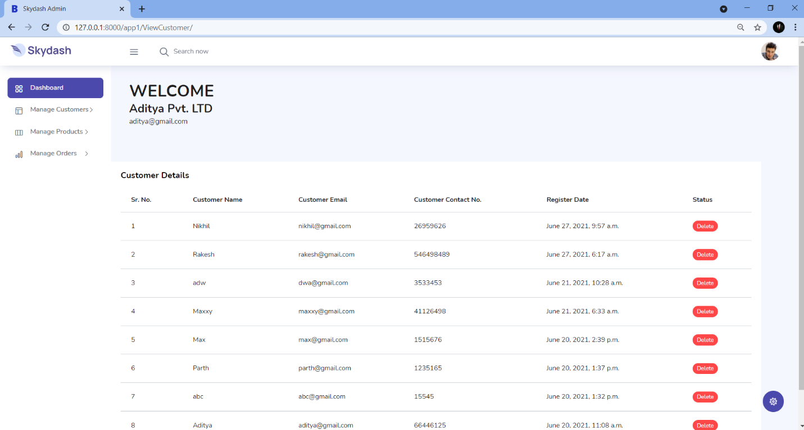

**Manage Product:**

1. **Add Product:**

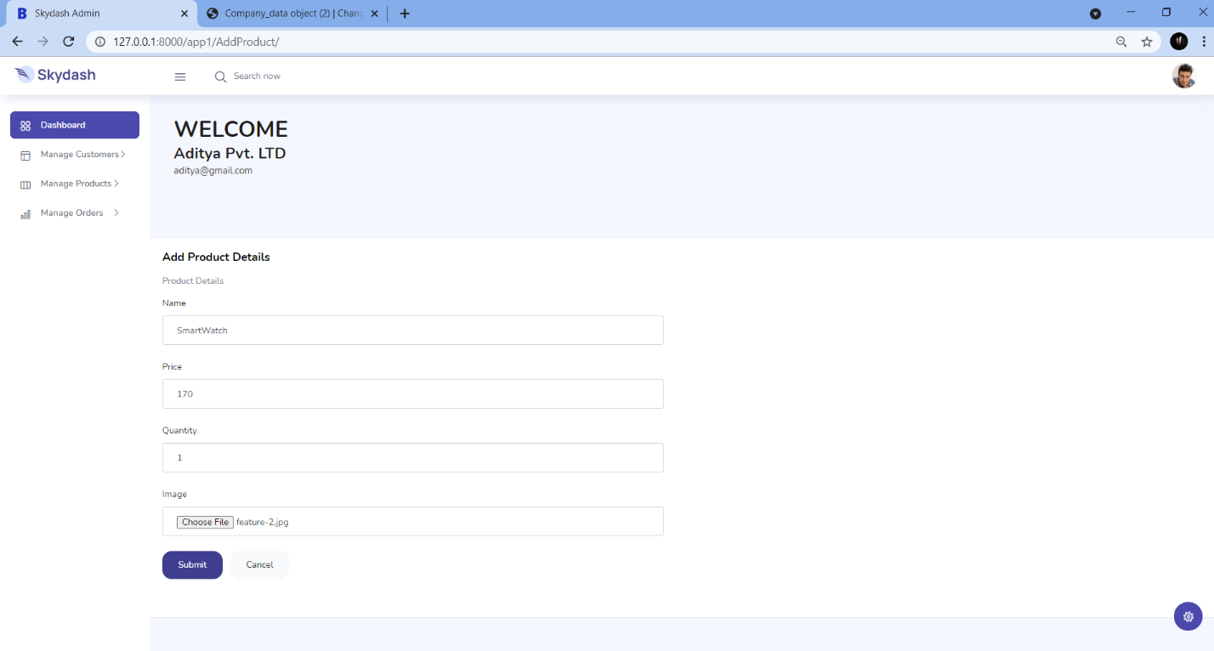

1. **View Product:**

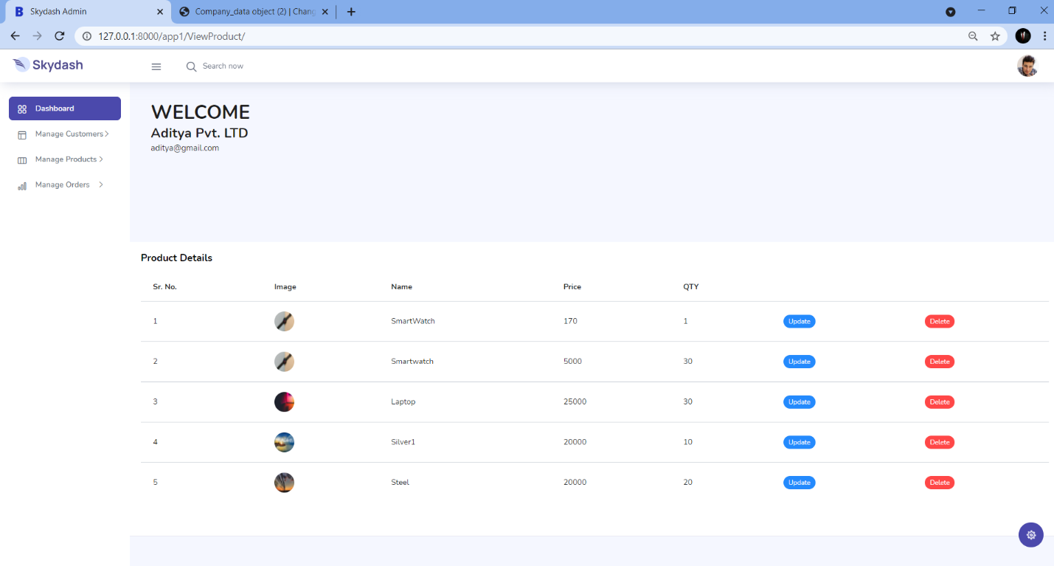

**Manage Orders:**

1. **View orders:**

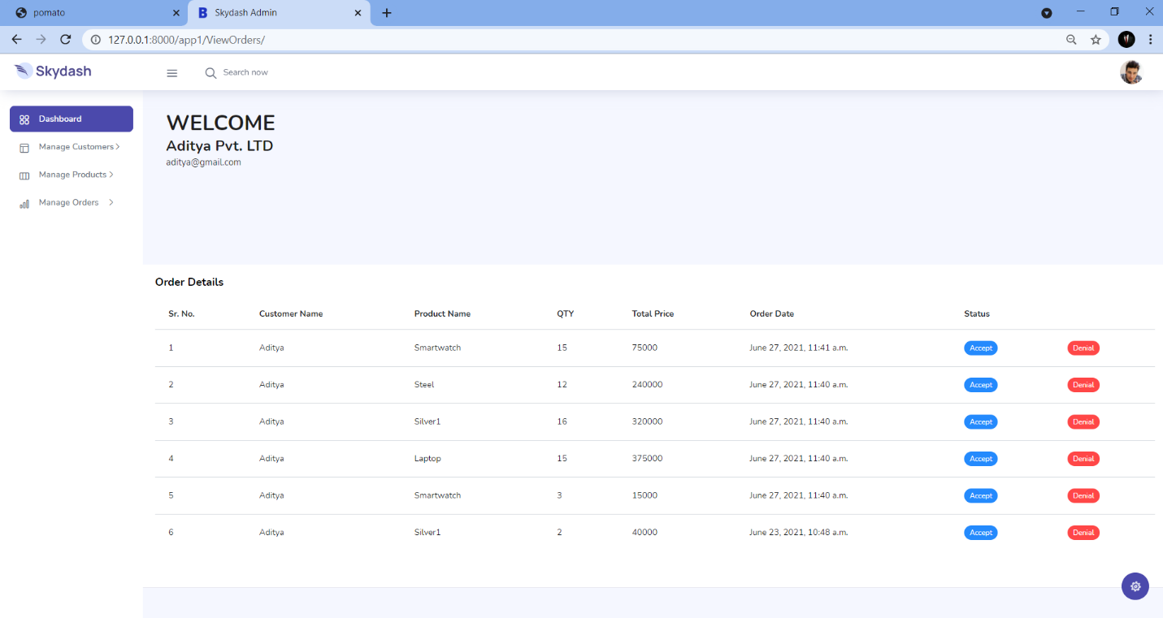

* **Customer**

1. **Customer Login:**

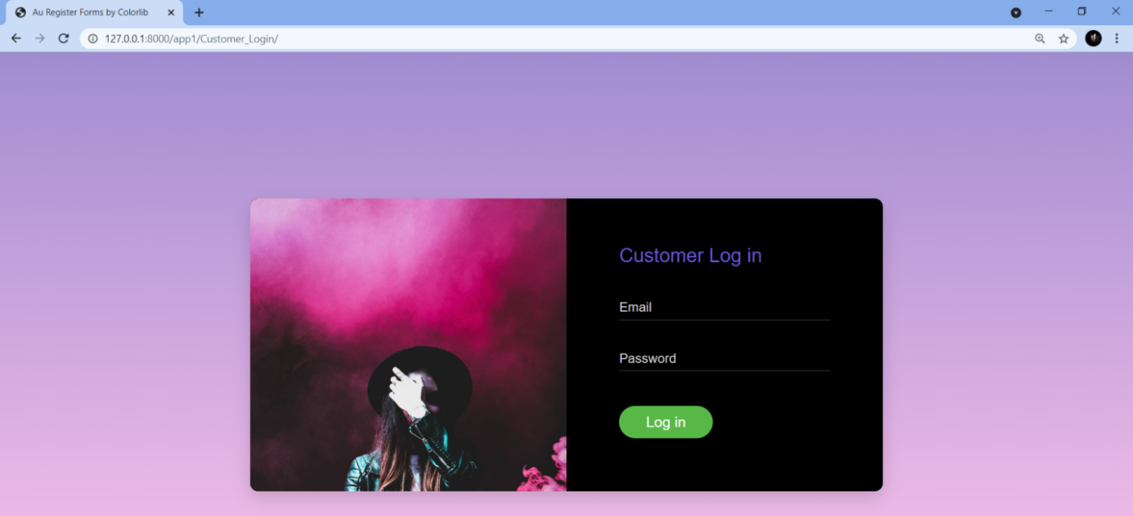

1. **Customer Dashboard**

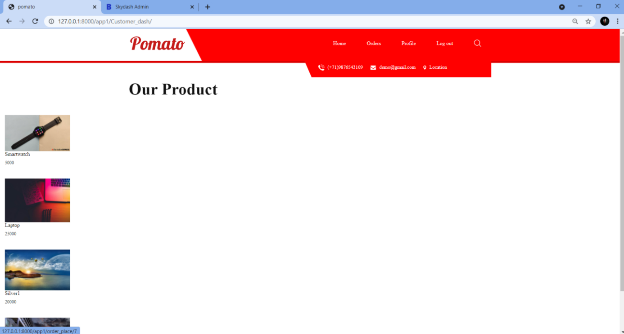

1. **Order Place:**

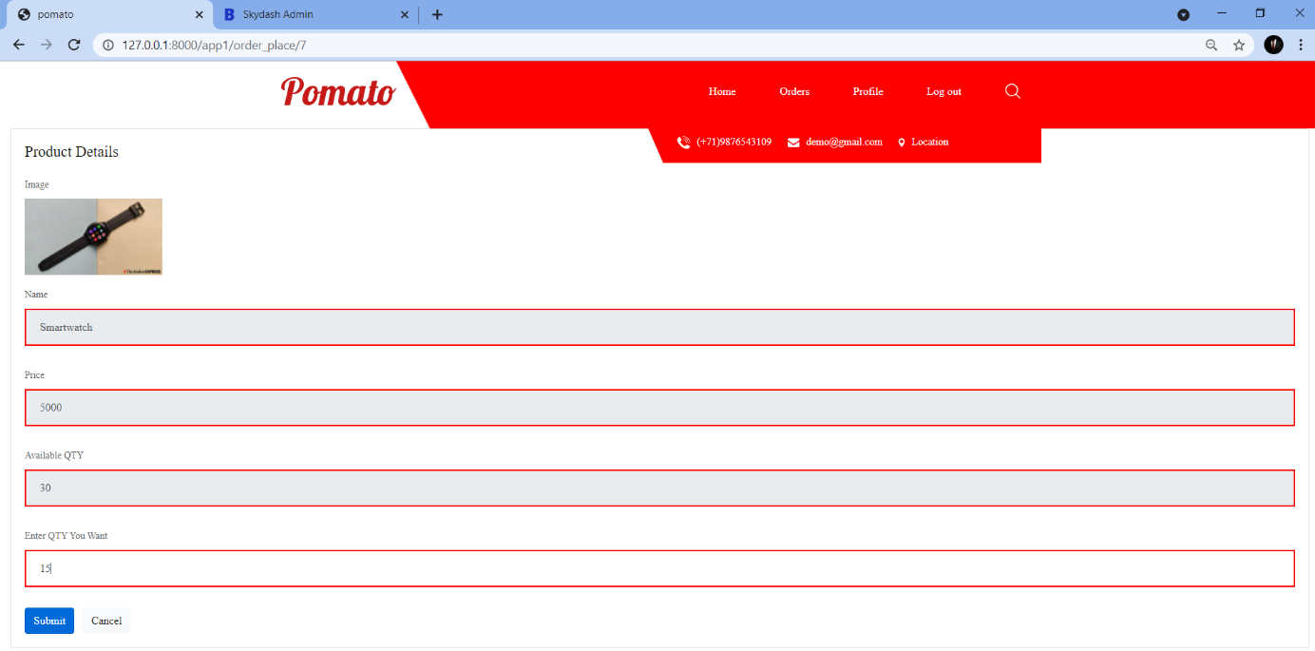

1. **Order Status:**

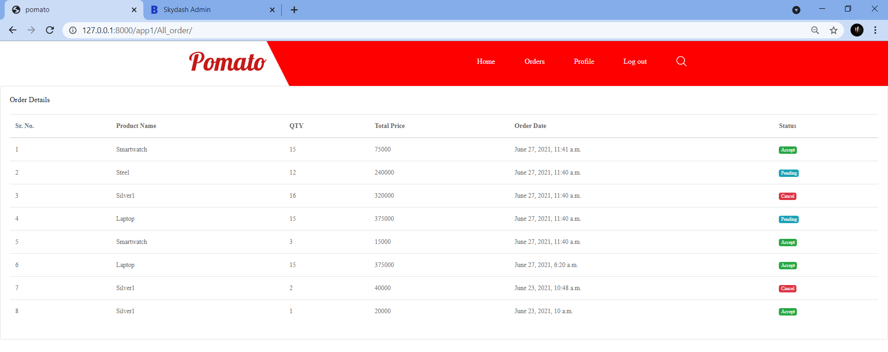

**Video Lecture’s Link:**

**Date: 27-05-2021**

**Time: 3:00 PM**

**Link of recorded session:**

[**https://drive.google.com/file/d/100gn75zvDF8WfwPSm9mVaq5Wsziz-mwZ/view?usp=sharing**](https://drive.google.com/file/d/100gn75zvDF8WfwPSm9mVaq5Wsziz-mwZ/view?usp=sharing)

**Date: 28-05-2021**

**Time: 3:00 PM**

**Link of recorded session:**

[**https://drive.google.com/file/d/1bei_LOpDUx9YPvnH-a1uicDuqRxMTOwc/view?usp=sharing**](https://drive.google.com/file/d/1bei_LOpDUx9YPvnH-a1uicDuqRxMTOwc/view?usp=sharing)

**Date: 31-05-2021**

**Time: 3:00 PM**

**Link of recorded session:**

[**https://drive.google.com/file/d/18wvWZ9F6U3QjLiZ-_5TqvzcUx6aeYex3/view?usp=sharing**](https://drive.google.com/file/d/18wvWZ9F6U3QjLiZ-_5TqvzcUx6aeYex3/view?usp=sharing)

**Date: 1-06-2021**

**Time: 3:00 PM**

**Link of recorded session:**

[**https://drive.google.com/file/d/1sjmqmbO955D7bXdpm1Tfs0vRzzstyrUp/view?usp=sharing**](https://drive.google.com/file/d/1sjmqmbO955D7bXdpm1Tfs0vRzzstyrUp/view?usp=sharing)

**Date: 02-06-2021**

**Time: 3:00 PM**

**Link of recorded session:**

[**https://drive.google.com/file/d/15_mZgNrA0_RtfXyEf8eptCunU-lFTj-j/view?usp=sharing**](https://drive.google.com/file/d/15_mZgNrA0_RtfXyEf8eptCunU-lFTj-j/view?usp=sharing)

**Date: 03-06-2021**

**Time: 3:00 PM**

**Link of recorded session:**

[**https://drive.google.com/file/d/12K9tzT7dqGUW3yr3agF2deC0d_VLg4Kj/view?usp=sharing**](https://drive.google.com/file/d/12K9tzT7dqGUW3yr3agF2deC0d_VLg4Kj/view?usp=sharing)

**Date: 04-06-2021**

**Time: 3:00 PM**

**Link of recorded session:**

[**https://drive.google.com/file/d/1Ml7QSAlIDHkTSYiLxHPsj7eEf8Gej4Wd/view?usp=sharing**](https://drive.google.com/file/d/1Ml7QSAlIDHkTSYiLxHPsj7eEf8Gej4Wd/view?usp=sharing)

**Date: 09-06-2021**

**Time: 2:00 PM**

**Link of recorded session:**

[**https://drive.google.com/file/d/1R61XEaCRKbj_YgXbvN80hJA_CaYZEHds/view?usp=sharing**](https://drive.google.com/file/d/1R61XEaCRKbj_YgXbvN80hJA_CaYZEHds/view?usp=sharing)

**Date: 10-06-2021**

**Time: 2:00 PM**

**Link of recorded session:**

[**https://drive.google.com/file/d/1y5GIdV3djSaemsb0OCUnuQg64gLsICUe/view?usp=sharing**](https://drive.google.com/file/d/1y5GIdV3djSaemsb0OCUnuQg64gLsICUe/view?usp=sharing)

**Date: 11-06-2021**

**Time: 2:00 PM**

**Link of recorded session:**

[**https://drive.google.com/file/d/1CSYnwHxAFNFMyZMZl3qOGF9S1ytX8OHX/view?usp=sharing**](https://drive.google.com/file/d/1CSYnwHxAFNFMyZMZl3qOGF9S1ytX8OHX/view?usp=sharing)

**Date: 11-06-2021**

**Time: 2:00 PM**

**Link of recorded session:**

[**https://drive.google.com/file/d/1RByLjDPmmffYWRnhcT2Z_JezegXN1Spc/view?usp=sharing**](https://drive.google.com/file/d/1RByLjDPmmffYWRnhcT2Z_JezegXN1Spc/view?usp=sharing)

**Date: 12-06-2021**

**Time: 2:00 PM**

**Link of recorded session:**

[**https://drive.google.com/file/d/1RByLjDPmmffYWRnhcT2Z_JezegXN1Spc/view?usp=sharing**](https://drive.google.com/file/d/1RByLjDPmmffYWRnhcT2Z_JezegXN1Spc/view?usp=sharing)

**Date: 13-06-2021**

**Time: 2:00 PM**

**Link of recorded session:**

[**https://drive.google.com/file/d/1cG4_XzmkPG-WaD2_bXElz2ctx-0_UFn6/view?usp=sharing**](https://drive.google.com/file/d/1cG4_XzmkPG-WaD2_bXElz2ctx-0_UFn6/view?usp=sharing)

**Date: 14-06-2021**

**Time: 2:00 PM**

**Link of recorded session:**

[**https://drive.google.com/file/d/1uCZLkSEtc4nrpHA-354ZliPNyQKKX-vf/view?usp=sharing**](https://drive.google.com/file/d/1uCZLkSEtc4nrpHA-354ZliPNyQKKX-vf/view?usp=sharing)

**Date: 15-06-2021**

**Time: 2:00 PM**

**Link of recorded session:**

[**https://drive.google.com/file/d/1wsvDPIDgkgOGxt9X9SaXZkULz-5q7Ila/view?usp=sharing**](https://drive.google.com/file/d/1wsvDPIDgkgOGxt9X9SaXZkULz-5q7Ila/view?usp=sharing)

**References:**

[**https://www.python.org/downloads/release/python-397/**](https://www.python.org/downloads/release/python-397/)

[**https://docs.python.org/3/library/functions.html**](https://docs.python.org/3/library/functions.html)

[**https://www.javatpoint.com/python-tutorial**](https://www.javatpoint.com/python-tutorial)